**Website Analytics 2016-17 School Year**

Website analytics provides insight into who is visiting the website with details of traffic patterns, demographics and technology used. This tool provides the information to create and maintain an effective website.

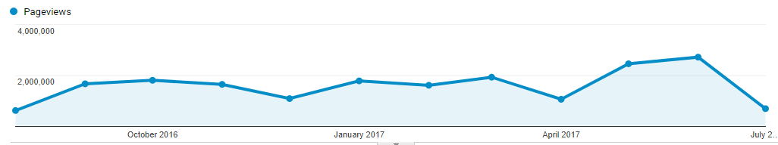

**Overview**

2,107,891 individuals visited the site

6,367,624 visits were made by the individuals above

19,154,005 pages were viewed during those visits

32.51% of the visitors were new to the site.

The average number of pages visited on each visit was 3.01.

The average time spent on each page was 2:45.

Most visits came from the following countries:

1. United States
2. India
3. Canada
4. Russia
5. Philippines
6. United Kingdom
7. Indonesia
8. Germany
9. South Korea
10. Australia

People who prefer to view the web with a different language have a setting on their computers that the analytic tool can read. The top five languages preferences that were not a variant of English (US, AU, UK) were:

1. Spanish
2. Korean
3. Russian
4. Japanese
5. Chinese

**Browsers**

This data shows that Chrome is the most popular browser.

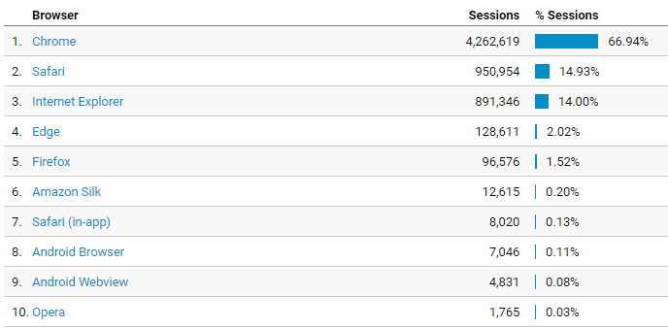

**Operating System**

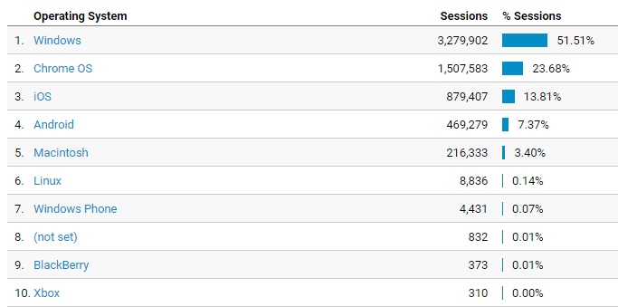

**Service Providers**

This tells us what provider the visitor is using.

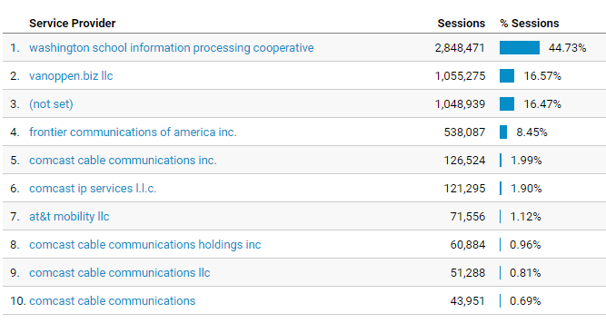

**Mobile Operating Systems**

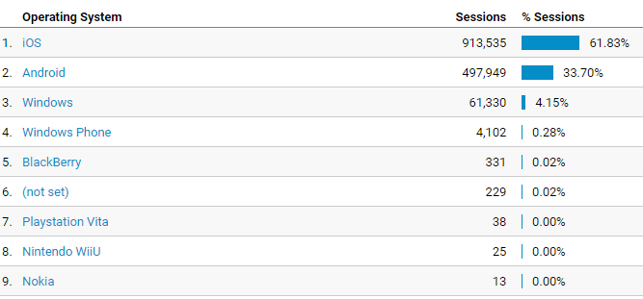

**Overall Screen Resolution**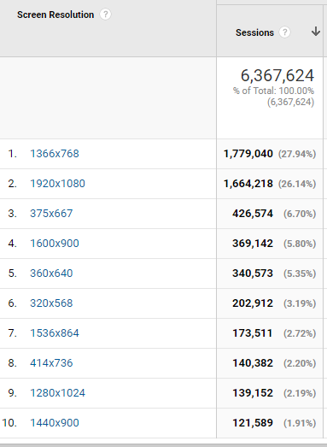

**Mobile Screen Resolution** 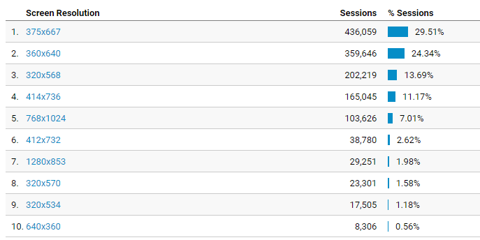

**Device Category**

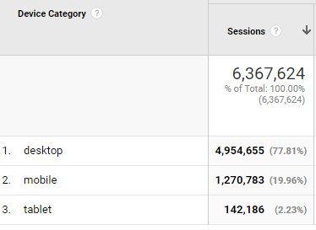

**Most visited pages**

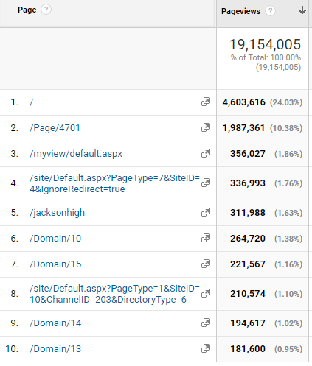

Login page

Jackson High

Jackson High

MyView (must login to see)

Evergreen Middle

Gateway Middle

Web Directory

Heatherwood Middle

LMS welcome page

District home page