**Website Analytics August 2017**

Website analytics provides insight into who is visiting the website with details of traffic patterns, demographics and technology used. This tool provides the information to create and maintain an effective website.

Analytics are provided on a monthly basis. **Overview**

94,516 individuals visited the site

221,234 visits were made by the individuals above

1,389,168 pages were viewed during those visits

30.96% of the visitors were new to the site.

The average number of pages visited on each visit was 6.28.

The average time spent on each page was 3:05.

Most visits came from the following countries:

1. United States
2. India
3. Philippines
4. Canada
5. Mexico
6. Australia
7. South Korea
8. United Kingdom
9. Japan
10. Vietnam

People who prefer to view the web with a different language have a setting on their computers that the analytic tool can read. The top five languages preferences that were not a variant of English (US, AU, UK) were:

1. Spanish
2. Korean
3. Chinese
4. Russian
5. Japanese

**Browsers**

This data shows that Chrome is the most popular browser.

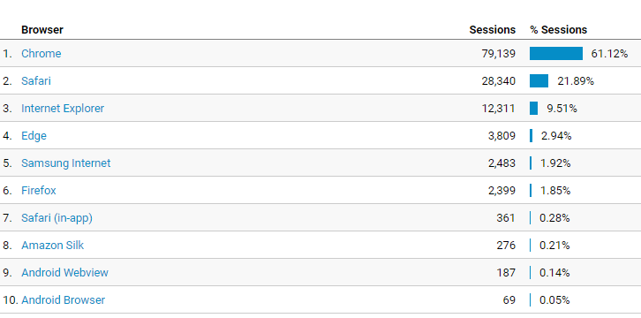

**Operating System**

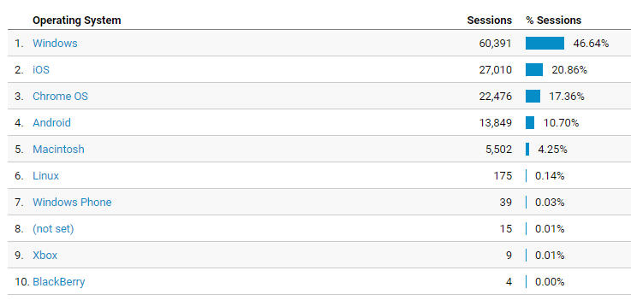

**Service Providers**

This tells us what provider the visitor is using.

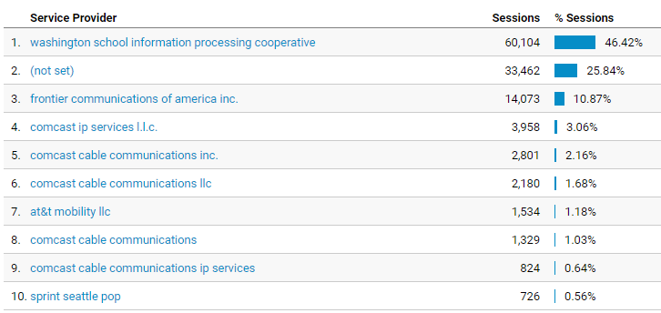

**Mobile Operating Systems**

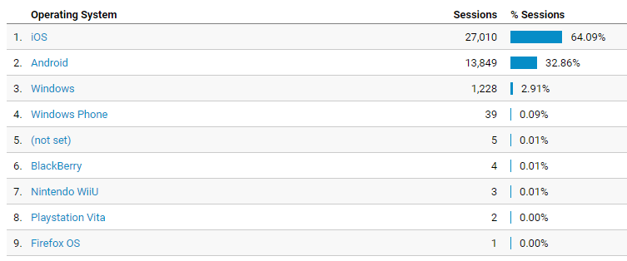

**Overall Screen Resolution**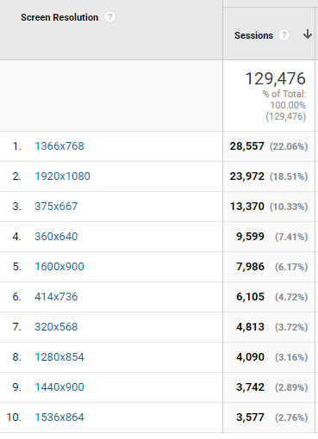

**Mobile Screen Resolution** 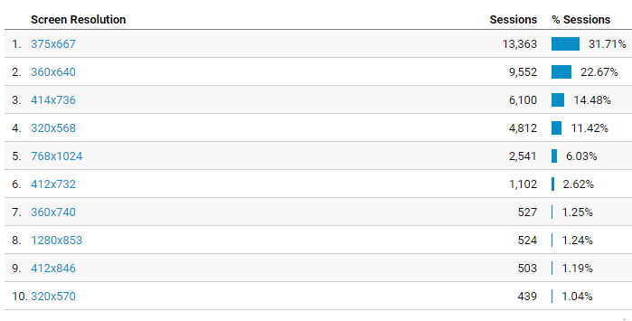

**Mobile Devices**

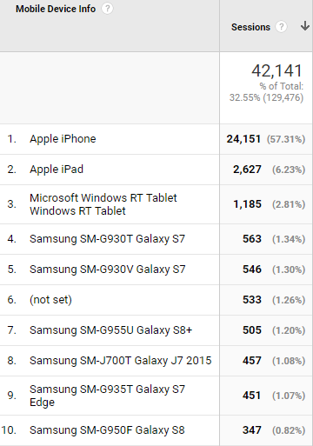

**Device Category**

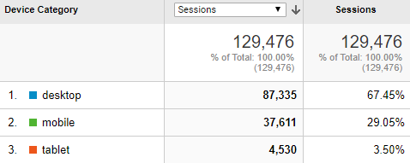

**Most visited pages**

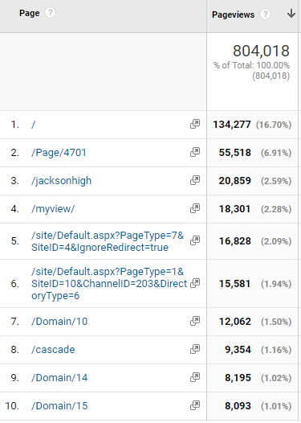

LMS welcome page

District home page

Jackson High

MyView (must login to see)

Login page

Staff Directory

Jackson High

Cascade High

Gateway Midlle

Heatherwood Middle