**Website Analytics February 2018**

Website analytics provides insight into who is visiting the website with details of traffic patterns, demographics and technology used. This tool provides the information to create and maintain an effective website.

Analytics are provided on a monthly basis.

**Overview**

368,184 **53,362**individuals visited the site

765,645 visits were made by the individuals above

3,353,937 pages were viewed during those visits

28.5% of the visitors were new to the site.

The average number of pages visited on each visit was 4.38**5.66 5.66**.

The average time spent on each page was 02:27.

Most visits came from the following countries:

1. United States
2. Canada
3. India
4. Philippines
5. Ukraine
6. United Kingdom
7. Japan
8. Brazil
9. Germany
10. Mexico

People who prefer to view the web with a different language have a setting on their computers that the analytic tool can read. The top five languages preferences that were not a variant of English (US, AU, UK) were:

1. Spanish
2. Korean
3. Russian
4. Chinese
5. Arabic

**Browsers**

This data shows that Chrome is the most popular browser.

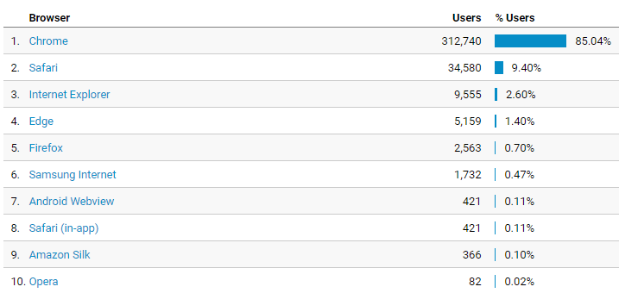

**Operating System**

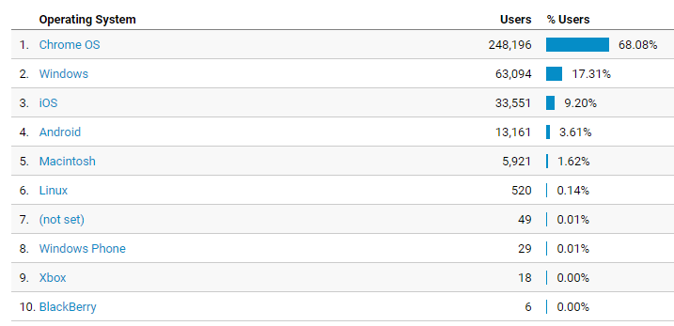

**Service Providers**

This tells us what provider the visitor is using.

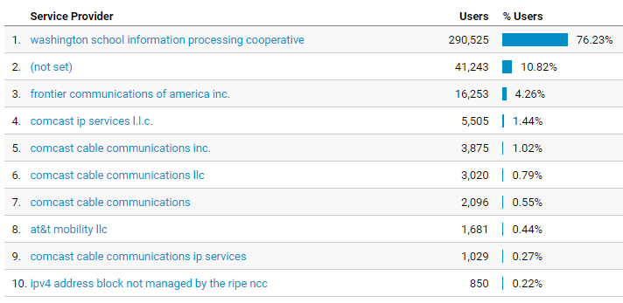

**Mobile Operating Systems**

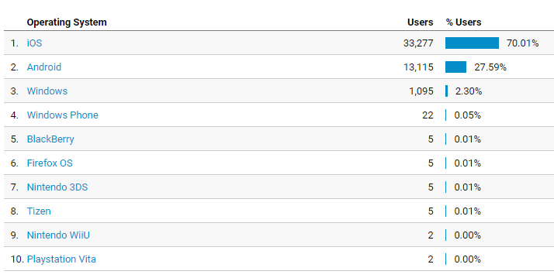

**Overall Screen Resolution**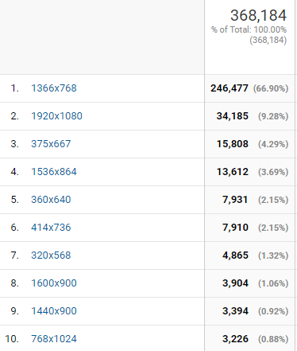

**Mobile Screen Resolution** 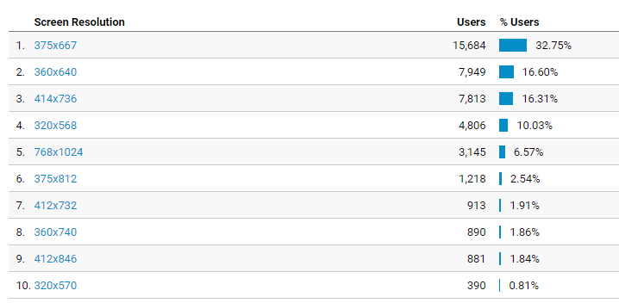

**Mobile Devices**

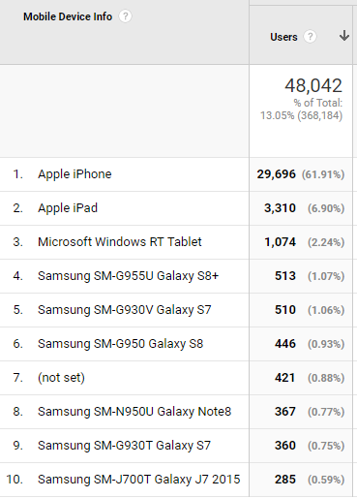

**Device Category**

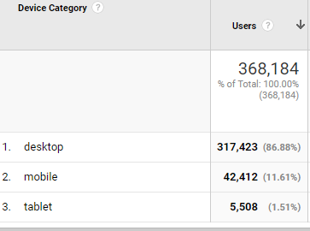

**Most visited pages**

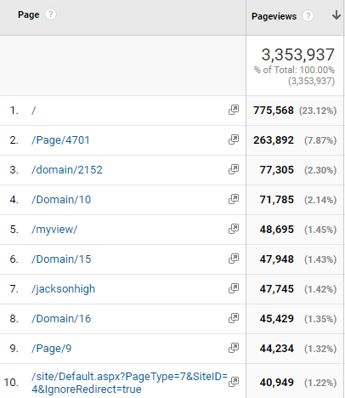

Cascade High

Login page

North Middle

Jackson High

Heatherwood Directory

MyView (must login to see)

Jackson High

Student Tools

LMS welcome page

District home page

Capital Project - 233 people entered the website (69% came through the friendly URL). There were 751 unique page views and the average time on each page viewed was 27 seconds.

Bond and Levy had 34 people. There were 416 unique page views and the average time was 45 seconds.