**Website Analytics March 2014**

Website analytics provides insight into who is visiting the website with details of traffic patterns, demographics and technology used. This tool provides the information to create and maintain an effective website.

Analytics are provided on a monthly basis. The following is for the last month.

**Overview**

160,365 individuals visited the site

523,789 visits were made by the individuals above

1,415,782 pages were viewed during those visits

18% of the visitors were new to the site.

The average number of pages visited on each visit was 2.70.

The average time spent on each page was 2:30.

Most visits came from the following countries:

1. United States
2. Canada
3. India
4. United Kingdom
5. Germany
6. Brazil
7. Philippines

People who prefer to view the web with a different language have a setting on their computers that the analytic tool can read. The top five languages preferences that were not a variant of English (US, AU, UK) were:

1. Korean
2. Spanish
3. Ukraine
4. Japanese
5. Chinese

**Page Count**

This shows us how many visits made. Visits represent the number of individual sessions initiated by all the visitors to your site. Of the visitors who only visited once there were 98,110 individual sessions that viewed 301,892 pages.   
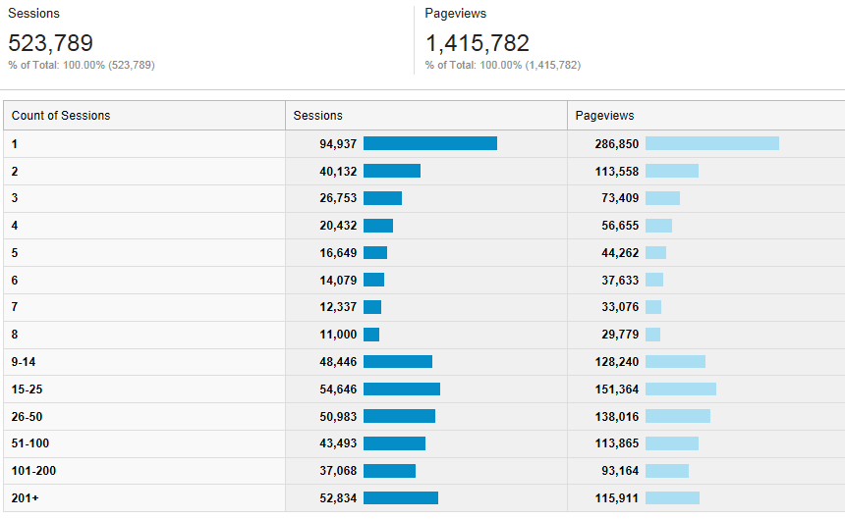

**Browsers**

This data shows that Internet Explorer is still the most popular browser.

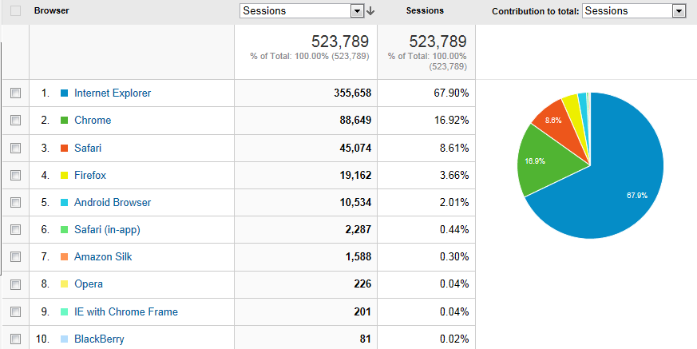

**Traffic**

191,881 users enter directly (meaning they have bookmarked or know the URL they want.

100,273 were referred by Google

28,676 were referred by Bing

4,208 were referred by imbd.com

**Operating System  
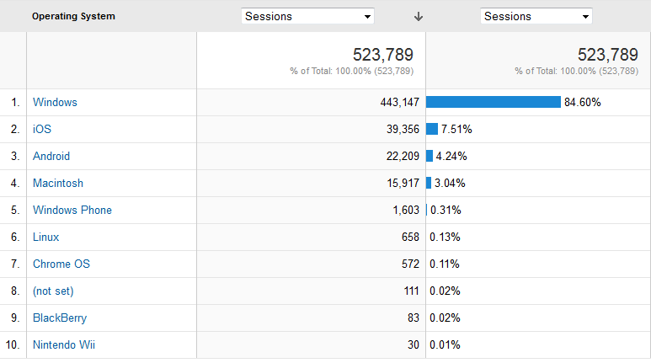**

**Screen Resolution  
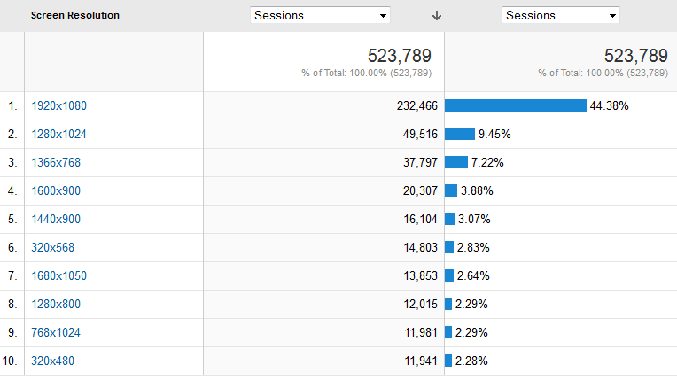**

**Devices**

While desktops are still primarily used for accessing the website. Mobileand tablet use is rising, especially with new visitors. Fortunately we made the new website a responsive design so that it functions effectievly on all devices.

**Statistics for all visits to website**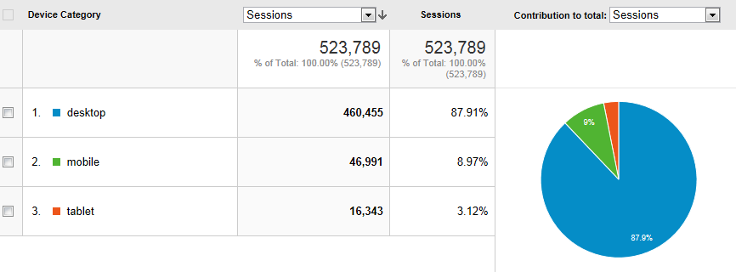

**For new visits to website**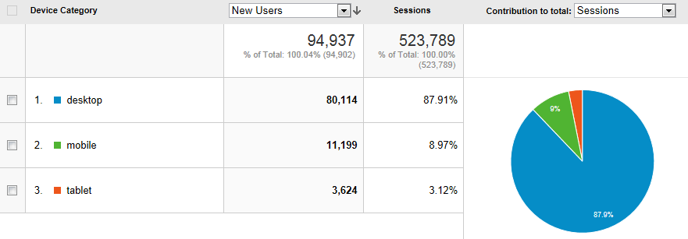

**Mobile Device Info**

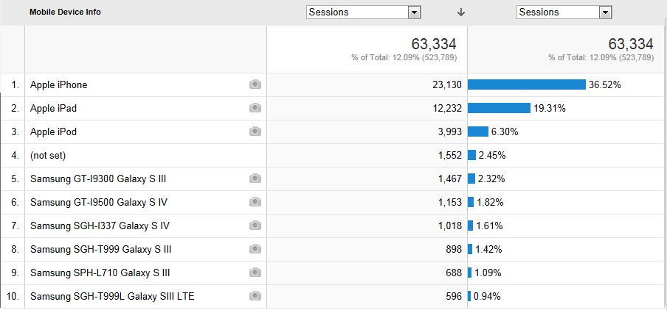

**Service Providers**

This tells us what provider the visitor is using.

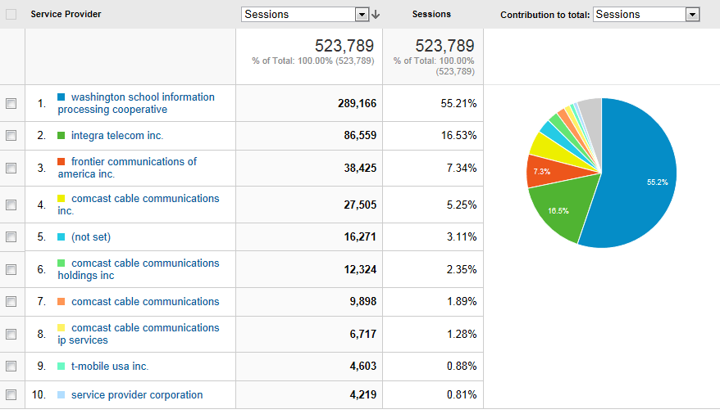

Most visited pages

http://www.everettsd.org/Page/4701 LMS  
http://www.everettsd.org/Domain/10 JHS  
http://www.everettsd.org/Domain/8 CHS  
myView   
http://www.everettsd.org/Domain/15 HMS  
 JHS teacher directory  
http://www.everettsd.org/Domain/9 EHS  
http://www.everettsd.org/Domain/13 EVE