**Website Analytics - November**

Website analytics provides insight into who is visiting the website with details of traffic patterns, demographics and technology used. This tool provides the information to create and maintain an effective website.

Analytics are provided on a monthly basis. The following is for the last month.

**Overview**

147,471 individuals visited the site

505,902 visits were made by the individuals above

1,405,695 pages were viewed during those visits

19.04% of the visitors were new to the site.

The average number of pages visited on each visit was 2.78.

The average time spent on each page was 2:49.

Most visits came from the following countries:

1. United States
2. India
3. Australia
4. Canada
5. Phillipines

People who prefer to view the web with a different language have a setting on their computers that the analytic tool can read. The top five languages preferences that were not a variant of English (US, AU, UK) were:

1. Spanish
2. Korean
3. Chinese
4. Japanese
5. Romanian

**Page Count**

This shows us how many visits made. Visits represent the number of individual sessions initiated by all the visitors to your site.

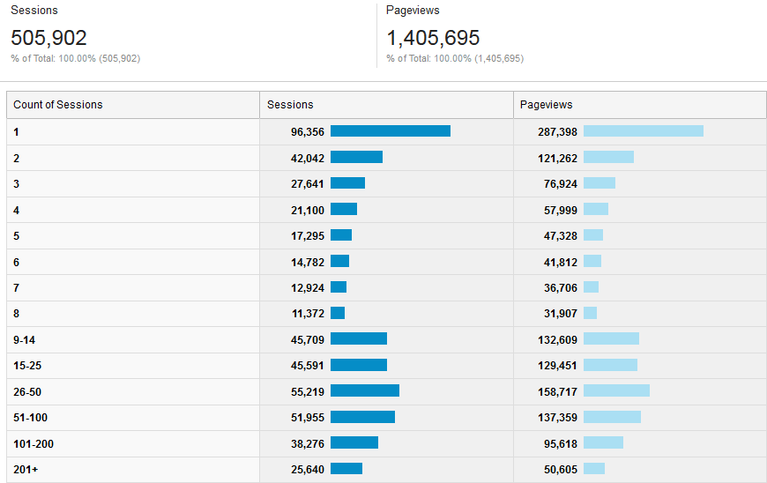

**Browsers**

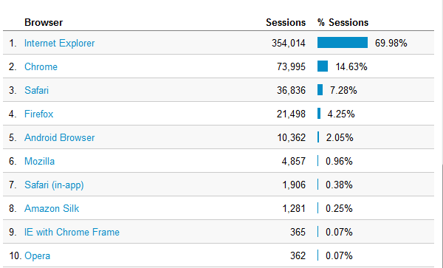

**Traffic**

195,471 users enter directly (meaning they have bookmarked or know the URL they want.

74,939 were referred by Google

23,934 were referred by Bing

4,240 were referred by heraldnet.com

3,905 were referred by coolmathgames.com

**Operating Systems**

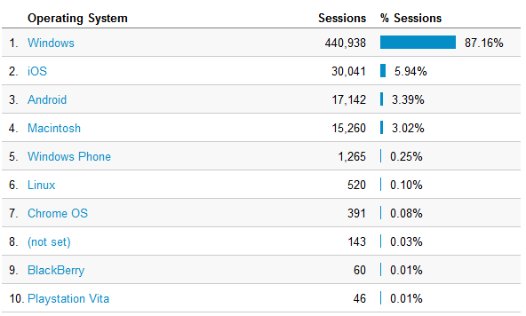

**Screen Resolutions**

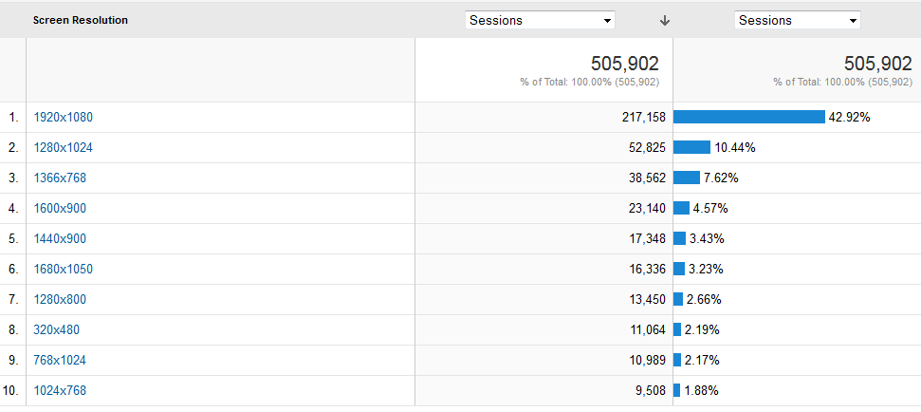

**Devices**

While desktops are still primarily used for accessing the website. Mobile and tablet use is rising, especially with new visitors

**Statistics for all visits to website**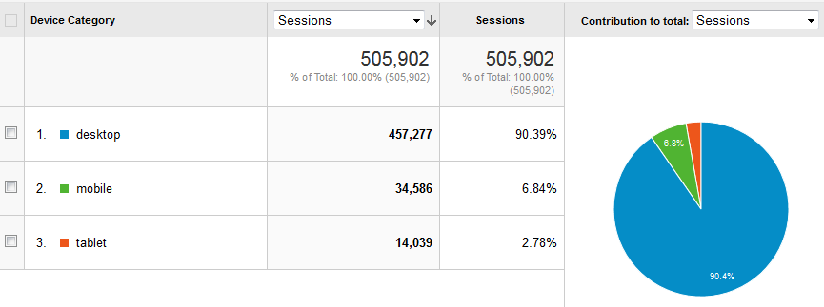

**For new visits to website**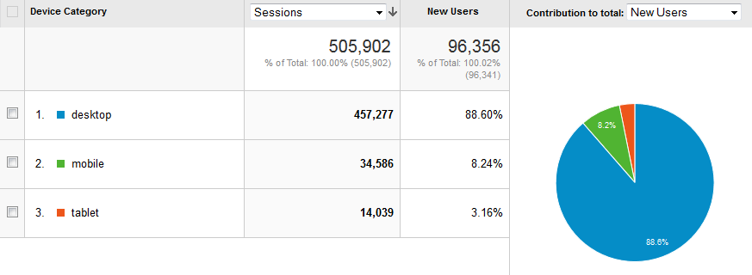

**Mobile Device Info**

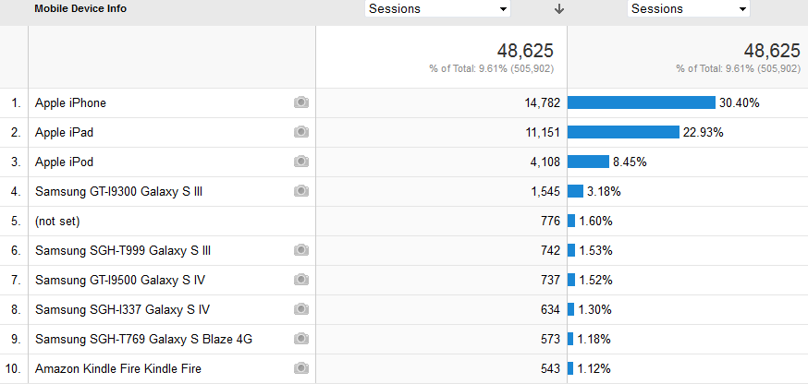

**Service Providers**

This tells us what provider the visitor is using.

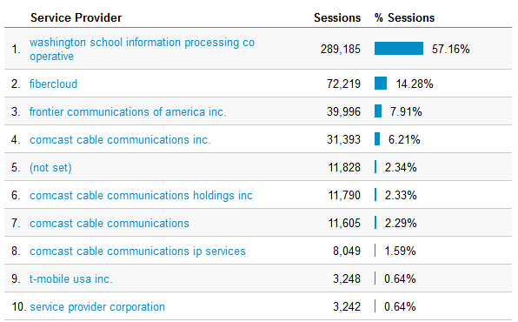

Most visited pages

http://www.everettsd.org/Page/4701 LMS  
http://www.everettsd.org/Domain/10 JHS  
http://www.everettsd.org/Domain/8 CHS  
JHS teacher directory  
myView  
http://www.everettsd.org/Domain/9 EHS  
http://www.everettsd.org/Domain/15 HMS