**Website Analytics September 2014**

Website analytics provides insight into who is visiting the website with details of traffic patterns, demographics and technology used. This tool provides the information to create and maintain an effective website.

Analytics are provided on a monthly basis. The following is for the last month.

**Overview**

140,418 individuals visited the site

392,206 visits were made by the individuals above

1,384,173 pages were viewed during those visits

29% of the visitors were new to the site.

The average number of pages visited on each visit was 3.53.

The average time spent on each page was 3:34.

Most visits came from the following countries:

1. United States
2. India
3. Canada
4. Turkey
5. Brazil
6. United Kingdom
7. Philippines
8. Germany
9. Spain
10. Mexico

People who prefer to view the web with a different language have a setting on their computers that the analytic tool can read. The top five languages preferences that were not a variant of English (US, AU, UK) were:

1. Korean
2. Japanese
3. Spanish
4. Chinese
5. Portuguese

**Browsers**

This data shows that Internet Explorer is still the most popular browser.

|  |  |  |
| --- | --- | --- |
| **Browser** | **Sessions** | **% Sessions** |
| %1. | Internet Explorer | 195,386 | 49.82% |
| 2. | Chrome | 111,148 | 28.34% |
| 3. | Safari | 56,201 | 14.33% |
| 4. | Firefox | 18,248 | 4.65% |
| 5. | Android Browser | 8,830 | 2.25% |
| 6. | Amazon Silk | 1,355 | 0.35% |
| 7. | Safari (in-app) | 402 | 0.10% |
| 8. | Opera | 166 | 0.04% |
| 9. | Opera Mini | 87 | 0.02% |
| 10. | IE with Chrome Frame | 71 | 0.02% |

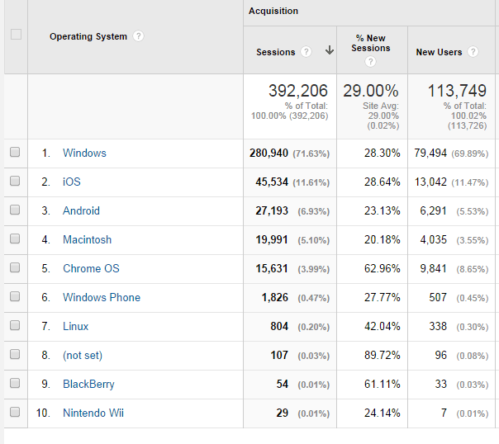**Operating System**

**Mobile Operating Systems**

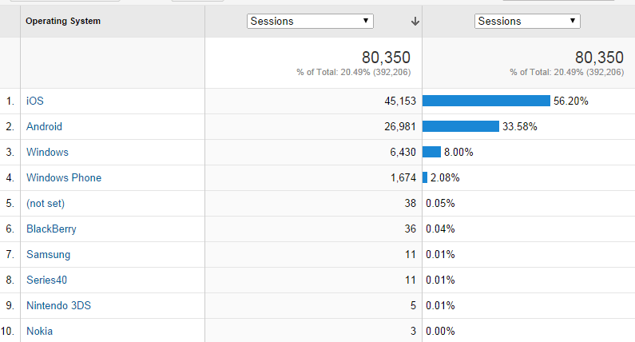

**Screen Resolution  
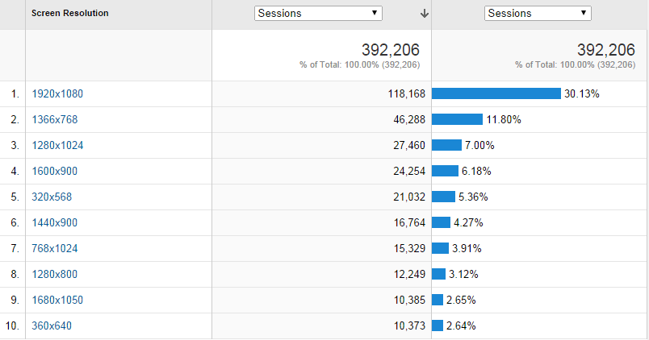**

**Service Providers**

This tells us what provider the visitor is using.

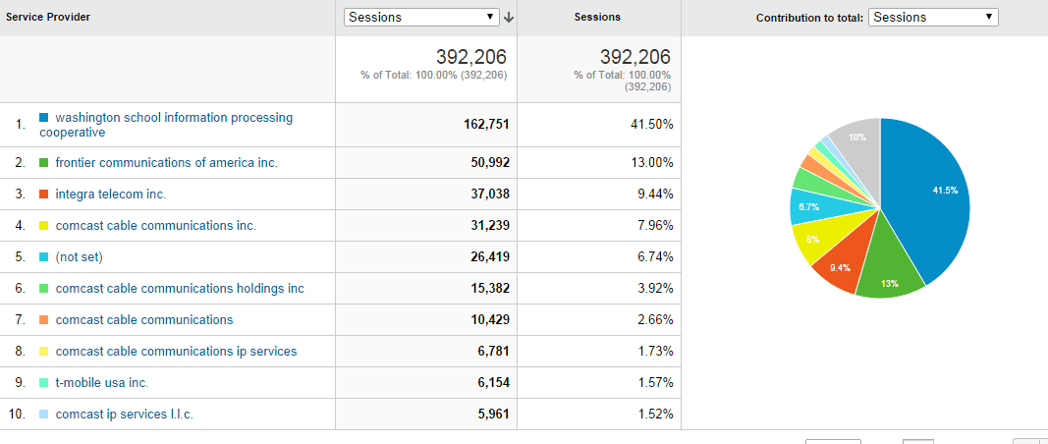

Most visited pages

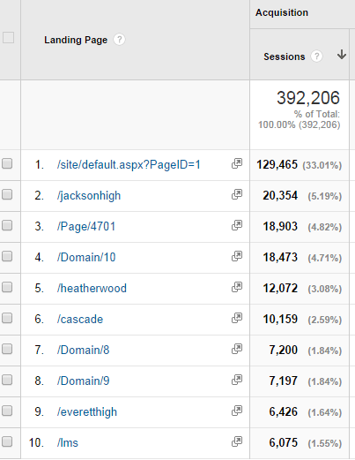

Everett High

Cascade High

Jackson High

LMS welcome page

School Board 568 unique page views, 1:52

Superintendent 228 unique page views, 1:21