**Website Analytics April 2015**

Website analytics provides insight into who is visiting the website with details of traffic patterns, demographics and technology used. This tool provides the information to create and maintain an effective website.

Analytics are provided on a monthly basis. The following is for the last month.

**Overview**

155,008 individuals visited the site

404,833 visits were made by the individuals above

1,080,508 pages were viewed during those visits

26% of the visitors were new to the site.

The average number of pages visited on each visit was 2.71.

The average time spent on each page was 3:02.

Most visits came from the following countries:

1. United States
2. India
3. Canada
4. Japan
5. Israel
6. United Kingdom
7. Philippines
8. Brazil
9. South Korea
10. Russia

People who prefer to view the web with a different language have a setting on their computers that the analytic tool can read. The top five languages preferences that were not a variant of English (US, AU, UK) were:

1. Korean
2. Japanese
3. Spanish
4. Romanian
5. Chinese

**Browsers**

This data shows that Chrome is the most popular browser.

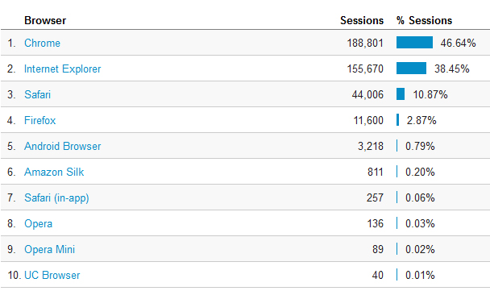

**Operating System**

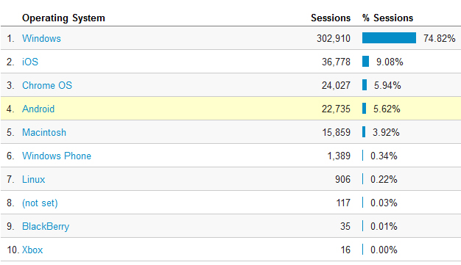

**Mobile Operating Systems**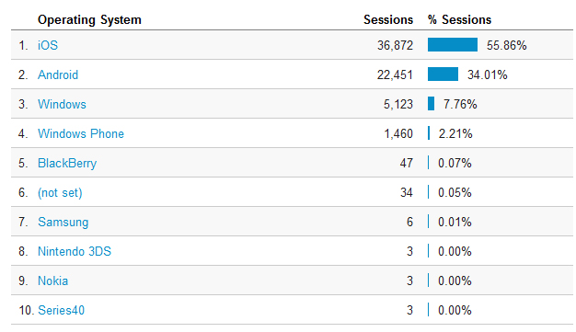

**Overall Screen Resolution  
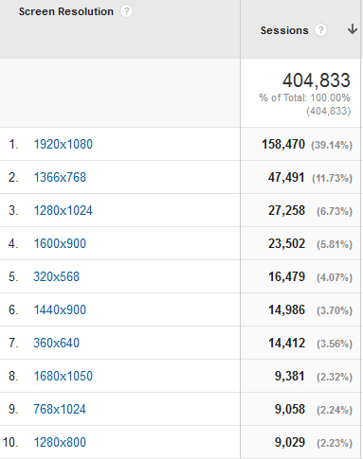**

**Mobile Screen Resolution**

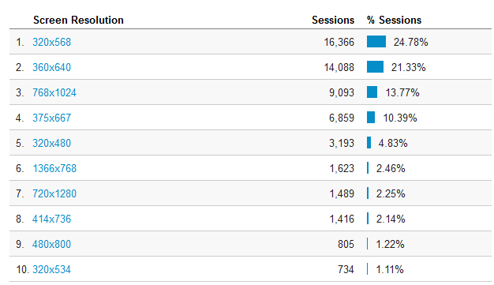

**Service Providers**

This tells us what provider the visitor is using.

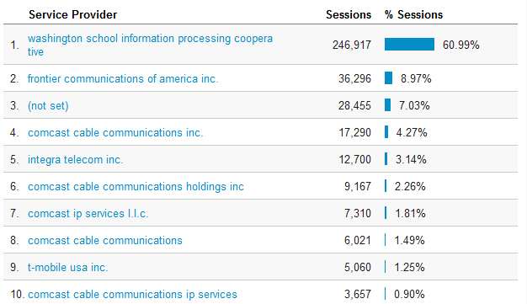

**Most visited pages**

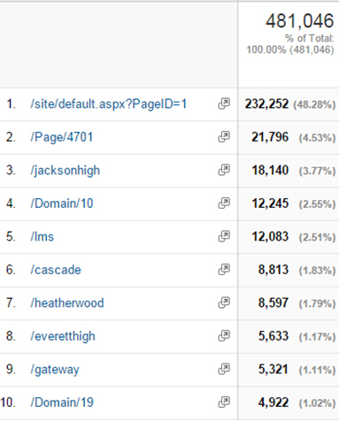

Forest View Elementary

Jackson High

LMS welcome page