**Digit-Place**

**Goal:**

To guess your partners mystery number. Use what you learn with each guess to make a better next guess.

**Materials:**

* A partner
* Something to write on (paper, mini white board, etc.)
* Writing utensil

**Directions:**

* One player chooses a two-digit number. (The digits must be different.) The other player tries to guess the number. For each guess, the first player tells how many digits are correct and how many of the correct digits are in the correct place. (If only one digit is correct, do not tell which digit it is; just say that one is correct.)
* Chart your progress
* Play again so that the other player can guess.

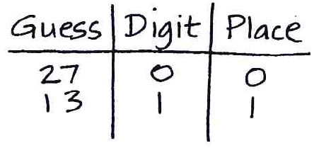

**Modifications:**

* Instead of a two-digit number, create a three-digit, four-digit, or five-digit number.