Note: be sure and select 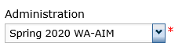

1. Log into eDirect <https://www.drcedirect.com/all/eca-portal-ui/welcome/WA>
2. 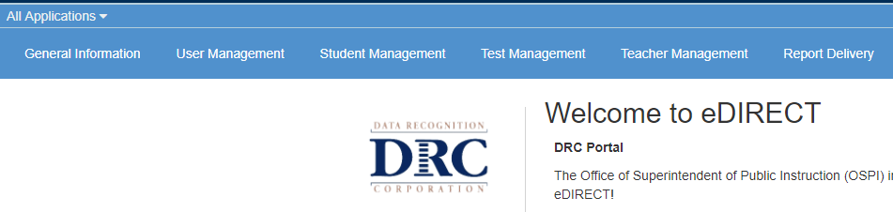Click ‘All Applications’ to view all available tabs, then select ‘Test Management’
3. 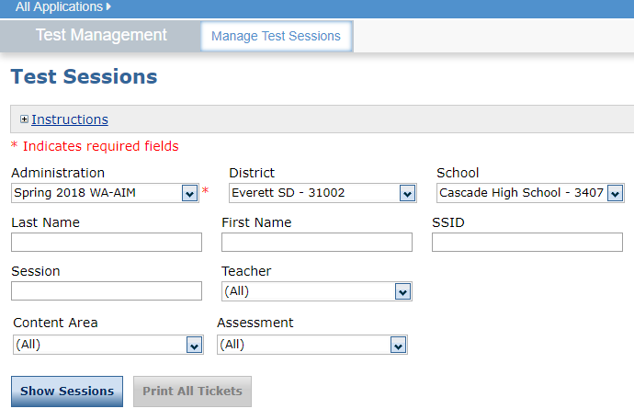Click ‘Manage Test Sessions’ tab and select the fields for your building, then ‘Show Sessions’
4. Check the ‘Status’ column for test progress and ‘Export Student Details’ to Excel

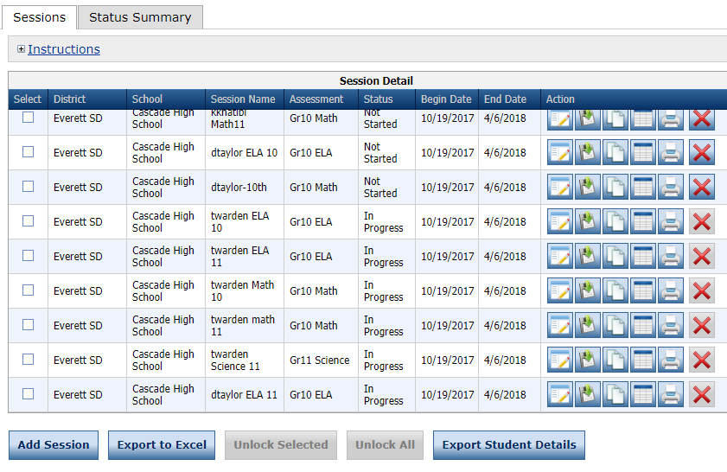

1. Excel spreadsheet will download to bottom left of computer screen. The report will include student details along with Status, Date Started and Date Completed.

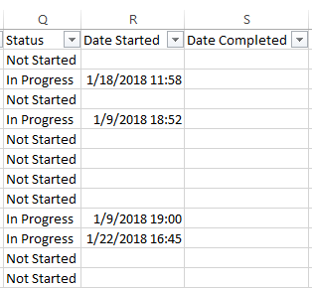

View Students without a Session Assignment

1. Select Student Management, then the ‘Manage Student’ tab. Select Spring 2018 WA-AIM, Session Assignment None, then Find Students. If there are any students at your building who do not have a session assigned to them, please talk with your IEP team to find out why the student has not been assessed.

