***Information Only***

???, 2019

To: All Principals & Assistant Principals

From: LauriBeth Hull, Internet Technology Specialist

Re: School Supply List Recommendation

Many schools want to put up their new supply lists before summer. This is technically the responsibility of the school’s website editors.

Every school has a school collection in DocuShare and a document titled School Supply List. Unless your school modified it every school’s School Supply List link under Our School opens a page that displays and links to this supply list. All the school needs to do is upload the new version in DocuShare and it will automatically show on the school website.

**Instructions:**

**Convert** your supply list to PDF

**Go** **to** <http://docushare.everett.k12.wa.us/docushare/dsweb/View/Collection-117>

**Log in** with your district network username and password.

**Open** your school’s collection

**If there is a supply list:**

**If there is a supply list:**

**Click** on the three dots to the right   


**Click** Upload a New Version

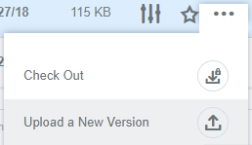

**Upload** the new supply list

**Click** *Apply*

If you have any questions contact LauriBeth Hull at [lhull@everettsd.org](mailto:lhull@everettsd.org) or 425-385-4208