Notice and Wonder

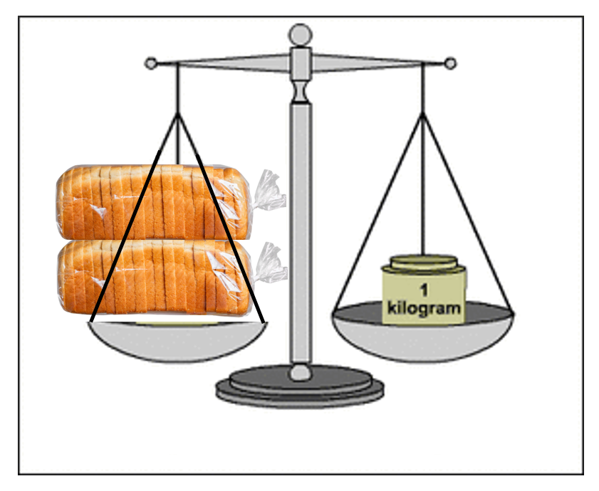

|  |  |
| --- | --- |
| What do you NOTICE? | What do you WONDER? |
|  |  |