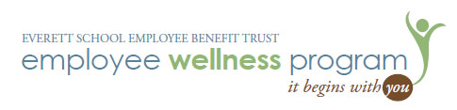

Wellness Program Report

May/June 2015

**Physical Fitness:** May- National Physical Fitness Month!

* Triathlon Challenge: 70 participants, 58 completed the challenge
* Bike Month: 46 participants rode over 6,500 miles and completed 679 trips collectively.

**Live Healthy 2020:** Enrolled Everett Public Schools in the Snohomish County Health Leadership Coalition’s ***Live Health 2020***. This initiative is engaging local businesses and organizations to champion and model healthy lifestyles in an effort to make Snohomish County a healthy place to live and work. WALKTOBER will be our model for the community. “Edge of Amazing” Summit (gathering of all committed organizations) will be held July 23rd with Governor Inslee in attendance.

**Weight Management:**

**Weight Watchers at Work** Meetings:

* CRC: Group has lost over 450 pounds this year.
* Penny Creek Group lost over 150 pounds this year.

**Wellness Reads**

**Eat, Move, Sleep**: Books distributed to all SLT Team in the fall. Survey results (66 respondents)

* 20 read the entire book
* 33 read part of the book
* 13 did not read the book

As a result of reading part or the entire book:

* 26 made changes to their diet
* 21 made changes in their level of physical activity
* 30 stated their sleep had improved

**Comments**

* Put excerpts of the book in to Principals Packet and include as a “standing item” for group discussion at Principal level meetings.
* Please continue to provide healthy snacks at meetings and standing activity breaks!!
* Highlight tips from the book and include in SLT meetings. Small group discussions regarding the “tip”.
* Share more of these great tips and strategies at SLT meetings. Include a “Wellness Moment” at SLT meetings.