

EVERETT PUBLIC SCI-IOOLS

Elementary Student Transportation Routing **and**

On-Boarding Process



**Elementary Student Transportation Routing and On-Boarding Process**

|  |  |  |  |
| --- | --- | --- | --- |
| **Completion**  **Date** | **Action/Task** | **Responsible**  **Party** | **Comments** |
| August 25 | Special Ed route information  sent by Blackboard Connect message | Transportation | Blackboard Connect message sent to parents/guardians with student specific route information. |
| August 25 | Student route assignments | Transportation | Student route assignment lists will be sent to all elementary schools. Further updates will be printed by  schools out of Versatrans E-Link. |
| August 30 | Route information sent by Blackboard Connect message | Transportation | Blackboard Connect message to families of all students as of August 30. Route information for students registering August 30 and beyond will be  printed by schools for classroom distribution. |
| September 2 & 3 | Print sample set of color- coded bus badge labels. Labels will not have classroom info until class lists are finalized. | Office Team | Transportation for use during the first two weeks of school. Office staff will run Cognos bus badge label report and print sample set of color badges to check accuracy. |
| September 3 | Final class lists and student schedules are complete in E-  Schools | Office Manager | Office completes entry of class lists and schedules for September 2. This allows class lists to be  merged with route information. |
| September 8-17 | Print student bus route lists  for all teachers each day | Office Team | Distribute alphabetical student bus route lists to **all**  teachers from Versatrans E-Link **each day.** |
| September 8-24 | Print color-coded bus badge  labels for K & 1st Grade students each day | Office Team | Distribute color-coded bus badge labels to K & 1st Grade teachers by 11:00 a.m. **each day.** |
| **Entire School Year** | **Print color-coded bus badge labels for new bus-riding kindergartners and first**  **graders** | Office Team | **Print color-coded bus badge labels for new bus- riding kindergartners and first graders for 5 school days after their enrollment at your school.** |
| Entire School Year | Bus route assignments | Office Team | Parents/Guardians who register students after 12:00  p.m. need to provide transportation for their students to school the following morning. New students will have their bus route assignment in time for them to ride the bus home that afternoon. Schools will assist  students in finding their bus at the end of the day. |
|  |  |  |  |

**Elementary Student Transportation Routing and On-Boarding Process**

**Kindergarten students will not be dropped off at their bus stop if a parent/guardian is not there to meet them, unless a waiver form has been completed.**

Students who have parent/guardian permission to ride a different bus home, must have a bus pass issued by the school office. The pass must be printed on **YELLOW** paper, and include the following information: Student name, name of student they are riding with, route number, bus stop and signature of the office personnel issuing the pass. Students without a bus pass **WILL NOT** be allowed on a bus that is not their normal route.

# Elementary Student Transportation Routing and On-Boarding Process

How to Run Versatrans e-Link Reports

Open the e-link below and enter your user name and password

The url to open e-Link is:

<https://versatransweb05.tylertech.com/Everett2/elinkrp/Welcome.aspx>

**General Note: Versatrans downloads updated student information to eSchools each night. The e-Link report will have the most current route information but student information in eSchools will be from the prior day until download occurs.**

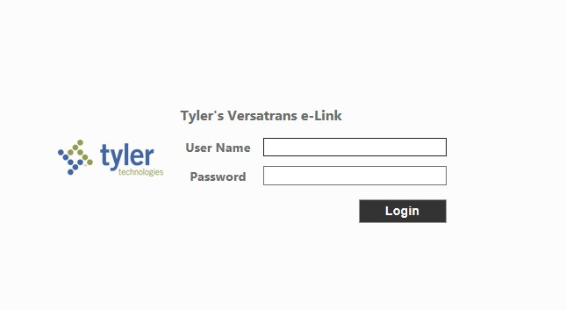

Select - Run Reports

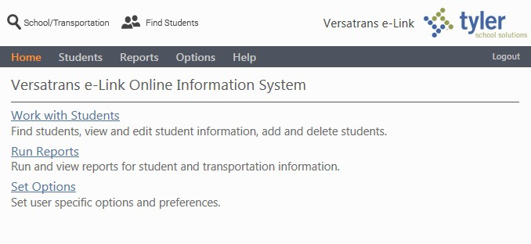

To run a Student List Report choose “Student List Reports,” set your criteria and select "Create Report."

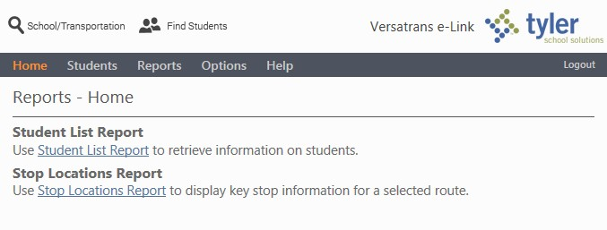

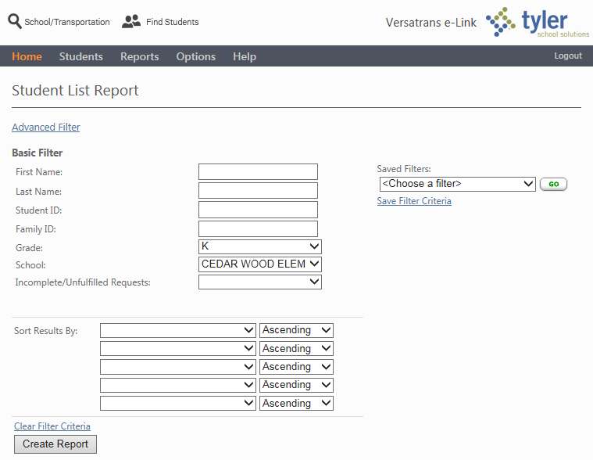

The three checkboxes at the top of the report can be selected or unselected depending on the information you want to show. If unselected, only the student name and grade will display. The student names are links that will open a page with their detailed transportation information.

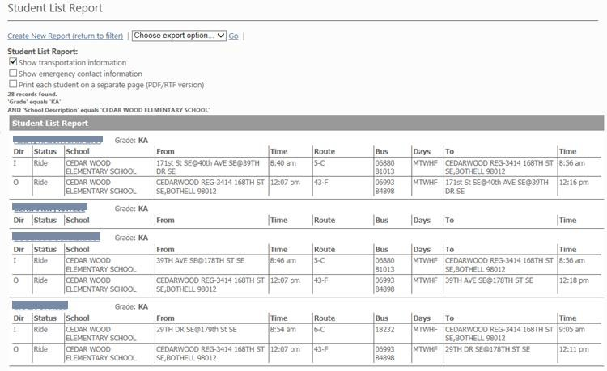

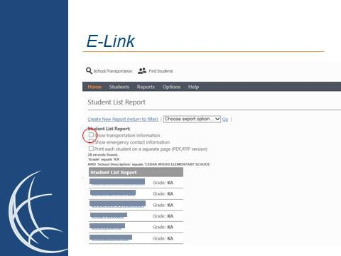

To run a Stop Locations Report select “Stop Locations Report,” choose the bus route number and select "Generate Report."



Select the bus that you want a list for in the list below.

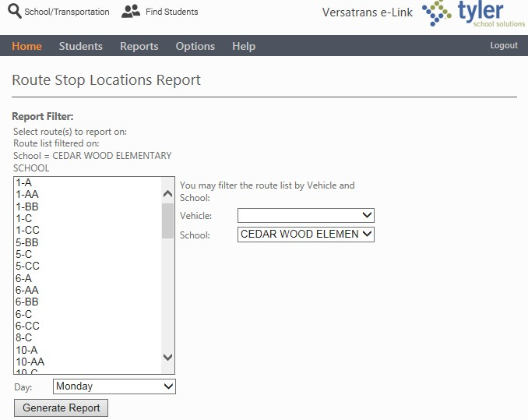

You can choose how much or how little information shows up on the report by selecting the three checkboxes.

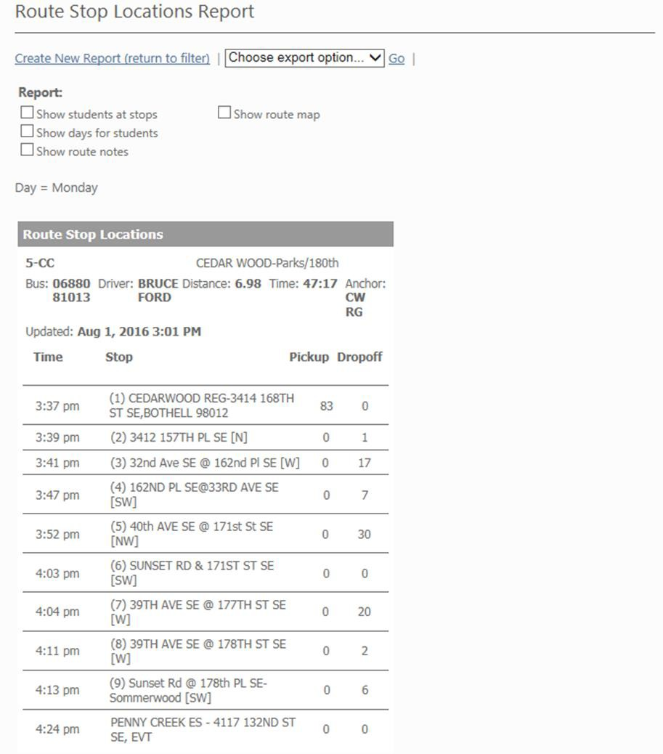

You can create a pdf or export your report by choosing the format from the dropdown box and selecting "Go." Right click to save or print the file.

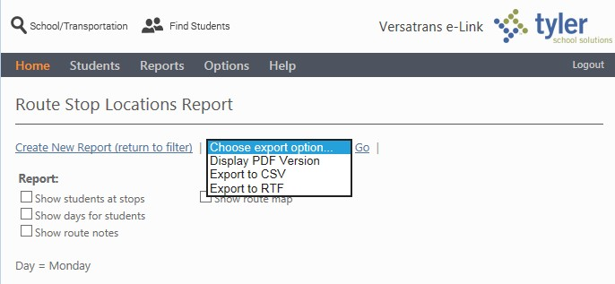

# Student Transportation Information

Maintaining Student Transportation Information

*Student’s bus route and stop information is updated from Transportation, but we also have the ability to record their other transportation options and choices within eSchoolPLUS. This is especially important for the youngest students at the start of school, and recorded Transportation information is used to produce reports like Transportation labels to help route students to their correct mode of transportation.*

The most commonly used Travel Types are:

* G – Boys & Girls Club
* D – Daycare Provided Transportation
* P – Parent
* W - Walk

***Two codes exist for information pulled into eSchoolPLUS from Versatrans. These codes are B – for regular Bus Route Information, and X for errors. Neither of these codes should be entered and nothing in these trips should be changed by office personnel.***

**TO ADD STUDENT TRANSPORTATION INFORMATION**

**(Student Center > Demographics > Transportation)**

1. Enter in a Trip number (use the next number in sequence if there is already a row for the student)
2. Check the appropriate days of the week
3. Enter 1 for the segment number
4. Choose the travel type from the drop down. **(DO NOT CHOOSE B OR X)**
5. Add any detail information under the Stop Description.

You can use the same process to enter information about the student travel either to or from school.

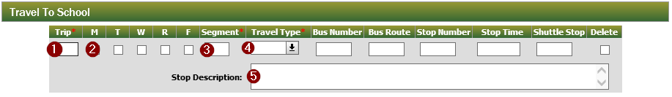



August 2016 Version 0.1

# First Week Transportation Label Report

The First Week Transportation Label Report can be found in eSchools > Cognos > Public folders > eSchool application reports > Transportation. ***Any student without a code in the transportation information field of eSchool will print with black parenthesis,*** allowing for handwritten entry of information. Please make sure this handwritten information is communicated to the office for updating in eSchool. ***Any route not assigned a color by Transportation, will print in black.***

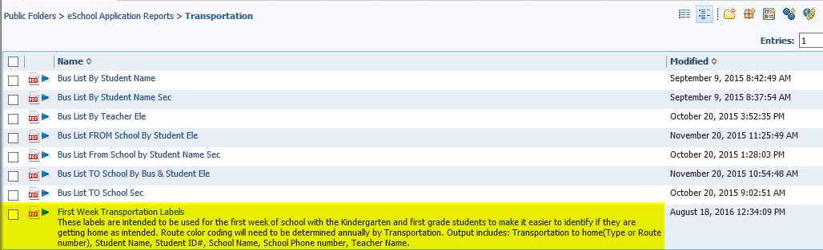

**Page 1 of 2**

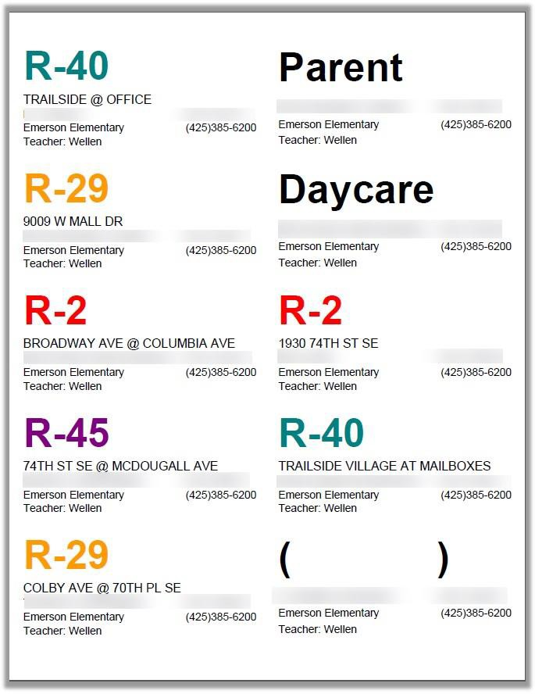***Sample Labels***

STUDENT'S NAME ID #XXXXX STUDENT'S NAME ID #XXXXX

STUDENT'S NAME ID #XXXXX STUDENT'S NAME ID #XXXXX

STUDENT'S NAME ID #XXXXX STUDENT'S NAME ID #XXXXX

STUDENT'S NAME ID #XXXXX STUDENT'S NAME ID #XXXXX

**HANDWRITE DESTINATION**

STUDENT'S NAME ID #XXXXX STUDENT'S NAME ID #XXXXX

**Page 2 of 2**

|  |  |  |  |
| --- | --- | --- | --- |
| ***BUSPASS*** |  | ***BUSPASS***  Student Name: Guest of:  Date of Travel: Bus Route: Bus Stop:  Completed by: |  |
|  |  |
|  | (Date) | (Date) |
| Student Name: |  |  |
|  |  |
| Guest of: |
| Date of Travel: |  |  |
|  |  |
| Bus Route: |
|  |  |
| Bus Stop:  Completed by: |
|  |  |
|  |  |
| ***BUSPASS*** |  | ***BUSPASS*** |  |
|  |  |
|  | (Date) |  | (Date) |
| Student Name: |  | Student Name: |  |
|  |  |
| Guest of: | Guest of: |
|  |  |
| Date of Travel: | Date of Travel: |
|  |  |
| Bus Route: | Bus Route: |
|  |  |
| Bus Stop:  Completed by: | Bus Stop:  Completed by: |
|  |  |
|  |  |
| ***BUSPASS*** |  | ***BUSPASS*** |  |
|  |  |
|  | (Date) |  | (Date) |
| Student Name: |  | Student Name: |  |
|  |  |
| Guest of: | Guest of: |
|  |  |
| Date of Travel: | Date of Travel: |
|  |  |
| Bus Route: | Bus Route: |
|  |  |
| Bus Stop:  Completed by: | Bus Stop:  Completed by: |
|  |  |
|  |  |