# EVERETT PUBLIC SCHOOLS

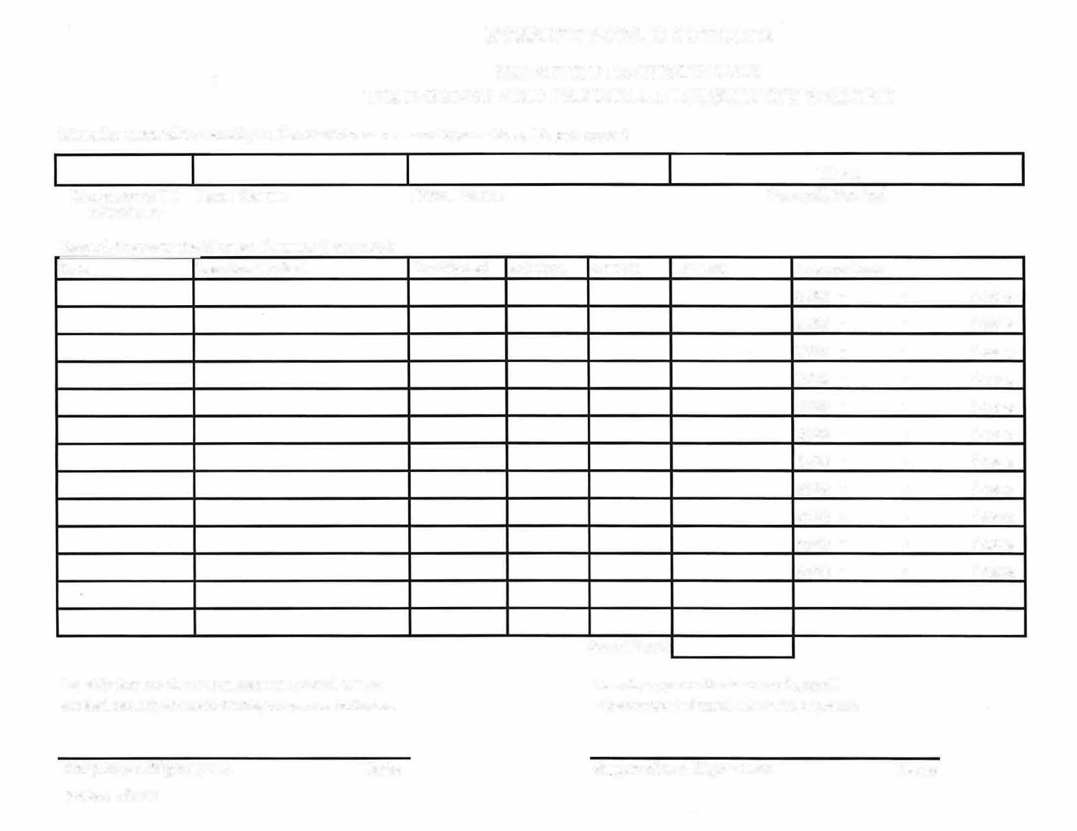

**SUBSTITUTE CUSTODIAN**

**TIME SHEET ANDPAYROLLADJUSTMENT RECORD**

## **Must be turned in weekly to the Maintenance and Operations Department**

### Employee ID Last Name

REQUIRED

### Record Hours to the Nearest Quarter Hour (.25)

Date Location Worked

I certify that the above is an accurate record of time worked and adjustments during the period indicated.

### First Name

Hrs Worked Sub Rate

## **Thru**

### Payroll Period

OT Rate Total$$ Account Code

10-97-63- 741431-43122

10-97-63- 741431-43122

10-97-63- 741431-43122

10-97-63- 741431-43122

10-97-63- 741431-43122

10-97-63- 741431-43122

10-97-63- 741431-43122

10-97-63- 092740-43122

10-97-63- 092740-43122

10-97-63- 092740-43122

### Grand Total

I hereby approve the hours and payroll adjustments indicated above for payment.

### Employee Signature

### Date Supervisor Signature Date