**INTRODUCING TIMECARD ONLINE**

The Everett School District payroll office is introducing an online timecard program to replace existing paper processes around the submission of extra time for pay. The online process is based on monthly submission and approvals will also be electronic. The timeliness and accuracy will be improved, along with the ability to track employee payments more precisely.

**TIMECARD ONLINE will now be a new tab available through the EMPLOYEE ONLINE product.**



SAVE to revisit at a later date, and to calculate totals

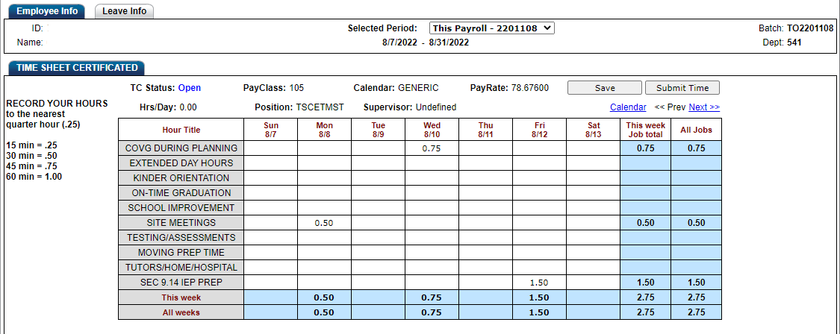STEP 1: Choose from an open pay period

STEP 2: ENTER hours (rounded to nearest .25 hours) on the appropriate dates, under the applicable program and hour. Use the “Next” or “Prev” link to move between open weeks.

37



STEP 3: Click into the hours entered to display an ellipsis box.

A Detailed Time Entry panel will pop up. Here you will provide a short description of work performed (**see example below**; please include student name). You can describe the whole amount, or split the hours between time as applicable. When completed click on the SAVE button.

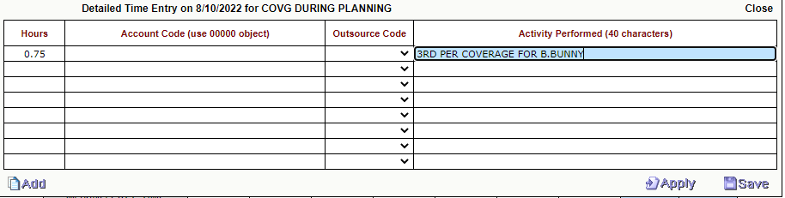

SAVE to revisit at a later date, and to calculate totals



STEP 4: SUBMIT to send for approval

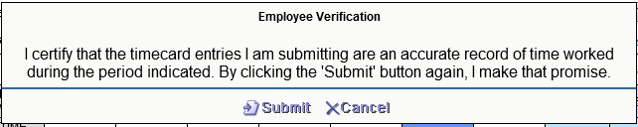

STEP 4: Before clicking on SUBMIT, be sure you have entered ALL your additional time for the entire pay period identified (i.e. typically a 4-week period). This means you will submit only one time per month. Once submitted, the records will route for budget authorization and you will not be able to add or edit the records. If an error has been identified, you will need to contact your school timekeeper.

Failing to submit your time by the Payroll Calendar submission deadlines may result in delayed payment.

You will receive an email (an example shown below) once your records have completed the electronic process.

Only **the hour categories above** will be submitted through Timecard Online at this time. Additional hours worked in other assignments or in other capacities will be recorded via the existing methods (PD and/or paper timesheets) as applicable.

