1. Search for Google Input Tools and select the link below

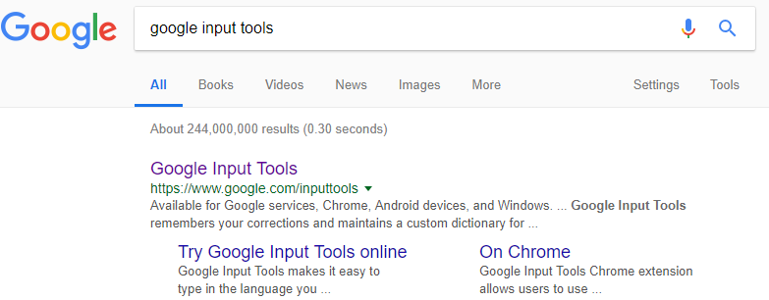

2. Select Install Google Input Tools

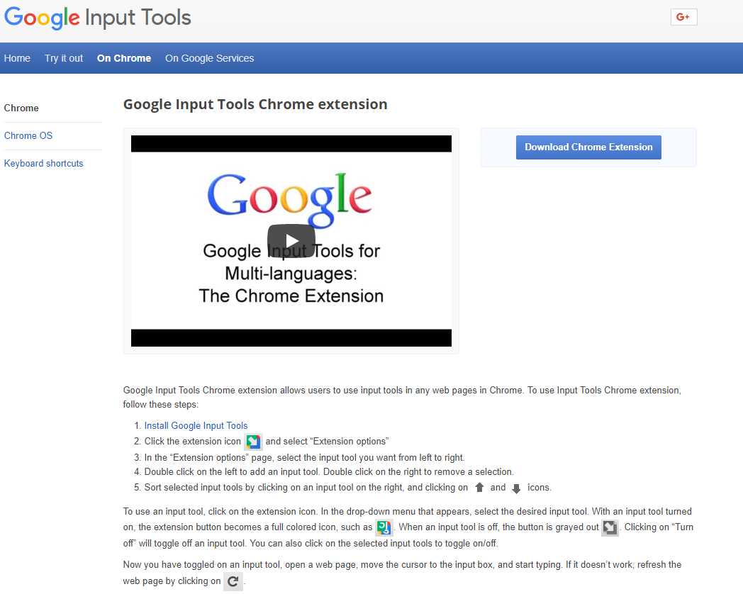

3. Select Add to Chrome and then add extension

