**Grade 7 Course Requests**

Core Classes

|  |
| --- |
| Department Credit |
| English (select one) |
| * English 7 791ENG * Honors English 8 893ENG |
| Mathematics (select one) |
| * Algebraic Concepts Graduation cap with solid fill 117MTH 1.0 * Accelerated 7 713MTH * Math 7 700MTH |
| Physical Education / Health (select both) |
| * Health 7 HTH701 * Fitness 7 PED701 |
| Science |
| * Science 7 700SCI |
| Social Studies |
| * WA State History Graduation cap with solid fill HIS755 0.5 |

Elective Options (Choose three semesters Hint: the circles add up to 3)

|  |  |  |  |  |  |  |
| --- | --- | --- | --- | --- | --- | --- |
| **Fine Arts (Pick one or more)** | | | | | | |
| Request | Description | Course | Credit | Alternate (two drop down menus)  Alternate to the Course: Course code of favorite | | |
|  | Art 7 | ELC771 | 0.00 | *Make Course an Alternate* |  | |
|  | Band I | 909MUS | 0.00 | *Make Course an Alternate* |  | |
|  | Band II | 919MUS | 0.00 | *Make Course an Alternate* |  | |
|  | Badge outlineBand III *Instructor Approval | 929MUS | 0.00 | *Make Course an Alternate* |  | |
|  | Badge outlineChoir I | 901MUS | 0.00 | *Make Course an Alternate* |  | |
|  | Badge outlineChoir II | 903MUS | 0.00 | *Make Course an Alternate* |  | |
|  | Badge outlineChoir III *Instructor Approval | 907MUS | 0.00 | *Make Course an Alternate* |  | |
|  | Badge 1 outlineExploring Graphic Arts Graduation cap with solid fill | CTE137 | 0.50 | *Make Course an Alternate* |  | |
|  | Badge 1 outlineGeneral Music | ELC901 | 0.00 | *Make Course an Alternate* |  | |
|  | Badge outlineOrchestra I - Prelude | 921MUS | 0.00 | *Make Course an Alternate* |  | |
|  | Badge outline Orchestra II - Intermezzo | 923MUS | 0.00 | *Make Course an Alternate* |  | |
|  | Badge outline Orchestra III - Chamber *Instructor Approval | 925MUS | 0.00 | *Make Course an Alternate* |  | |
| **Other Electives** | | | | | | |
| Request | Description | Course | Credit | Alternate (two drop down menus)  Alternate to the Course: Course code of favorite | | |
|  | Badge outlineAVID *Instructor Approval | ALT752 | 0.00 | *Make Course an Alternate* | |  |
|  | Badge 1 outlineDigital ManufacturingGraduation cap with solid fill | CTE183 | 0.50 | *Make Course an Alternate* | |  |
|  | Badge 1 outlineExploring Industrial Tech 7 | ELC751 | 0.00 | *Make Course an Alternate* | |  |
|  | Badge 1 outlineHuman Geography | HIS925 | 0.00 | *Make Course an Alternate* | |  |
|  | Badge 1 outlineIntegrated Tech I | ELC927 | 0.00 | *Make Course an Alternate* | |  |
|  | Badge 1 outlineIntegrated Tech II | ELC937 | 0.00 | *Make Course an Alternate* | |  |
|  | Badge 1 outlineLifetime PE | PED925 | 0.00 | *Make Course an Alternate* | |  |
|  | Badge 1 outlineMS Team Sports | PED927 | 0.00 | *Make Course an Alternate* | |  |
|  | Badge 1 outlineRobotics Tech IGraduation cap with solid fill | CTE131 | 0.50 | *Make Course an Alternate* | |  |
|  | Badge 1 outlineRobotics Tech IIGraduation cap with solid fill | CTE133 | 0.50 | *Make Course an Alternate* | |  |

* Make sure to choose **Alternate to this course:** for your alternates to your first-choice electives.

**Selecting Fine Arts and Electives Guide**

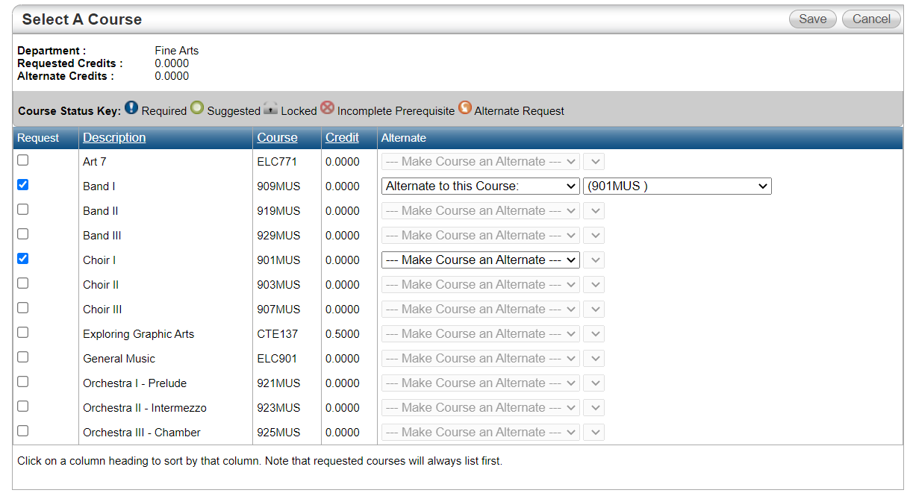This is what you will see in the computer when selecting your electives:

Notice that the course code for your **alternate** is the SAME as the course code for your **first choice**!

Each class is only a first choice OR an alternate choice.

**What is an alternate choice?** If you can’t get your first-choice class, we will try to give you your alternate (second choice) class instead.

**Fine Arts and Electives Choices**

Fine Arts

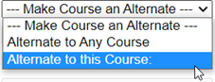**Step 1**: Put a check next to all **Fine Arts** classes you want, **both** your first choices and alternate choices. You must have 1 first choice and 1 alternate to that choice.

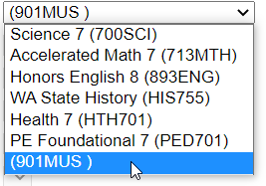**Step 2:** Next to your **Fine Art** alternate class, click the alternate dropdown and select **“**Alternate to this course:”

**Step 3:** In the new dropdown that just appeared, select the code for your first-choice **Fine Art** class.

*Ask an Adult for help if one of your Fine Art alternates is for an Other Elective.*

### Other Electives

**Step 1**: Put a check next to all **Elective** classes you want, **both** your first choices and alternate choices.

**Step 2:** Next to each **Elective** alternate class, click the alternate dropdown and select **“**Alternate to this course:”

**Step 3:** In the new dropdown that just appeared, select the code for your first-choice **Elective** class.

**FINAL STEP:** Double Check Selections

* I have three semesters of electives CHECKED.
* I have CHECKED an alternate for each first-choice elective and fine art.
* My course code next to alternate matches my first-choice class.

**Elective Request Planning Guide**

**This guide will help me determine:**

* What electives do I want to take?
* If I can’t get my first-choice classes, what are my second choices?

**Fine Arts**

**Step 1**: Write down your top TWO Fine Art Elective Options

_______________________________________________

_______________________________________________

Circle your second Choice, this is your alternate.

Write the Course code for your first choice: ___________

### **Other Electives**

**Step 1**: Write down your top TWO Elective Options

_______________________________________________ Course Code: ________

_______________________________________________ Course Code: ________

**Step 2:** Write down TWO more Elective Options, these are your alternates.

_______________________________________________

_______________________________________________