Grade 6 Course Requests

Core Classes

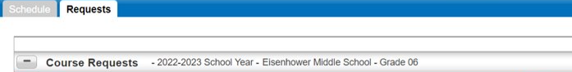

|  |
| --- |
| Department |
| English (select one) |
| * English 6 691ENG * Honors English 7 793ENG |
| Mathematics (select one) |
| * Accelerated 6 613MTH * Math 6 600MTH |
| Physical Education / Health (select both) |
| * Health 6 HTH600 * Fitness 6 PED601 |
| Science |
| * Science 6 600SCI |
| Social Studies |
| * History 6 HIS601 |

Elective Options (Choose three semesters. Hint: the circles add up to 3.)

|  |  |  |  |  |  |
| --- | --- | --- | --- | --- | --- |
| **Fine Arts (Pick one or more)** | | | | | |
| Request | Description | Course | Credit | Alternate (two drop down menus)  Alternate to the Course: Course code of favorite | |
|  | Badge 1 outlineArt 6 | ELC671 | 0.00 | *Make Course an Alternate* |  |
|  | Band I | 611MUS | 0.00 | *Make Course an Alternate* |  |
|  | Badge outlineChoir I | 601MUS | 0.00 | *Make Course an Alternate* |  |
|  | Badge outlineOrchestra I - Prelude | 921MUS | 0.00 | *Make Course an Alternate* |  |
|  | Badge outlineOrchestra II – Intermezzo *Instructor Approval | 923MUS | 0.00 | *Make Course an Alternate* |  |
|  | Badge outlineOrchestra III – Chamber *Instructor Approval | 925MUS | 0.00 | *Make Course an Alternate* |  |
| **Other Electives** | | | | | |
| Request | Description | Course | Credit | Alternate (two drop down menus)  Alternate to the Course: Course code of favorite | |
|  | Badge outlineAvid 6 *Instructor Approval | ELC671 | 0.00 | *Make Course an Alternate* |  |
|  | Badge 1 outlineExploring Industrial Tech 6 | ELC651 | 0.00 | *Make Course an Alternate* |  |
|  | Badge 1 outlineExploring Robotics | ELC941 | 0.00 | *Make Course an Alternate* |  |
|  | Badge 1 outlineIntegrated Tech I | ELC927 | 0.00 | *Make Course an Alternate* |  |
|  | Badge 1 outlineLifetime PE | PED925 | 0.00 | *Make Course an Alternate* |  |

* Make sure to choose **Alternate to this course:** for your alternates to your first-choice electives.

**Selecting Fine Arts and Electives Guide**

This is what you will see in the computer when choosing your electives:

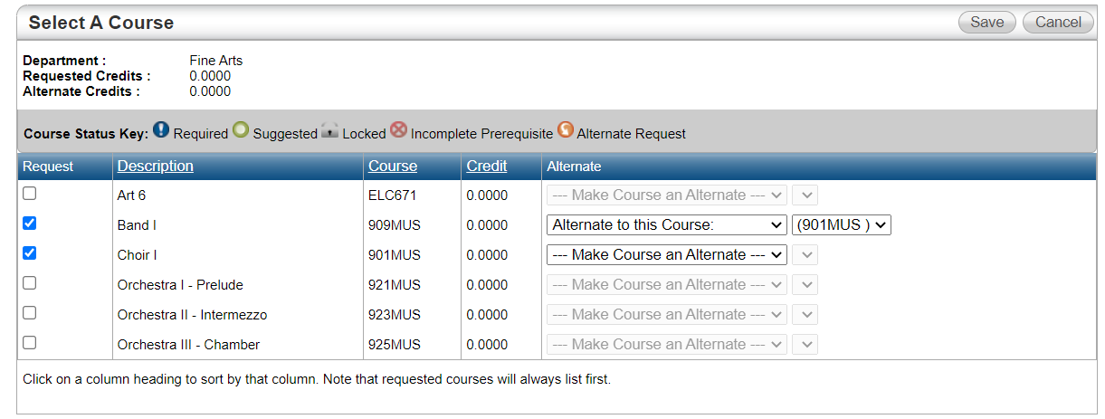

Notice that the course code for your **alternate** is the SAME as the course code for your **first choice**!

Each class is only a first choice OR an alternate choice

First Choice: 

Alternate: 

**What is an alternate choice?** If you can’t get your first-choice class, we will try to give you your alternate (second choice) class instead.

Now let’s enter your selections in Home Access Center!

**Making Fine Arts and Electives Choices**

**Fine Arts**

**Step 1**: Put a check next to the two **Fine Arts** classes you want, **both** your first and second choice.

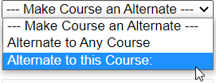**Step 2:** Next to your second choice **Fine Art** class, click the alternate dropdown and select **“**Alternate to this course:”

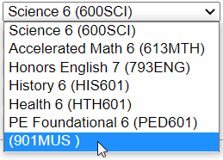**Step 3:** In the new dropdown that just appeared, select the code for your first-choice **Fine Art** class.

### **Other Electives**

**Step 1**: Put a check next to all other elective classes you want, **both** first-choice classes, and alternate choices.

**Step 2:** Next to your alternate class or classes, click the alternate dropdown and select **“**Alternate to this course:”

**Step 3:** In the new dropdown that just appeared, select the code for your first-choice class.

**LAST STEP:** Double Check Selections

* I have three semesters of electives CHECKED.
* I have CHECKED an alternate for each first-choice elective.
* My course codes next to my alternate matches my first-choice class

**Elective Request Planning Guide**

**This guide will help me determine:**

* What electives do I want to take?
* If I can’t get my first-choice classes, what are my second choices?

**Fine Arts**

**Step 1**: Write down your top TWO Fine Art Elective Options

_______________________________________________

_______________________________________________

Circle your second Choice, this is your alternate.

Write the Course code for your first choice: ___________

### **Other Electives**

**Step 1**: Write down your top TWO Elective Options

_______________________________________________ Course Code: ________

_______________________________________________ Course Code: ________

**Step 2:** Write down TWO more Elective Options, these are your alternates.

_______________________________________________

_______________________________________________