What is financial aid? | Financial aid is available from a vareity of sources.  - The U. S. Federal Government  - Your State Government  - Your College or Career School  - Nonprofit or Private Organization  It is free to apply and the money can help you pay for post-secondary education and training programs
- After high school, the more education or training you receive your earning potential grows! | 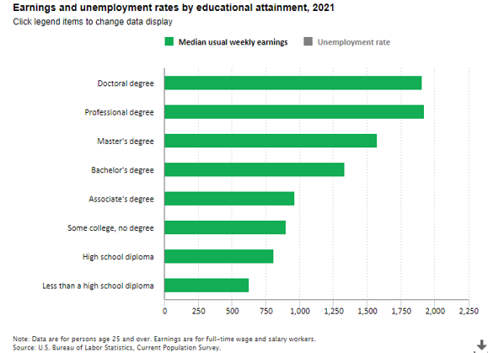
- Benefits of continuing your education and/or training after graduation. | - Higher earning potential  - More job/promotion opportunities  - More employer-provided benefits  - More job satisfaction  - More on-the-job training opportunities  - Better working conditions
- There are different types of financial aid.  By filling out the financial aid application your eligibility for each type will be determined based on your family income. | Grants Need based money with no repayment  Scholarships Merit or preformanced based money with no repayment  Work Study Need based campus job, earnings get paid directly to student as wages  Federal Loans Fixed low interest rate money that has to be repayed after college graduation
- Are you a College Bound Scholar? Check with your counselor or Career Center Specialist | - You would’ve been signed up in middle school  - Need at least a 2.0 GPA  - It can pay up to full tuition in Washington State  - Scholarship is based on famiy income
- The financial aid process can seem overwhelming, but it is best to apply early and ask for help if needed.  Add ALL potential colleges to your list within the financial aid application.  Each college will provide a financial aid award offer. | 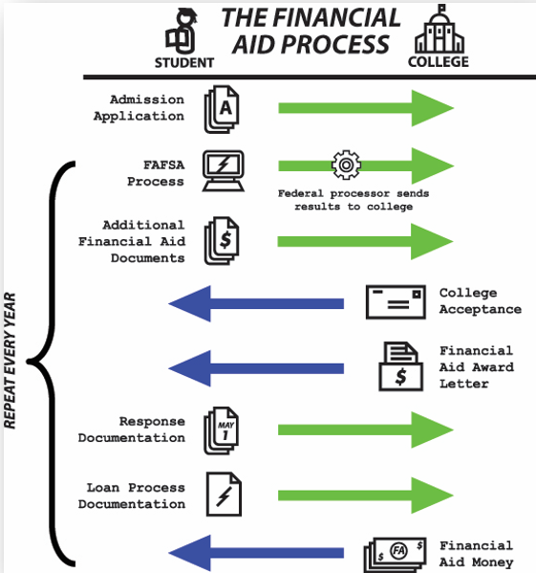
- This year, there is a new financial aid application coming out in December.  (*Note: Typically, the financial aid application is available Oct. 1st of each year) | - Prior to the application opening, create your account.  - Complete the application as close to the date it opens as possible.  - Add all colleges/programs you either applied to or plan to apply to and update as needed.  - Fill out the 2024-2025 financial aid application.  - Use 2022 tax information for the application.
- In Washington State there are two different applications for financial aid.  You will fill out one application based on your eligibility.  FAFSA= Free Application for Federal Student Aid  WASFA =Washington Application for State Financial Aid | FAFSA WASFA  File the FAFSA if you are a U. S. citizen or eligible non-citizen. File the WASFA if you are not eligible to complete the FAFSA due to immigration status and you meet the eligibility criteria for one of the state aid programs providing aid to non-citizens.
- After you apply for FAFSA/WASFA be sure to: | - Check email for any additional information needed for your financial aid application.  - Make corrections/updates promptly.  - Apply for scholarships.  - Check your email for financial aid award offers from the college/program
- What do you do when you receive a financial aid award offer from a college or program? | - Compare award offers before accepting.  - Determine your own “out of pocket” costs for each college/program option.  - Ask for help from your counselor or Career Center Specialist at your school.
- Log into Naviance |   Username: district ID#  Password: district password
- Task Completion: | Click on Planner>Tasks  Click the title of the task, Complete Financial Aid Survey

