Installing Lynx Whiteboard
Lynx Whiteboard (Lynx) is an interactive lesson creation software used with interactive panels. This software allows teachers to create interactive and engaging lessons where students can move, sort, and duplicate objects. Lynx also has many built-in tools to make lessons interactive. Lynx slides are created on the computer to use on interactive panels.
Lynx needs to be installed on each teacher device. By logging in to Lynx cloud you will be able to use the same files across devices. | 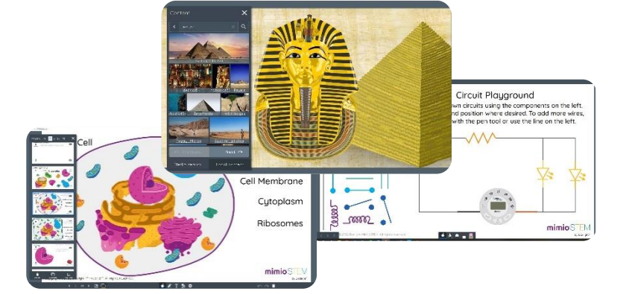
Search for Software Center  - On the Windows Task Bar, click the magnifying glass.  - Type “Software Center” into the search bar.  - Click “Open.” | 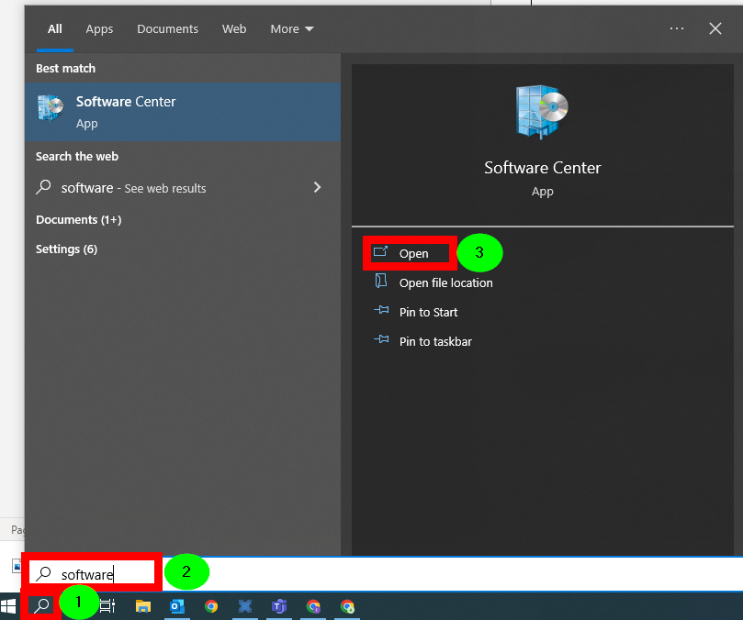
Click “Lynx Whiteboard” from the Applications tab. | 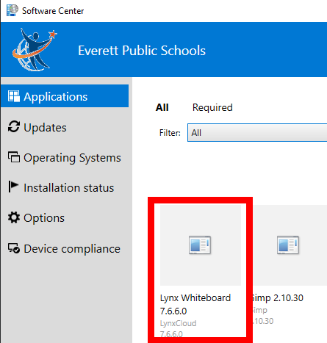
Click “Install” | 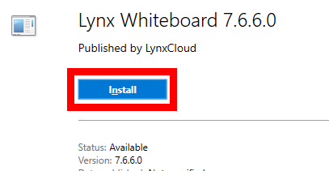
Once installed, the Lynx app will appear on your desktop. | 