**Hello! Congratulations to your student on completing the *i-Ready Diagnostic*!**

What is the *i-Ready Diagnostic*?

The Diagnostic is an adaptive reading and mathematics assessment that identifies students’ strengths and opportunities for growth. That information helps determine how to best support their learning. Watch this [video](https://i-readycentral.com/view-resource/?id=42513) to learn more.

**How can I access my student’s results?**

1. **­­­Log in to your student’s *i-Ready* Dashboard** by clicking the *i-Ready* icon on the Student Tools page.
2. **Click** on the **For Fami­lies dropdown** and **select** the **For Families report**.
3. A qr code on a white background

   Description automatically generated**Enter your** **District’s Report Code: 75DT4Z**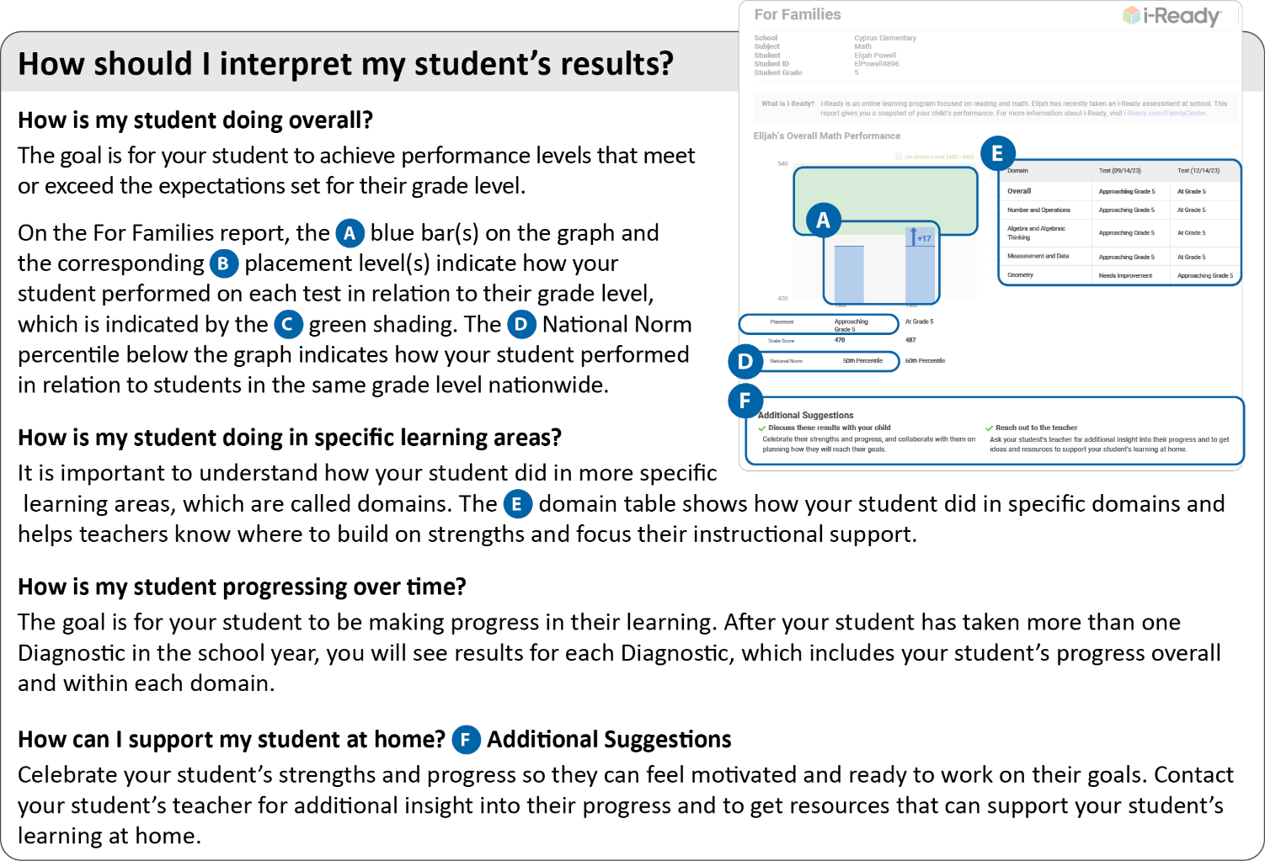

For more information and support, visit the [*i-Ready* Family Center: Understanding Diagnostic Results](https://i-readycentral.com/familycenter/understanding-your-students-i-ready-diagnostic-results/).

Thank you again for your continued partnership and support of your student’s learning. Please contact **[insert school contact name]** with any questions.

Best,

**[Principal’s Signature Block]**