**Credit Recovery 1st Semester United States History DBQ**

**United States Imperialism, 1865 – 1910**

**Evaluate the relative importance of different causes for the expanding role of the United States in the world in the period from 1865 to 1910**

In your essay you should do the following:

* Respond to the prompt with a historically defensible thesis or claim that establishes a line of reasoning.

**(Thesis – Paragraph 1)**

* Describe a broader historical context relevant to the prompt.

**(Contextualization – Paragraph 2)**

* Support an argument in response to the prompt using at least 4 documents.

**(Describe and use evidence from at least 4 documents – Paragraphs 3 and 4)**

* Use at least one additional piece of specific historical evidence relevant to an argument about the prompt.

**(Outside Evidence – Within paragraphs 3 or 4)**

* For at least three documents, explain the document’s Intended **A**udience and/or **P**urpose,

**(A/P – Within paragraphs 3 and/or 4)**

**Thesis/Claim**

Responses to the prompt with a historically defensible thesis/claim that establishes a line of reasoning. The thesis must make a claim that responds to the prompt rather than simply restating or rephrasing the prompt.

**The following thesis statements meet standard. You may use ONE of them for your essay OR write your own. If you choose to use one of the following thesis statements, make sure to give evidence to prove each claim throughout your essay.**

* This change in foreign policy was caused by the need for new markets to expand the US economy and by imperialist sentiment. However, the most important cause of this change in the US’s role can be attributed to nationalist and Darwinist sentiment because it was driven emotionally, and therefore was a stronger motive.
* In expanding its role in the world, the United States sought economic opportunity through international business relationships, political opportunity to police the world, and they sought to cultivate other societies to better spread the American culture.
* While some historians may argue that the US desire to expand its role in the world was due to the fact that the US felt it was its duty to civilize nations and act as a global police, the most important reason for America expanding its role in the world can be attributed to its competition with Europe over global influence, its desire to expand its economy through trading opportunities and the U.S. ideal of manifest destiny.

**U.S. Imperialism optional RESOURCES (view prior to starting work):**

Khan Academy – <https://www.khanacademy.org/humanities/us-history/rise-to-world-power>

- Introduction to the age of empire document

- The age of empire video

- The Spanish-American War document (Possible contextualization and/or outside evidence)

**Documents to Analyze using the chart on page 6**

**Document 1 –** Source: *Treaty concerning the Cession of the Russian Possessions in North America by his Majesty the Emperor of all the Russias to the United States of America, June 20, 1867.*

His Majesty the Emperor of all the Russias agrees to cede to the United States, by this convention, immediately upon the exchange of the ratifications thereof, all the territory and dominion now possessed by his said Majesty on the continent of America and in the adjacent islands, the same being contained within the geographical limits herein set forth….

The inhabitants of the ceded territory, according to their choice… may return to Russia within three years; but if they should prefer to remain in the ceded territory, they, with the exception of uncivilized native tribes, shall be admitted to the enjoyment of all the rights, advantages, and immunities of citizens of the United States, and shall be maintained ad protected in the free enjoyment of their liberty, property, and religion. The uncivilized tribes will be subject to such laws and regulations as the United States my, from time to time, adopt in regard to aboriginal tribes of that country….

In consideration of the cession aforesaid, the United States agree to pay… seven million two hundred thousand dollars in gold.

**Document 2 –** Source: *Josiah Strong, Our Country: Its Possible Future and Its Present Crisis, 1885.*

It seems to me that God, with infinite wisdom and skill, is training the Anglo-Saxon race for an hour sure to come in the world’s future. Heretofore there has always been in the history of the world a comparatively unoccupied land westward, into which the crowded countries of the East have poured their surplus populations. But the widening waves of migration, which millenniums ago rolled east and west from the valley of the Euphrates, meet today on our Pacific coast. There are no more new worlds. The unoccupied arable lands of the earth are limited, and will soon be taken. The time is coming when the pressure of population on the means of subsistence will be felt here as it is now felt in Europe and Asia. Then will the world enter upon a new stage of history – the final competition of races, for which the Anglo-Saxon is being schooled…. Then this race of unequaled energy, with all the majesty of umbers and the might of wealth behind it – the representative, let us hope, of the larges liberty, the purest Christianity, the highest civilization – having developed peculiarly aggressive traits calculated to impress its institutions upon mankind, will spread itself over the earth.

**Document 3 –** Source: *Captain Alfred Thayer Mahan, The Interest of America in Sea Power, Present and Future, 1897.*

To affirm the importance of distant markets, and the relation to them of our own immense powers of production, implies logically the recognition of the link that joins the products and the markets, - that is, the carrying trade; the three together constituting that chain of maritime power to which Great Britain owes her wealth and greatness. Further, is it too much to say that, as two of these links, the shipping and the markets, are exterior to our borders, the acknowledgment of them carries with it a view of the relations of the United States to the world radically distinct from the simple idea of self-sufficient?... There will dawn the realization of America’s unique position, facing the older worlds of the East and West, her shores washed by the oceans which touch the one or the other, but which are common to her alone.

Despite a certain great original superiority conferred by our geographical nearness and immense resources, - due, in other words, to our natural advantages, and not to our intelligent preparations, - the United States is woefully unready, not only in fact but in purpose, to assert in the Caribbean and Central America a weight of influence proportioned to the extent of her interests. We have not the navy, and, what is worse, we are not willing to have the navy, that will weigh seriously in any disputes with those nations whose interests will conflict there with our own. We have not, and we are not anxious to provide, the defense of the seaboard which will leave the navy free for its work at sea. We have not, but many other powers have, positions, either within or on the borders of the Caribbean.

**Document 4 –** Source: *The Boston Globe, May 28, 1898.*

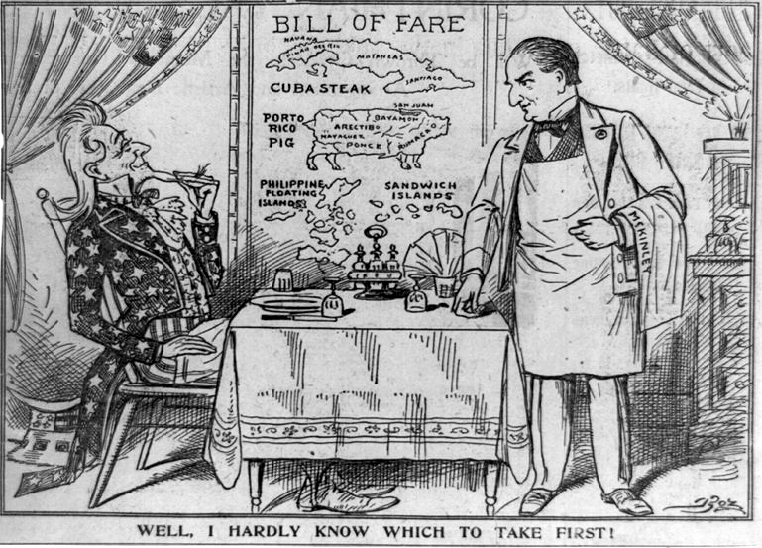

Courtesy of the Library of Congress #LC-USZ62-91465

**Document 5 –** Source: *John Hay, United States Secretary of State, The Second Open Door Note, July 3, 1900.*

To the Representatives of the United States at Berlin, London, Paris, Rome, St. Petersburg, and Tokyo

Washington, July 3, 1900

In this critical posture of affairs in China it is deemed appropriate to define the attitude of the United States as far as present circumstances permit this to be done. We adhere to the policy… of peace with the Chinese nation, of furtherance of lawful commerce, and of protection of lives and property of our citizens by all means guaranteed under extraterritorial treaty rights and by the law of nations…. We regard the condition at Peking as one of virtual anarchy…. The purpose of the President is… to act concurrently with the other powers; first, in opening up communication with Peking and rescuing the American officials, missionaries and other Americans who are in danger; secondly, in affording all possible protection everywhere in China to American life and property; thirdly, in guarding and protecting all legitimate American interests; and fourthly, in aiding to prevent a spread of the disorders to the other provinces of the Empire and a recurrence of such disasters…. The policy of the Government of the United States is to seek a solution which may bring about permanent safety and peace to China, preserve Chinese territorial and administrative entity, protect all rights guaranteed to friendly powers by treaty and international law, and safeguard for the world the principle of equal and impartial trade with all parts of the Chinese Empire.

**Document 6 –** Source: *Puck, a satirical magazine, November 20, 1901.*

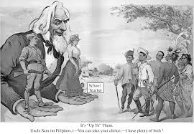

Text under the picture:

It’s “Up To” Them.

Uncle Same (to Filipinos.)-You can take your choice;-I have plenty of both!

Courtesy of the Library of Congress #LC-DIG-ppmsca-25583

**Document 7 –** Source: *President Theodore Roosevelt, Fourth Annual Message to Congress, December 6, 1904.*

There are kinds of peace which are highly undesirable, which are in the long run as destructive as any war. Tyrants and oppressors have many times made a wilderness and called it peace. Many times peoples who were slothful or timid or shortsighted, who had been enervated by ease or by luxury, or misled by false teachings, have shrunk in unmanly fashion from doing duty that was stern and that needed self-sacrifice, and have sought to hide from their own minds their shortcomings, their ignoble motives, by calling them love of peace….

It is our duty to remember that a nation has no more right to do injustice to another nation, strong or weak, than an individual has to do injustice to another individual; that the same moral law applies in one case as in the other. But we must also remember that it is as much the duty of the Nation to guard its own rights and its own interests as it is the duty of the individual so to do….

It is not true that the United States feels and land hunger or entertains any projects as regards the other nations of the Western Hemisphere save such as are for their welfare. All that this country desires is to see the neighboring countries stable, orderly, and prosperous. Any country whose people conduct themselves well can count upon our hearty friendship. If a nation shows that it knows how to act with reasonable efficiency and decency in social and political matters, if it keeps order and pays its obligations, it need fear no interference from the United States. Chronic wrongdoing, or an impotence which results in a general loosening of the ties of civilized society, may in America, as elsewhere, ultimately require intervention by some civilized nation, and … the exercise of an international police power.

**For the worksheet below, you need to complete all of the “Describe” and “Evidence” boxes and 3 of the “A/P” boxes. For your essay, you only need to describe and give evidence from at least 4 documents and A/P at least 3 documents.**

**Evaluate the relative importance of different causes for the expanding role of the United States in the world in the period from 1865 to 1910.**

|  |  |  |  |
| --- | --- | --- | --- |
| Document | **Describe** the Document | **Evidence** from the Document | Audience/Purpose  (at least 3 documents) |
| 1. Treaty concerning Russian possessions, 1867 | (Describe/Main Idea/Summarize) | (For example) |  |
| 2. Strong, *Our Country*, 1885 |  | (For example) |  |
| 3. Mahan, *Interest of America in Sea Power*, 1897 | . | (For example) |  |
| 4. *Boston Globe* cartoon, “Hardly Know Which to Take First,” 1898 |  | (For example) |  |
| 5. Hay, Second Open Door Note, 1900 |  | (For example) |  |
| 6. *Puck* cartoon, “It’s ‘Up to’ Them,” 1901 |  | (For example) |  |
| 7. Theodore Roosevelt, Fourth Annual Message, 1904 |  | (For example) |  |

**Evaluate the relative importance of different causes for the expanding role of the United States in the world in the period from 1865 to 1910.**

**A. Thesis/Claim**

Responses to the prompt with a historically defensible thesis/claim that establishes a line of reasoning. The thesis must make a claim that responds to the prompt rather than simply restating or rephrasing the prompt.

**Thesis Statement:**

________________________________________________________________________________________________________________________________________________________________________________________________________________________________________________________________________________________________________________________________________________________________________________________________________________

**B. Contextualization**

Describe a broader historical context relevant to the prompt. The response must accurately and explicitly connect the context of the prompt to broader historical events, developments, or processes that occur before, during, or continue after the time frame of the question.

*Examples of context might include the following:*

* The impact of the Civil War on the United States role in the world
* International competition to establish colonies and maintain empires from 1865 to 1910
* Increasing United States industrialization and desire to develop new markets for goods
* The closing of the frontier in 1890

**Contextualization:** ________________________________________________________________________________________________________________________________________________________________________________________________________________________________________________________________________________________________________________________________________________________________________________________________________________

*Examples that could be used as outside evidence:(must be explained and used to prove a claim, not just mentioned)*

Dollar diplomacy Annexation of Guam

Annexation of Hawaii Roosevelt Corollary to the Monroe Doctrine

Mexican Revolution Manifest Destiny

USS Maine; The Maine Social Darwinism

Panama (Hay-Bunau-Varilla Treaty, 1903) Panama Canal

Spanish-American War Filipino Insurrection, Emilio Aguinaldo

Venezuela Crisis “White Man’s Burden”

William Seward (Seward’s Folly, Seward’s Icebox) Treaty of Paris, 1899

Yellow Journalism (William Randolph Hearst, Joseph Pulitzer)

Theodore Roosevelt’s foreign policy; Big Stick diplomacy, jingoism

Russo-Japanese War; United States mediation (Treaty of Portsmouth, 1905)