**Credit Recovery 2nd Semester United States History DBQ**

**Causes of Women’s Rights Movement, 1945 – 1975**

**Explain the causes of the rise of women’s rights movement in the period 1940-1975**

In your essay you should do the following:

* Respond to the prompt with a historically defensible thesis or claim that establishes a line of reasoning.

**(Thesis – Paragraph 1)**

* Describe a broader historical context relevant to the prompt.

**(Contextualization – Paragraph 2)**

* Support an argument in response to the prompt using at least 4 documents.

**(Describe and use evidence from at least 4 documents – Paragraphs 3 and 4)**

* Use at least one additional piece of specific historical evidence relevant to an argument about the prompt.

**(Outside Evidence – Within paragraphs 3 or 4)**

* For at least three documents, explain the document’s Intended **A**udience and/or **P**urpose

**(A/P – Within paragraphs 3 and/or 4)**

**Thesis/Claim**

Responses to the prompt with a historically defensible thesis/claim that establishes a line of reasoning. The thesis must make a claim that responds to the prompt rather than simply restating or rephrasing the prompt.

**The following thesis statements meet standard. You may use ONE of them for your essay OR write your own. If you choose to use one of the following thesis statements, make sure to give evidence to prove each claim throughout your essay.**

**Underline each specific claim that needs to be proven throughout the essay:**

* The women’s rights movement from 1940-1975 was caused politically by unfair treatment towards females, economically by financial discrimination towards females, and socially by the defiance of the traditional image of an America woman.
* The women’s rights movement occurred because men kept going to war leaving women behind at the home front. Women were getting more and more jobs. Women were frequently mistreated and undervalued during a time when rights were to be given to everyone

|  |
| --- |
| **Women’s Rights Movement optional RESOUCES (view prior to starting work):**    Khan Academy – <https://www.khanacademy.org/humanities/us-history/rise-to-world-power#1920s-america>     * The Nineteenth Amendment document (Possible contextualization and/or outside evidence)     Khan Academy – <https://www.khanacademy.org/humanities/us-history/postwarera>   * African Americans, women, and the GI Bill document * The baby boom document * The growth of suburbia document * The dark side of suburbia document. (Possible contextualization and/or outside evidence) |

**Documents to Analyze using the chart on page 6**

**Document 1 -** Source: *“Victory Waits On Your Fingers – Keep ‘Em Flying Miss U.S.A.,” produced by the Royal Typewriter Company for the United States Civil Service Commission, 1942.*

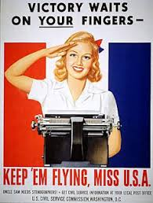

UNCLE SAM NEEDS STENOGRAPHERS

GET CIVIL SERVICE INFORMATION AT YOUR LOCAL POST OFFICE

U.S. CIVIL SERVICE COMMISSION, WASHINGTON, D.C.

Courtesy of the National Archives

**Document 2 -** Source: *Betty Friedan, UE (United Electrical, Radio and Machine Workers of America) Fights for Women Workers, 1952*

In advertisements across the land, industry glorifies the American woman – in her gleaming GE kitchen, at her Westinghouse laundromat, before her Sylvania television set. Nothing is too good for her – unless she works for GE, or Westinghouse, or Sylvania or thousands of other corporations throughout the U.S.A.

As an employee, regardless of her skill, she is rated lower than common labor (male). She is assigned to jobs which, according to government studies, involve greater physical strain and skill than many jobs done by men – but she is paid less than the underpaid sweeper, the least skilled men in the plant. She is speeded up until she may faint at her machine, to barely earn her daily bread.

Wage discrimination against women workers exists in every industry where women are employed. It exists because it pays off in billions of dollars in extra profits for the companies. According to the 1950 census, the average wage of women in factories was $1,285 a year less than men…. In just one year. U.S. corporations made five billion four hundred million dollars in extra profits from their exploitation of women.

**Document 3 –** Source: *“Sex and Caste: A kind of Memo from Casey Hayden and Mary King to a number of other women in the peace and freedom movements,” 1965.*

Women we’ve talked to who work in the [peace and civil rights] movement seem to be caught up in a common-law caste system that operates, sometimes subtly, forcing them to work around or outside hierarchical structures of power which may exclude them. Women seem to be placed in the same position of assumed subordination in personal situations too. It is a caste system which, at its worst, uses and exploits women.

The caste system perspective dictates the roles assigned to women in the [peace and civil rights] movement, and certainly even more to women outside the movement. Within the movement, questions arise in situations ranging from relationships of women organizers to men in the community, to who cleans the freedom house, to who holds leadership positions, to who does secretarial work, and who acts as spokesman [ spokesperson] for groups. Other problems arise between women with varying degrees of awareness of themselves as being as capable as men but held back from full participation, or between women who see themselves as needing more control of their work than other women demand.

Casey Hayden and Mary Elizabeth King. Excerpt edited by the publisher

**Document 4 -** Source: *Robin Morgan and the New York Radical Women, press release, “No More Miss America!” 1968.*

FOR IMMEDIATE RELEASE

On September 7th in Atlantic City, the Annual Miss America Pageant will again crown “your ideal.” But this year, reality will liberate the contest auction-block in the guise of “genyooine” de-plasticized, breathing women…. Women of every political persuasion – all are invited to join us in a day-long boardwalk-theater event…. We will protest the image of Miss America, an image that oppresses women in every area in which it purports to represent us. There will be: Picket Lines; Guerrilla Theater; Leafleting; Lobbying Visits to the contestants urging our sisters to reject the Pageant Farce and join us; a huge Freedom Trash Can (into which we will throw bras, girdles, curlers, false eyelashes, wigs, and representative issues of Cosmopolitan, Ladies’ Home Journal, Family Circle, etc. – bring any such woman-garbage you have around the house); we will also announce a Boycott of all those commercial products related to the Pageant…. It should be a groovy day on the Boardwalk in the sun with our sisters. In case of arrests, however, we plan to reject all male authority and demand to be busted by policewomen only.

Male chauvinist-reactionaries on this issue had best stay away, nor are male liberals welcome in the demonstrations. But sympathetic men can donate money as well as cars and drivers.

Male reporters will be refused interviews. We reject patronizing reportage. Only newswomen will be recognized

“No More Miss America!” from SISTERHOOD IS POWERFUL An Anthology of Writings from the Women’s Liberation Movement © 1970 by Robin Morgan. By permission of Edite Kroll Literary Agency Inc.

**Document 5** - Source: *Mirta Vidal, “Women: New Voice of La Raza,” 1971.*

[The] awakening of Chicana consciousness has been prompted by the “machismo” she encounters in the movement…. This behavior… is a serious obstacle to women anxious to play a role in the struggle for Chicano liberation.

The oppression suffered by Chicanas is different from that suffered by most women in this country. Because Chicanas are part of an oppressed nationality, they are subjected to the racism practiced against La Raza. Since the overwhelming majority of Chicanos are workers, Chicanas are also victims of the exploitation of the working class. But in addition, Chicanas… are relegated to an inferior position because of their sex. Thus, Raza women suffer a triple form of oppression…. Because sexism and male chauvinism are so deeply rooted in this society, there is a strong tendency… to deny the basic right of Chicanas to organize around their own concrete issues. Instead they are told to stay away from the women’s liberation movement because it is an “Anglo thing.”

Copyright © 1971 by Pathfinder Press. Reprinted by permission.

**Document 6 -** Source: *United States Congress, Title IX, Education Amendments, 1972.*

No person in the United States shall, on the basis of sex, be excluded from participation in, be denied the benefits of, or be subjected to discrimination under any education program or activity receiving Federal financial assistance.

**Document 7 -** Source: *Image of a crowd at a reproductive rights demonstration, Pittsburgh, PA, 1974.*

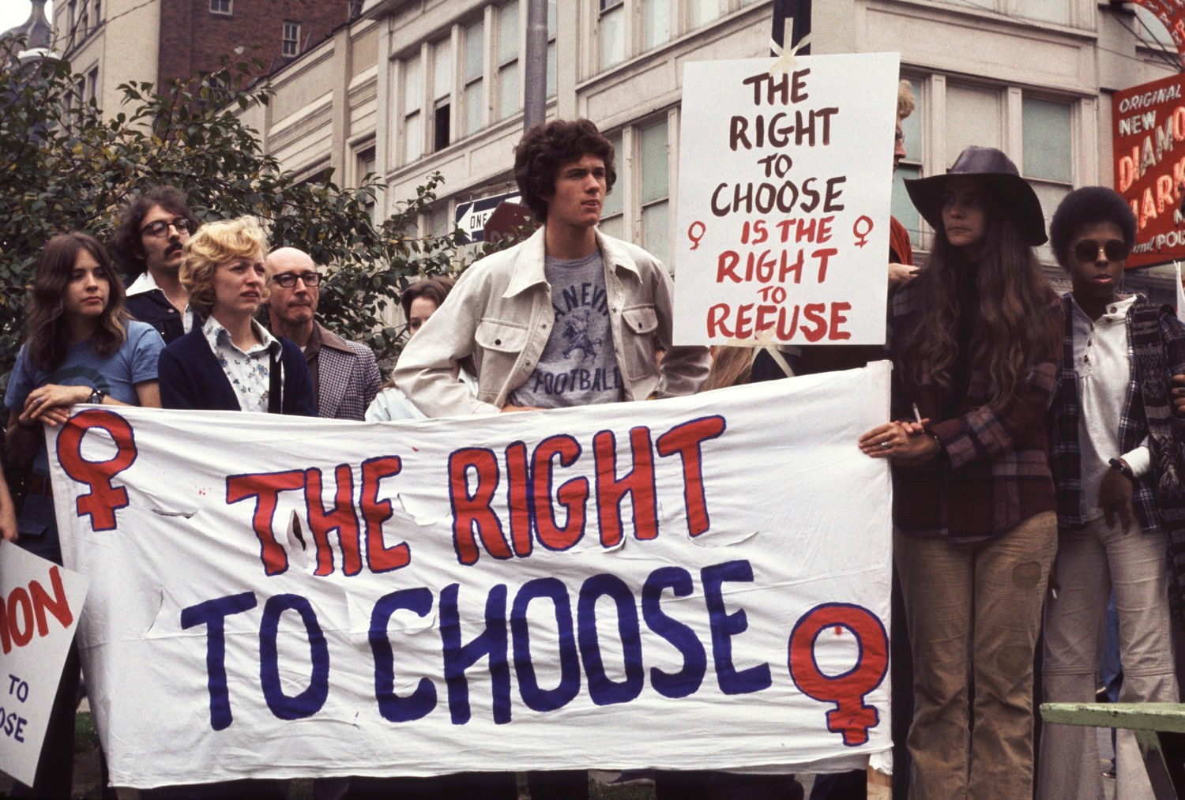

Barbara Freeman/Getty Images

For the worksheet below, you need to complete all of the “Describe” and “Evidence” boxes and 3 of the “A/P” boxes. For your essay, you only need to describe and give evidence from at least 4 documents and A/P at least 3 documents.

**Explain the causes of the rise of women’s rights movement in the period 1940-1975.**

|  |  |  |  |
| --- | --- | --- | --- |
| Document | **Describe** the Document | **Evidence** from Document | **A**udience/**P**urpose  (at least 3 documents) |
| 1. Victory Waits On Your Fingers - 1942 | (Describe/Main Idea/Summarize) | (For example) |  |
| 2. Betty Friedan, Fights for Women Workers - 1952 |  |  |  |
| 3. Sex and Caste, Casey Hayden and Mary King - 1965 |  |  |  |
| 4. Robin Morgan and the New York Radical Women, “No More Miss America!” - 1968 |  |  |  |
| 5. Mirta Vidal, “Women: New Voice of La Raza” - 1971 |  |  |  |
| 6. United States Congress, Title IX, Education Amendments - 1972 |  |  |  |
| 7. Image of a crowd at a reproductive rights demonstration, The Right To Choose - 1974 |  |  |  |

**Explain the causes of the rise of women’s rights movement in the period 1940-1975.**

**A. Thesis/Claim**

Responses to the prompt with a historically defensible thesis/claim that establishes a line of reasoning. The thesis must make a claim that responds to the prompt rather than simply restating or rephrasing the prompt.

**Thesis Statement:**

________________________________________________________________________________________________________________________________________________________________________________________________________________________________________________________________________________________________________________________________________________________________________________________________________________

**B. Contextualization**

Describe a broader historical context relevant to the prompt. The response must accurately and explicitly connect the context of the prompt to broader historical events, developments, or processes that occur before, during, or continue after the time frame of the question.

*Examples of context might include the following*:

* Calls for women’s rights and writing on women’s rights in the period of the American Revolution
* Seneca Falls Convention, 1848; Declaration of Sentiments and Resolutions
* First Wave of the women’s movement in United States, 1830s to 1920, culminated in the 19th Amendment to the Constitution, which outlawed sex discrimination in voting
* Exploration of women’s rights movement in the United States after 1975, including opposition and setbacks during the 1980s; recognition of sexual harassment
* Rise of the Third Wave of feminism in 1990s; recognition of the glass ceiling in the 1990s
* Anita Hill accusations and hearings against Clarence Thomas, 1991
* Lilly Ledbetter Fair Pay Act, 2009
* Dismissal of women’s job discrimination claims in class action cases such as Walmart v. Dukes, 2011

**Contextualization:**

________________________________________________________________________________________________________________________________________________________________________________________________________________________________________________________________________________________________________________________________________________________________________________________________________________

*Examples that could be used as outside evidence:   
(must be explained and used to prove a claim, not just mentioned)*

Affirmative Action policies, 1960-1970s Birth control pill, 1961

Betty Friedan, The Feminine Mystique, 1963 Ruth Bader Ginsburg

Billie Jean King, tennis match against Bobbie Riggs, 1973 Equal Rights Amendment

National Association for the Repeal of Abortion Laws (NARAL), 1969 Roe v. Wade, 1973

National Organization for Women (NOW), 1966 Rosie the Riveter

Eleanor Roosevelt