|  |  |
| --- | --- |
|  | **English 4**  Semester 2 Credit Recovery Opportunity  Springboard |

**Option 1: Unit 3, Embedded Assessment 1**

**Writing a Literary Analysis**

Assignment:

Select a character from Othello and write a literary analysis about him or her using one of the critical lenses that you have studied (choose Feminist, Marxist, Cultural, Historical, or Archetypal for this assignment). You will support your analysis with valid reasoning and sufficient evidence from your reading, observations, and previous written work.

Prework: Read *Othello* in preparation to write this essay.

|  |  |
| --- | --- |
| Planning and Pre-Writing | * How will you evaluate the different critical perspectives and decide which will provide a strong analysis of one of the characters? * How will you go about collecting textual evidence that supports your thesis? * How will you analyze the character’s behaviors and motivations? * What sorts of tools will you use to record your ideas and structure the essay (for instance, an outline or a graphic organizer)? |
| Drafting | * How can you craft a single thesis statement so that it makes a clear assertion about a character through a specific critical lens? * How will you use the evidence you selected to support your thesis and clarify your thinking? * Which literary elements will you analyze and how will they contribute to supporting your thesis? * How can you conclude your work in a way that follows naturally from the ideas while avoiding unnecessary repetition? |
| Evaluating and Revising | * How will you make sure that the evidence you include clearly and consistently supports your position? * How will you make sure you avoid oversimplifying the critical perspective you are using to analyze your character? (For example, “from a Feminist critical perspective, all men are bad”)? * What kinds of feedback from peers and the Scoring Guide can you use to guide your revision? |
| Checking and Editing for Publication | * How will you ensure that your essay maintains an academic, formal tone; that it seamlessly embeds quotations within the text; and that it uses varied syntax? * How will you check for grammatical and technical accuracy? * What sort of outside resources can help you to check your draft? * How will you publish and present your essay to its intended reader or readers in a format that reflects its content and purpose? |

Reflection:

After completing this Embedded Assessment, think about how you went about accomplishing this assignment, and respond to the following:

* How were you able to consider your audience when crafting your thesis, anticipating what information they would need, and what potential questions they might have?

Resources:

* This Embedded Assessment is the culmination of Unit 3, Part 1. This portion of the unit begins on Page 329 of the English 4 Student Edition.

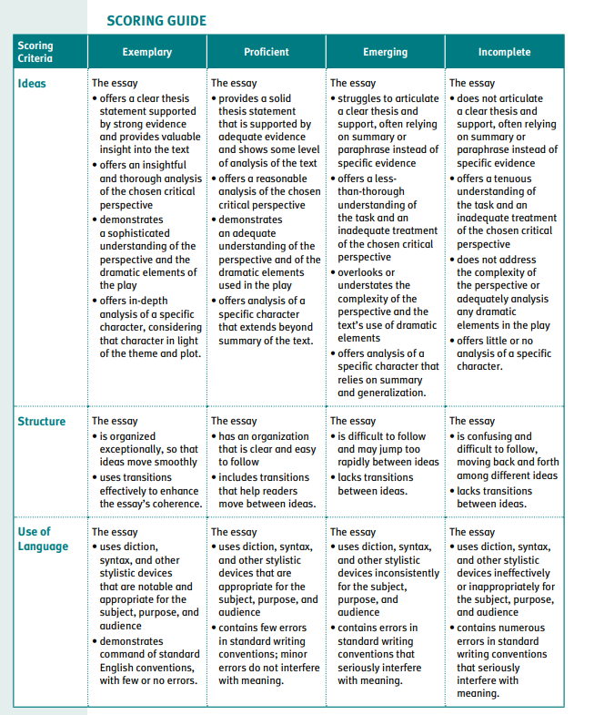

**Option 2: Springboard Writer’s Workshop Research Writing**

Learning targets:

* Engage in steps of the research process to answer a question, and share your findings in a research presentation essay.
* Gather and synthesize information from multiple sources to answer a research question, and assess the reliability and validity of each source you use.
* Consult a style manual and adhere to guidelines for accurately citing sources.
* Share research findings in a clear and logically structured presentation appropriate to purpose, audience, and task.
* When presenting research findings in essay format, demonstrate command of standard English conventions

**Research Writing**

To write reports or communicate information to others, you may need to conduct research on a chosen topic. Creating and following an organized plan for your research will help you collect appropriate information for your finished report or communication. When conducting and presenting research, it is important to follow a process that includes:

* Developing a research plan for a research question on a multifaceted topic.
* Locating and examining multiple sources for information that identifies the issues and debates in the field of inquiry.
* Using graphics, visuals, images, and other forms to represent information.
* Carrying out an investigation of sources using tools that demonstrate accuracy, reliability, authority, objectivity, and usefulness.
* Paraphrasing, summarizing, and/or quoting material from research, correctly cited and integrated into the text, as evidence to support conclusions and reasoning.
* Using an appropriate mode of delivery to present findings to address a specific purpose and audience.
* Developing an organized presentation of information that supports personal. opinions with evidence synthesized from a variety of sources and perspectives and that anticipates counterarguments.
* Writing text that maintains consistent verb voice and mood.
* Demonstrating ability to separate factual data from complex inferences.
* Demonstrating ability to determine whether evidence to support theories is weak or strong and how that evidence helps create a cogent, or convincing, argument.

Activity 1: Discovering the Elements of Research Writing

Research a Topic

1. Think about your previous experiences with research. Work with a partner to record and share responses.
   1. How did you choose a topic to research?
   2. What role did audience and purpose play in helping you choose a topic?
   3. How did you locate relevant sources to research your topic?
   4. What types of sources did you use?
   5. How did you examine sources and decide which were good (i.e., valid, credible, objective, authoritative)?
   6. How did you take notes and summarize the information you found?
   7. How did you tie together information from multiple sources?
   8. How did you write about or present your findings?

As You Read

* Work with your classmates to examine the sample research material your teacher provides.
* What is the research question? Record your response in the margin.
* Circle the thesis sentence.
* Take notes on the possible opposing arguments to the writer’s point of view.
* Look at the sources cited for the information presented. How do you know the sources are credible and reliable? Which are primary and which are secondary sources? Which is a print source and which is electronic?

Working from the Text

**Language and Writer’s Craft Practice: Maintaining Consistent Verb Voice and Using Appropriate Mood**

As you write longer and more complex sentences, it becomes more of a challenge to maintain consistent verb voice and use appropriate mood. All verbs in your sentences should have the same voice (active or passive) and an appropriate mood (e.g., indicative or subjunctive).

**Active vs. Passive Voice**

When you use active voice, the “actor” of the sentence is clear. Also, active voice tends to use more vigorous action verbs and fewer be verbs such as are or was.

Passive: The cookies were eaten.

Active: Lance ate the cookies.

Typically, you should opt for active voice, because it is clearer and more direct. However, when using either one, it is often important to maintain the same voice throughout one sentence.

Awkward: Tim turned on the oven and cookies were made.

Better: Tim turned on the oven and made cookies

Revise the next two sentences for consistent verb voice.

Jim Henson created the Muppets and many strange characters were brought to life.

The committee collects all the ballots and each vote is counted.

**Moods: Indicative and Subjunctive**

The indicative mood is the most common verb mood. It indicates a stated fact or opinion.

Lance ate the cookies. (This is a fact.)

The subjunctive mood indicates a wish, a desire, or something that might happen but has not happened. It can also indicate a state of being contrary to reality.

Lance wishes there were cookies to eat.

If I were like Lance, I would eat nothing but cookies. 4

Label the mood of the boldface verb in each of the next two sentences as indicative or subjunctive.

I wish I were a Martian.

I wish I were a Martian.

*For the purpose of this assignment, we are skipping activities 2 and 3 which require group/class writing.

Activity 4: Independent Writing

Research a topic and present your findings in an essay.

Be sure to:

* Choose an issue that has multiple competing perspectives and can be researched.
* Write a major research question.
* Create a research plan, identifying valid sources and generating search terms.
* Determine an appropriate audience that would need the information from your research. Consider what kind of background information they might need on the topic. Address this audience directly in your presentation.
* Conduct your research and take notes.
* Analyze the rhetorical strategies in your source materials, so you understand the techniques of persuasion the writers are using to convince their readers.
* Evaluate your findings, and determine whether to write additional questions for research.
* Compile your findings. Make sure that you are using a variety of sources and not depending too much on a single source. Refer to the Scoring Guide for this writing task—it will help you plan your efforts.
* Based on your research, create a thesis that represents your opinion about the issue you have selected.
* Write a thesis paragraph and supporting paragraph(s) that demonstrate sound reasoning based on evidence and conclusions that represent your own thinking, in addition to that of your research sources.
* Present your findings to in an essay.

Resources:

The full activities are found within the English 4 Writers Workshop Student Edition. Pages 81-90.

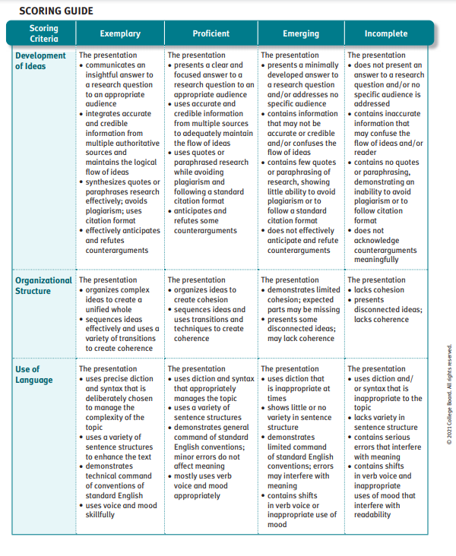

*Please note, where the rubric says “presentation” it means essay.