**Long-Term Sub Recommendation Form**

Substitute Services

1. **Log in to Frontline Recruiting and Hiring and select “Forms”**

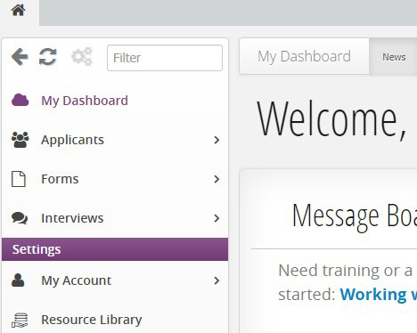

1. **Fill Out a New Form**

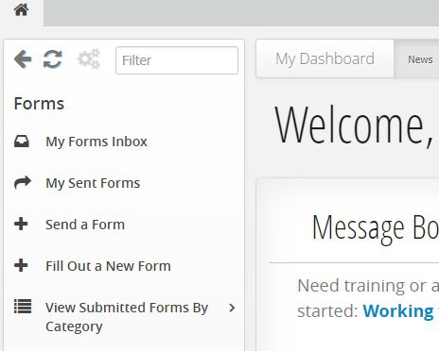

**3. Go to EPS Internal forms to locate 4-P: Hire Recommendation Form: Long-Term Certificated Substitute and check the box then click “Continue with Selected Form”**

**4. Add the job posting number (if applicable) and the associated applicant then click “Next”**

General Long-Term post ID 7817



**5. Fill out the required items marked with an asterisk, sign the document, and submit form**

**\***Applicants who do not hold the appropriate endorsement require a [Plan of Assistance](https://docushare.everett.k12.wa.us/docushare/dsweb/Get/Document-103960/Teacher%20Plan%20for%20Certification%20Requirements%20(1).pdf).