Monday Morning Messages June 3, 2024

Did you hear?? Our very own Amy Perusse has won an award! Now, for those not in the know, she has won the “Raisin Pay” award previously, but I think this current one beats that!



Way to go Amy! And special shout out to Diane, for being part of this KIT team that does outstanding work!!

Here are some fun holidays to celebrate:

* National Egg Day- personally, I’m a fan of deviled eggs!
* Insect Repellent Awareness Day: Mosquitos love me unfortunately!
* World Bicycle Day: can’t even remember last time I cycled?
* National Chocolate Macaroon Day: yum, yes please!

**News and Announcements:**

Thanks to all that helped spread the word about the Resource Fair. While the vendor list was outstanding, out turnout could have been better. Please share ideas on how we can get more families out to events! We are looking now on getting some food trucks for next year!!!

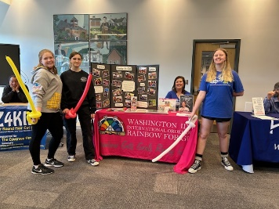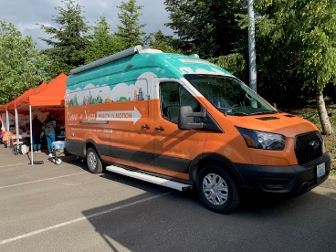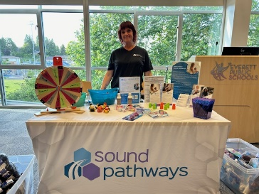

**Summer Session parenting classes:** Incredible Years-light version, starting next Wednesday via Zoom (flyer attached). Please share out. I did do an email blast, but if you can get these out in school newsletters or such, I’d appreciate it!

**Professional Development**

n/a

**Resources**

Creative Camp ideas:

<https://www.imaginecm.org/programs-camps-events/summercamps/#elementarycamps57>

<https://snoco.recliquecore.com/programs/1024/discovery-camp/#division_3283>

<https://online.traxsolutions.com/bgcsc/everett#/dashboard>

<https://www.schack.org/camps>

More attached!

Abby