TCE Developmental Preschool Supply List

Please send the following items:
1) A full-size backpack (one to fit a take home folder in, please no smaller than letter size-8.5 x 11 paper, PLEASE DO NOT BRING A BACKPACK SMALLER THAN THIS as our students often bring home larger art projects/work)
2) Diapers or training pull-ups with Velcro side closures that your child may need (if training pullups, we will ONLY accept the pull ups with Velcro side closures)
3) 2 Box of Kleenex
4) Box of quart sized zippered food storage bags
5) 1 Ream of White Paper
6) Baby Wipes (No Scent)
7) Disinfectant Wipes

Tambark Creek Elementary
Developmental Kindergarten Supply List This list is for Miss Eldridge class only
School Supply | Quantity | Picture
Backpack (full size, no wheels) | 1
Headphones with a cord, no earbuds | 1 | 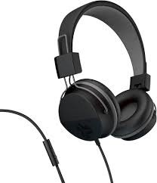
Pocket Folder/ Twin Pocket | 1 | 
Folder with Prongs on the inside to hold papers | 1 | 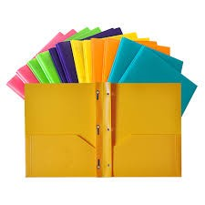
**Dry erase markers (EXPO, Black Only, Chisel Tip)  Preferably a 4 pack | 1 pack | 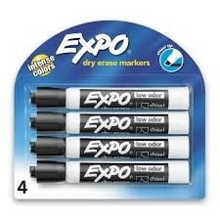
Old White Sock (This is instead of a whiteboard eraser) | 1 each
**Crayola Crayons (24 count) | 2 packs | 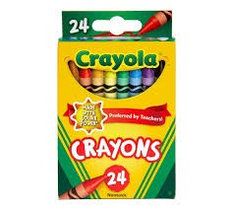
**Crayola Washable Markers (Broad line, 10 count, Classic Colors) | 2 packs | 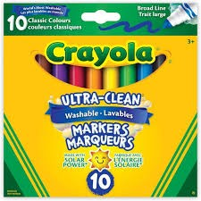
**Elmers Glue Sticks (Regular sized) | 12 sticks | 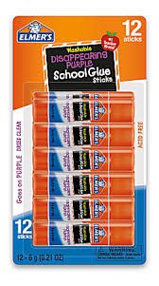
**Watercolor Paint set | 1 set | 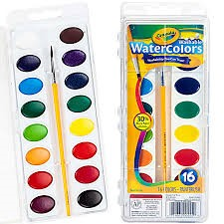
**Large box of tissue | 2 boxes | 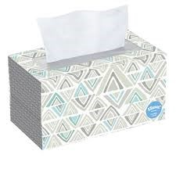
**Baby Wipes | 3 packs
Child Size Scissors (6 in) | 1 pair | 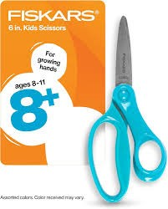
Plastic Snap Close Pencil Box | 1 | 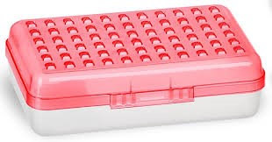
**White printer paper | 1 ream | 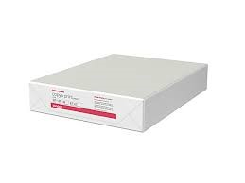

**Please DO NOT label ANY of these supplies, these will be shared**

Tambark Creek Elementary
Kindergarten Supply List

School Supply | Quantity | Picture
Backpack (full size, no wheels) | 1
Headphones  WITH A CORD, no earbuds  (PLEASE LABEL) | 1 pair | 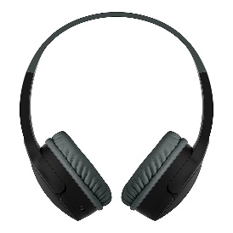
White Board Eraser | 1 each | 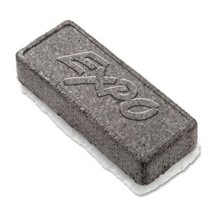
Pocket folder/ twin pocket  (PLEASE LABEL) | 1 | 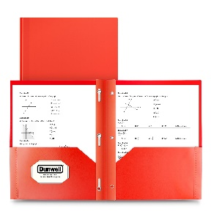
**Dry Erase Markers  (EXPO brand, fine tip, black only) | 1 pack | 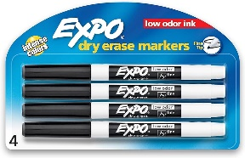
**Crayola Crayons  (24 count) | 2 boxes | 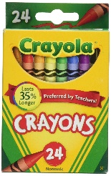
**Crayola Washable Markers  (Broad line, 10 count, Classic Colors) | 2 packs | 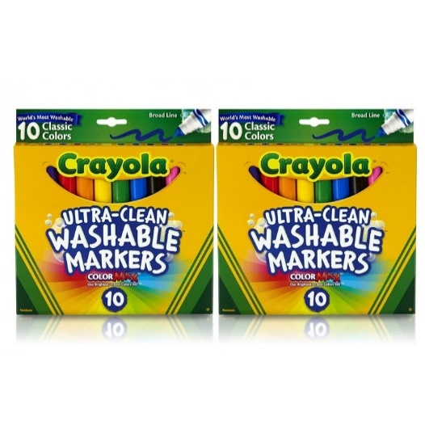
**Elmer’s Glue Sticks  (Regular sized) | 12 sticks | 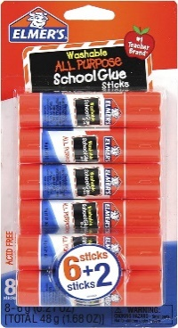
**Watercolor paint set | 1 set | 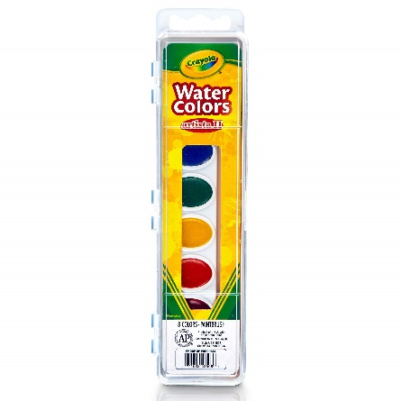
**Large box of tissue | 1 box | 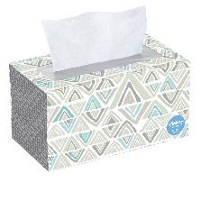
**Baby wipes | 3 packs
**child-size scissors (6 in) | 1 pair
Plastic snap close pencil box  (PLEASE LABEL) | 1 | 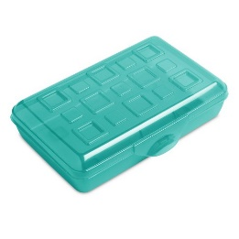
**White Printer Paper | 1 ream | 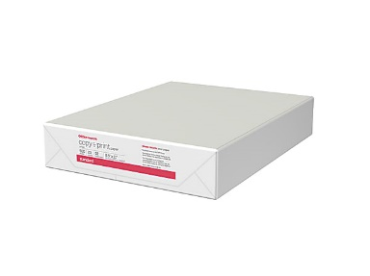

**Please DO NOT label ANY of these supplies, these will be shared**

1st Grade Supply List
Tambark Creek Elementary
School Supply | Quantity | Picture
Backpack | 1
Tennis shoes for PE | 1
No. 2 Ticonderoga Pencils | 1 package (pre-sharpened) | 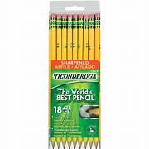
Crayola Crayons | 2 boxes (24 count)
Crayola Washable Markers | 1 package (8 count) | 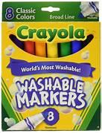
Glue Sticks | 2 packages (3 pack)
Tissue Boxes | 2 boxes | 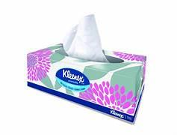
Dry erase markers  (black only) | 1 package | 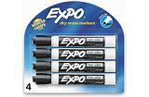
Scissors (blunt kid size) | 1 pair
Headphones (no earbuds) | 1 pair
Baby wipes (scent free) | 2 packages
Plain white copy paper | 1 ream | 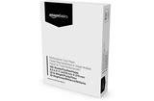
Ziploc sandwich bags | Last Name A-G
Ziploc gallon bags | Last Name H-L
Highlighters | Last Name M-Z
Please label your child’s name on all coats, jackets, backpacks, headphones & lunchboxes.

Tambark Creek Elementary
2nd Grade Supply List
School Supply | Quantity
Backpack (no wheels) | 1
Tennis shoes for PE | 1
Kid size water bottle | 1
Composition book (wide rule) | 1
Black Flair pens | 2
Two pocket folder- one black, one white, and one yellow | 3
Expo dry erase fine point marker black | 3 pack
No. 2 Ticonderoga Pencils | 2 packs of 12
Crayola Crayons (24 count) | 2 boxes
Crayola Washable Markers | 1 pack
Crayola Colored Pencils 12 | 12 pack
Regular glue sticks | 3 packs
Kleenex | 1 box
Baby wipes (scent free) | 1 pack
Kid size Scissors | 1 pair
Pink Pearl erasers | 2
Headphones (no earbuds) | 1 pair
White copy paper | 1 ream
Color copy paper | 1 ream
Sandwich Ziploc bags | Last name: A-G
Gallon Ziploc bags | Last name: H-L
Ream of White Cardstock | Last name: M-Z

Please label your child’s name on all coats, jackets, backpacks, water bottles, headphones & lunchboxes. Please do NOT label school supplies.

Tambark Creek Elementary
2/3 Grade Highly Capable Supply List
School Supply | Quantity
Backpack (no wheels) | 1
Composition book (wide rule) | 2 lined books
Pocket folders/ twin pocket | 3 folders
Small Pencil box | 1 box
No. 2 Ticonderoga Pencils (12) | 2 packs
Crayola Crayons (24 count) | 1 box
Black flair pens  Black Sharpie | 1 pack  2
Crayola Colored Pencils (12 count) | 1 pack
Small bottle Elmer’s glue | 1 bottle
Glue sticks | 1 pack
Crayola watercolor Paint set | Optional
Baby wipes | 1 pack
Kleenex Tissues | 2 packs
Scissors | 1 pair
Pink Pearl erasers  Eraser Tops | 2 pack  2 packs
Headphones (no earbuds) | 1 pair
Ziplock gallon bags | Boys bring 1 box
Ziplock quart bags | Girls bring 1 box
Post it notes | 1 package
Hand sanitizer (12 or 16 ounce) | 1 bottle
Ream of white copy paper | Boys
Ream of colored paper | Girls
Dry Erase Markers | 1 pack
Highlighters | 2
Tissue Paper- Colored | 1 Pack

Tambark Creek Elementary
3rd Grade Supply List

School Supplies | Quantity
Backpack (no wheels) | 1
Tennis Shoes (for PE) | 1
Composition Notebook (wide rule) | 2
Notebook paper (wide rule) | 1 pack
Two pocket folder (SOLID GREEN) | 1
Two pocket folder | 2
No. 2 Ticonderoga pre-sharpened Pencils (12) | 2 packs
Flair Pens (black only) | 4
Flair Pens (red only) | 2
Highlighters (yellow) | 1 pack
Glue Sticks | 1 pack
Kleenex | 1 box
Scissors | 1 pair
Pink Pearl Erasers | 2
Clipboard | 1
Headphones | 1 pair
White Copy Paper | 1 pack

Please label your child’s name on all coats, jackets, backpacks, headphones, & lunchboxes.
Tambark Creek 3rd Highly Capable Supply List
School Supply | Quantity
Backpack (no wheels) | 1
Tennis shoes for PE | 1
Notebook paper (wide rule) | 1 pack
Spiral notebooks | 3
Two pocket folders - 1 must be green | 2
Small pencil box | 1 box
Clipboard | 1
Scotch tape roll | 2
Flair pens (red only) | 2
Sharpies (regular tip black only) | 2
Crayola washable markers (12) | 1 pack
Crayola colored pencils (24 or less) | 1 pack
Highlighters | 3
Glue sticks | 8 sticks
Elmer’s glue bottle | 1
Post-its | 1 pack
Pencil sharpener | 1
White printer paper | 1 ream
Kleenex | 1 box - Boys
Baby wipes | 1 pack - Girls
Scissors | 1 pair
Ruler | 1
Protractor | 1
Pink Pearl erasers | 2
Headphones | 1 pair
Crayons, watercolor set, colored printer paper, ziplocks, colored flair pens, No. 2 Ticonderoga Pencils, Expo markers | Optional
Please label your child’s name on all coats, jackets, backpacks, headphones & lunchboxes.
Tambark Creek 4th Grade Supply List
School Supply | Quantity
Backpack (no wheels) | 1
Tennis shoes for PE | 1
Composition books | 3
Water Bottle | 1
Protractor | 1
Highlighters (blue and yellow) | 1 of each
Two pocket folders | 2
Hard-sided, One Compartment Pencil Box | 1 box (about 5 in. By 8 in.)
No. 2 Ticonderoga Pencils | 24 pencils
Expo markers | 2
Pencil Cap erasers | 1 Pack
Flair pens (black only) | 2
Post-It Notes 3-inch Block | 1
Sharpies (regular tip, black only) | 2
Crayola Crayons (24) | 2 packs
Crayola colored pencils (24 or less) | 1 pack
Glue sticks | 18 sticks
Scissors (7-8 Inches) | 1 pair
12-inch Ruler | 1
Pink Pearl erasers | 2
Labeled WIRED Headphones | 1 pair
Kleenex | 1 Box
White Printer Paper | 1 Ream
Quart-sized Ziploc Bags | 1 package
Small USB Fan | OPTIONAL
5 x 8 inch index cards | OPTIONAL
Please label your child’s name on all coats, jackets, backpacks, headphones & lunchboxes.

Tambark Creek Elementary 4th Grade Highly Capable
School Supply |  |  | Quantity
Required Supplies: Please label with student’s name
Backpack (no wheels) |  |  | 1
Tennis shoes for PE |  |  | 1
Headphones (in gallon Ziploc bag-labeled) |  |  | 1 pair
Water bottle |  |  | 1 bottle
Composition books |  |  | 3
Plastic folder-2 pocket with metal prongs to hold paper (inside pocket is needed) |  |  | 1
Paper folders- 2 pocket |  |  | 2
Pencil pouch-NO HARD BOXES |  |  | 1
12-inch ruler (inches/metric) |  |  | 1
Protractor (plastic) |  |  | 1
Scissors (pointed) |  |  | 1 pair
Crayola Washable markers |  |  | 1 pack
Crayola Colored pencils |  |  | 1 pack
Required supplies: DO NOT LABEL
White Printer Paper |  |  | 1 ream
No. 2 pencils Ticonderoga sharpened |  |  | 48 total pencils
Highlighters (two different colors) |  |  | 2 highlighters
Black Flair Pens |  |  | 2 pens
Sharpies-black |  |  | 2 pens
Glue sticks |  |  | 3 sticks
Kleenex |  |  | 2 boxes
Ziploc Bags: Gallons and sandwich sizes
Student Planners |  |  | Use the link to pay for the planner. Do not purchase a planner; the school provides one. The payment link opens September 1st, or send in $5.
Optional Supply Items
1 set-multi-colored flair pens for your student  * used all the time |  | Paper plates |  | paper Dixie cups 3 oz.
Please consider contributing the following shared items. We use them frequently! Thank You
Dry erase markers | Baby wipes

Tambark Creek Elementary 5th Grade Supply List

 | Quantity
Required Supplies: Please label with the student’s name
Backpack (no wheels) | 1
Tennis shoes for PE | 1
Headphones/Earbuds | 1 (to stay at school)
Water bottle | 1
Spiral Notebook (No binders) | 2
3 Ring Pencil Pouch (No boxes) | 1
2 Pocket Folder | 3
Scissors (Fiskar brand) | 1
Crayola Colored pencils | One pack
Art Sketch Book 8.5 x11 | 1
Required supplies: No need to label
Kleenex/Baby Wipes | 2 each
No. 2 pencils Dixon or Ticonderoga | 24 total pencils
Expo Markers | 24
Highlighters (different colors) | 2
Pencil cap erasers | One pack
Black Flair Pen | 2
Printer Copy Paper White | 1 Ream (For building use)
Optional Supply Items
White card stock 8.5 x11 | Colored copy paper 8.5 x 11
Crayola Washable Markers

Tambark Creek Elementary 5th Grade Highly Capable Supply List
School Supply | Quantity
Required Supplies: Please label with student’s name
Backpack (no wheels) | 1
Headphones (in Ziploc bag) | 1 pair
Water bottle | 1 bottle
Binder 2-inch heavy duty | 1
Clipboard | 1
Composition books | 5 notebooks  3 1-subject and 1 3-subject
Binder tabs (8 count) | 1 pack
Folders with pockets | 3
3 Ring Pencil Pouch (No Boxes) | 1
12 inch ruler (inches/metric) | 1
Scissors (pointed) | 1 pair
Crayola Washable markers | 1 pack
Crayola Colored pencils | 1 pack
Calculator | 1
Sketch book with black flair pen | 1
Multi-Color Flair Pens (Paper Mate) | 6 or more
Compass | 1
Required supplies: DO NOT LABEL
Notebook paper (college ruled) | 1 pack
No. 2 pencils Ticonderoga sharpened | 36 total pencils
Pink Pearl erasers | 2
Highlighters (two different colors) | 2 highlighters
Sharpies (Fine point-black) | 2 pens
Glue sticks | 6 sticks
Pens (red only) | 2 pens
Post-It notes (3 inch square block) | 3 pack
Pencil cap erasers | 1 pack
Ziploc Bags: Sandwich | Boys: 1 box
Ziploc Bags: Gallon | Girls: 1 box
Ream of white copy paper | 1 pack
Ream of multi color copy paper | 1 pack
Kleenex | 2 boxes
Expo Markers (3 Pack +) | 2 packs
Baby Wipes | 1 pack
Clear 2-liter empty bottle (for science) | 1-2
$ for planner ~Link will be provided to pay

