August 2025  Mon Tue Wed Thu Fri  1  4 5 6 7 8  11 12 13 14 15  18 19 20 21 22  25 26 27 28 29 |  | February 2026  Mon Tue Wed Thu Fri  2 3 4 5 6  9 10 11 12 13  16 17 18 19 20  23 24 25 26 27
September 2025  Mon Tue Wed Thu Fri  1 2 3 4 5  8 9 10 11 12  15 16 17 18 19  22 23 24 25 26  29 30 |  | March 2026  Mon Tue Wed Thu Fri  2 3 4 5 6  9 10 11 12 13  16 17 18 19 20  23 24 25 26 27  30 31
October 2025  Mon Tue Wed Thu Fri  1 2 3  6 7 8 9 10  13 14 15 16 17  20 21 22 23 24  27 28 29 30 31 |  | April 2026  Mon Tue Wed Thu Fri  1 2 3  6 7 8 9 10  13 14 15 16 17  20 21 22 23 24  27 28 29 30
November 2025  Mon Tue Wed Thu Fri  3 4 5 6 7  10 11 12 13 14  17 18 19 20 21  24 25 26 27 28 |  | May 2026  Mon Tue Wed Thu Fri  1  4 5 6 7 8  11 12 13 14 15  18 19 20 21 22  25 26 27 28 29
December 2025  Mon Tue Wed Thu Fri  1 2 3 4 5  8 9 10 11 12  15 16 17 18 19  22 23 24 25 26  29 30 31 |  | June 2026  Mon Tue Wed Thu Fri  1 2 3 4 5  8 9 10 11 12  15 16 17 18 19  22 23 24 25 26  29 30
January 2026  Mon Tue Wed Thu Fri  1 2  5 6 7 8 9  12 13 14 15 16  19 20 21 22 23  26 27 28 29 30 |  | July 2026  Mon Tue Wed Thu Fri  1 2 3  6 7 8 9 10  13 14 15 16 17  20 21 22 23 24  27 28 29 30 31

Non-instructional Workday | Major Milestone | LIF | Holiday/Break |  | Early Release  (2.5 hours) | Board Meeting Night  Awareness Night
2025-26 Designated School Event Nights  The 2nd and 4th Tuesday of each month are open to all grade level schools primarily to allow for scheduling at the Civic Auditorium with a 7 pm or later start. If you will be hosting an event at your school site, please check with your feeder schools for any existing conflicts.  Level Designated School Event Night  Elementary 1st and 3rd Monday of the month 2nd Thursday of the month 4th Wednesday of the month For elementary schools: When the first and third Monday is a holiday, the elementary designated school event night may move to the fifth Monday or Wednesday.  Middle 1st and 3rd Thursday of the month 2nd Wednesday of the month 3rd Tuesday of the month 4th Monday of the month For middle schools: When the fourth Monday is a holiday, the middle-designated school event night may move to the fifth Thursday.  High 1st Tuesday of the month 1st and 3rd Wednesday of the month 2nd Monday of the month 4th Thursday of the month All schools: Do not schedule bridging events at your schools the Thursday before high school graduations. This is the night Sequoia High School holds its graduation.  2025-26 School Board Meetings Avoid school events on school board meeting dates (events at the Civic Auditorium may be scheduled but should begin at 7 pm or later). September 9 and 30 October 14 and 28 November 18 December 9 January 13 and 27 February 10 March 10 and 24 April 21 May 12 and 26 June 9 and 23 July 1 August 18 - All schools need to schedule: Run-Hide-Fight / Reunification asynchronous modules (30 minutes each) in either ALIF or ALIF/staff meeting hybrid venue. Principals’ discretion to schedule follow up Q&A with Topher Ferreira. All schools need to repeat these modules once every 12 months. Please schedule accordingly on an annual basis. - All schools need to schedule a staff meeting to share information regarding the Education Levy and School Construction Bond between October 7 and November 13 (30 minutes) - does not need to be an extension. - Hold for extensions after A&S meetings on October 16, December 4, and January 15 for Citizens’ Committee meetings (1 hour, 5:30-6:30) - All schools need to schedule time for proctor training - Elementary principals: Please get fifth grade camp dates to us ASAP, especially if it is a fall date, so we can avoid conflicts with an IR. |  |  |  | 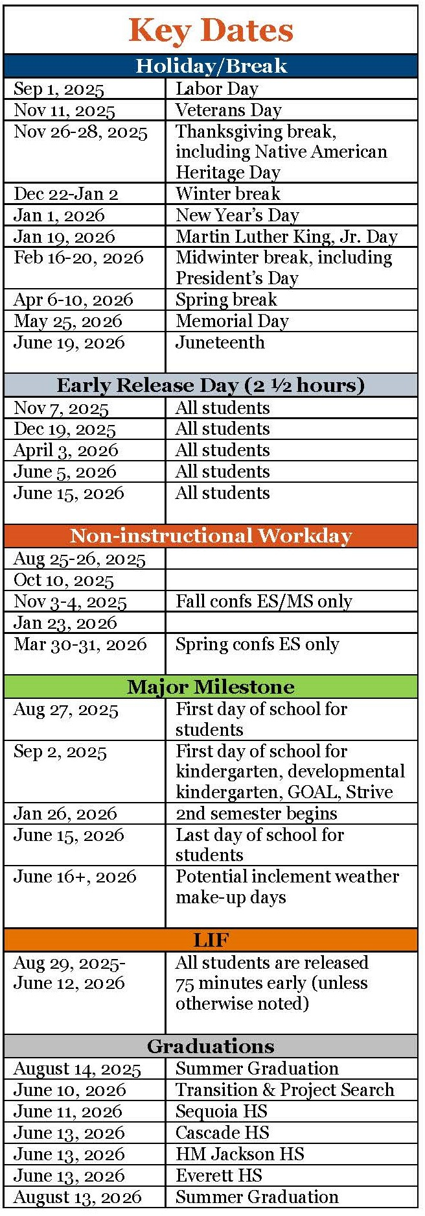

2025-26 Do Not Schedule Dates | 2025-26 Awareness Dates
- 2025 Summer Graduation:  August 14  - Rosh Hashanah: Do not schedule any evening events  September 22, 23, 24  - Yom Kippur:  evening of October 1 and all day October 2 | - Fall Student SEL Survey:  September 24-October 15  - The Great Washington ShakeOut Drill:  October 16, 10:16 a.m.
- High School & Beyond Nights:  - September 25 – CHS (combined w/Curriculum Night)  - October 15 – JHS (evening event)  - October 30 – EHS (during the school day) | - Assistant Principals differentiated leadership development meetings:  - October 29  - February 11
- Let’s Connect:  - November 6 at comprehensive high schools  - January 20 location TBD | - 2025-26 Job alike meetings:  - September 26  - February 27  - May 15
- Annual EPS Foundation event:  - March 16 – CHS  - March 18 – EHS/SHS  - March 31 – JHS | - Election dates 2025-26 (avoid if possible):  - November 4  - February 10 (special election)  - April 28 (special election)  (can plan on these days but be aware)
- Art Show Receptions:  - March 5 – ES  - April 30 – HS  - May 28 – MS | - Spring Stakeholder Survey:  - Students & Staff  February 23-March 13  - Families  March 16-April 3
- PTSA council award event:  May 27  - District Retirement recognition:  June 2  - District Athletic Award Recognition:  June 4 | - High School transitions (8th-9th grade):  - March 11 | CHS & EHS @ Eisenhower MS  - March 12 | JHS @ Heatherwood MS  - March 13 | CHS & EHS @ Evergreen MS  - March 18 | CHS & JHS @ Gateway MS  - March 19 | EHS @ North MS
2026 Commencement Ceremonies  ES & MS feeder pattern principals: please plan on attending at least one commencement ceremony of a feeder pattern high school on June 13.  - 11:00 am – JHS  - 3:00 pm – EHS  - 7:00 pm – CHS  - June 11 Sequoia HS graduation – encouraged but not required  - August 13 Summer Graduation | - Set elementary grad walks (in partnership with feeder high schools)  Student Device Collection Date Guidance  To maintain optimal learning and access for students through the end of the year, when scheduling the collection of student devices (i.e. Chromebooks), please ensure you do not begin collecting until 3 full days before the last day of the year. For example, if Thursday is the last day (half-day) then Monday would be the earliest day to collect student devices.

