Reading Targets

After Reading Skills
Identify Theme or Message  SettingCharacter  Theme  ProblemSolution  Summarize  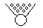  Make Inferences  Think ahead  Interpret Vocabulary  Apply Story Elements  MAP  Character  Setting  Problem  Events  Solution    Apply Text Features | Compare and Contrast  Identify Cause and Effect  Analyze Author’s Purpose  and Assumptions and Beliefs  Identify Facts and Opinions  Opinion  FACTS  Extend Information Beyond Text  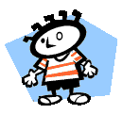    Self World

