News Release
Everett Public Schools
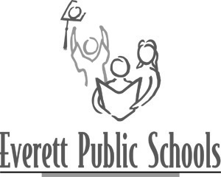
May 8, 2009
For more information:
Lyn Lauzon, 425-385-7178
Mary Waggoner, 425-385-4049

Town hall meeting for parents about student abuse of prescription drugs

Parents and community members are invited to a Town Hall meeting to learn how prescription drug abuse has affected our kids, our families, and communities.

Date: Monday, May 11, at 6:30 p.m.
Location: H.M. Jackson High School Commons, at 1508 136th St. SE, Mill Creek

Among the questions discussed will be:
- How do I know if someone is misusing prescription drugs?
- What are the dangers of misusing prescription drugs?
- What can I do to prevent prescription drug abuse?
- What do I do now that I know there’s a growing prescription drug abuse problem?

More information about prescription drug abuse among young people is on the Website of the National Youth Anti-Drug Campaign.

