News Release
Everett Public Schools
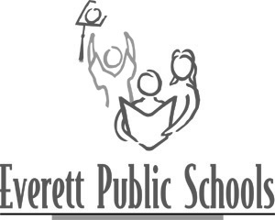
May 18, 2009
For more information:
Mary Waggoner, 425-385-4049
Kristie Dutton, 425-385-4693

Everett Public Schools’ Foundation honors Superintendent Scholars
Since 1987, the Foundation has honored students for academic achievement and lifelong learning with the annual Superintendent Scholar Award. Each year, extraordinary high school students and their families are honored at a special evening event. An anticipated highlight of the evening is when each student honors a “most influential” teacher.

This year’s Superintendent Scholars and their teachers honored Thursday night, May 14 are:
- Abigail Nastan, Cascade High School and Marilyn Donohew, Penny Creek Elementary second-grade teacher
- Owen Witek, Everett High School and Jim Lockman, Advanced Placement Spanish and Spanish 1 and 2
- Colin Bundschu, H.M. Jackson High School and William Moore, Calculus and Advanced Placement statistics

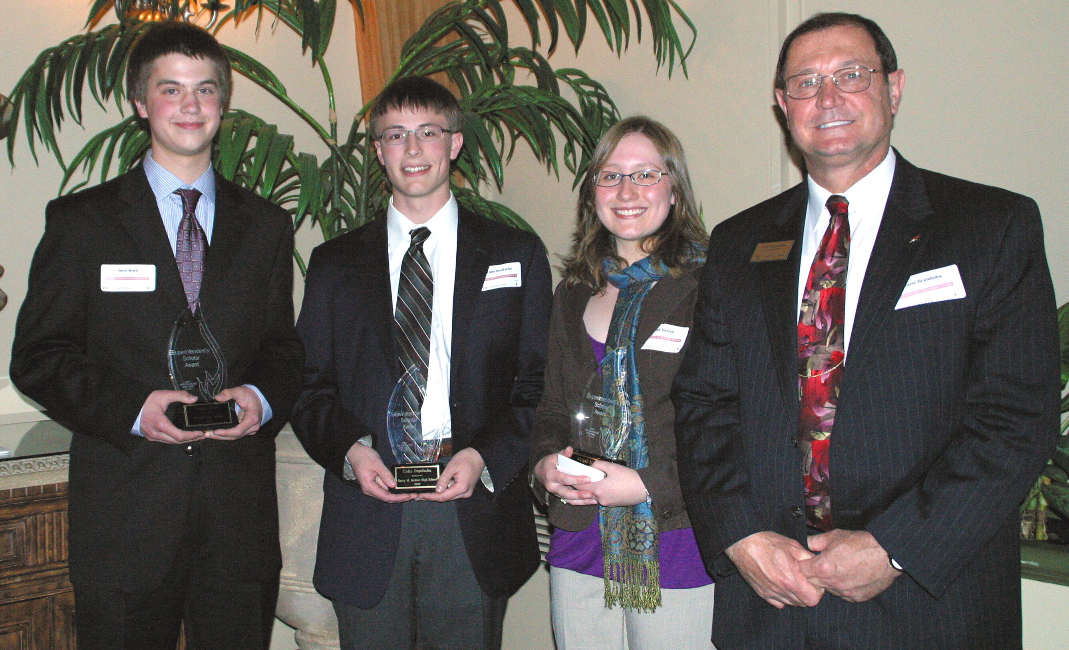

---end---

