Preserve Our Rainforest

Two hundred years ago Australia had large expanses of rainforest – lush areas of tall, densely packed trees – home to many unusual creatures.

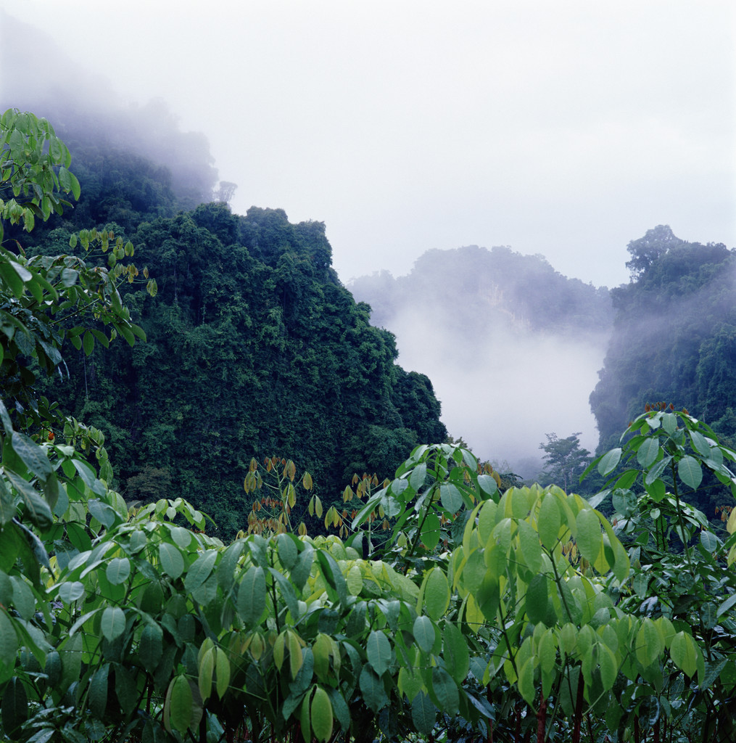
However, the early settlers who followed Captain Cook cleared and destroyed vast sections of this rainforest. They cleared land so that they farm, run cattle and grow crops. They also destroyed much rainforest by logging the rich, red cedar trees that were wanted by furniture makers. Gradually our rainforest started to disappear – now there is not very much left.

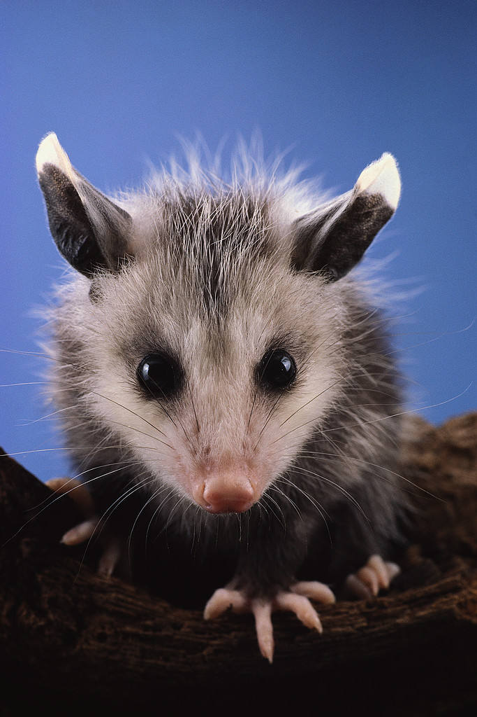
Australia must realize that the rainforest that remains must be preserved; clearing for farming and logging for timber must stop now before all of our rainforest is destroyed. Many animals need the rainforest to survive. The tree kangaroo and cuscus (a kind of possum) live only in the rainforest and are both endangered. What will happen to them if we don’t stop the destruction of our jungles? The government should preserve all rainforest areas as national parks so that all Australians, now and in the future, may enjoy their beauty.

What is the author’s purpose for writing the selection? Provide one detail from the selection to support your answer.

