Home

by Gwendolyn Brooks

Mama, Maud Martha and Helen rocked slowly in their rocking chairs, and looked at the late afternoon light on the lawn, and at the emphatic iron of the fence and at the poplar tree. These things might soon be theirs no longer. Those shafts and pools of light, the tree, the graceful iron, might soon be viewed possessively by different eyes.
Papa was to have gone that noon, during his lunch hour, to the office of the Home Owners' Loan. If he had not succeeded in getting another extension, they would be leaving this house in which they had lived for more than fourteen years. There was little hope. The Home Owners' Loan was hard. They sat, making their plans.
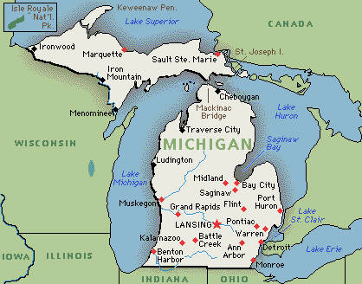
"We'll be moving into a nice flat somewhere," said Mama. "Somewhere on South Park, or Michigan, or in Washington Park Court." Those flats, as the girls and Mama knew well, were burdens on wages twice the size of Papa's. This was not mentioned now.
"They're much prettier than this old house," said Helen. "I have friends I'd just as soon not bring here. And I have other friends that wouldn't come down this far for anything, unless they were in a taxi."
Yesterday, Maud Martha would have attacked her. Tomorrow she might. Today she said nothing. She merely gazed at a little hopping robin in the tree, her tree, and tried to keep the fronts of her eyes dry.
"Well, I do know," said Mama, turning her hands over and over, "that I've been getting tireder and tireder of doing that firing. From October to April, there's firing to be done."
"But lately, we've been helping, Helen and I," said Maud Martha. "And sometimes in March and April and in October, and even in November, we could build a little fire in the fireplace. Sometimes the weather was just right for that."
She knew, from the way they looked at her, that this had been mistake. They did not want to cry.
But she felt that the little line of white, somewhat ridged with smoked purple, and all that cream-shot saffron, would never drift across any western sky except that in back of this house. The rain would drum with as sweet a dullness nowhere but here. The birds on South Park were mechanical birds, no better than the poor caught canaries in those "rich" women's sun parlors.
"It's just going to kill Papa!" burst out Maud Martha. "He loves this house! He lives for this house!"
"He lives for us," said Helen. "It's us he loves. He wouldn't want the house, except for us."
"And he'll have us," added Mama, "wherever."
"You know," Helen sighed, "if you want to know the truth, this is a relief. If this hadn't come up, we would have gone on, just dragged on, hanging out here forever."
"It might have," allowed Mama.
"Yes," Maud Martha cracked in, "that's what you always say."
Her mother looked at her quickly, decided the statement was not suspect, looked away.
Helen saw Papa coming. "There's Papa," said Helen.
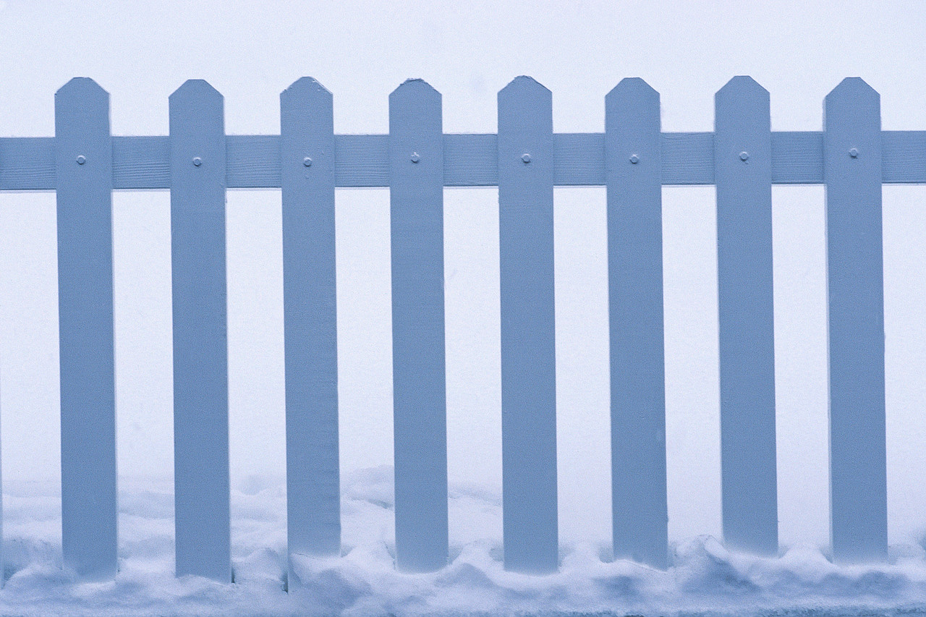
They could not tell a thing from the way Papa was walking. It was that same dear little staccato walk, one shoulder down, then the other, then repeat, and repeat. They watched his progress. He passed the Kennedys', he passed the vacant lot, he passed Mrs. Blakemore's. They wanted to hurl themselves over the fence, into the street, and shake the truth out of his collar. He opened his gate - the gate - and still his stride and face told them nothing.
"Hello," he said.
Mama got up and followed him through the front door. The girls knew better than to go in too.
Presently Mama's head emerged. Her eyes were lamps turned on.
"It's all right," she exclaimed. "He got it. It's all over. Everything is all right."
The door slammed shut. Mama's footsteps hurried away.
"I think," said Helen, rocking rapidly, "I think I'll give a party. I haven't given a party since I was eleven. I'd like some of my friends to just casually see that we're homeowners."
From "Maud Martha". © 1991 Gwendolyn Brooks. Published by THIRD WORLD PRESS, Chicago.
“Home” Inference Questions
Author’s Words (AW) | PLUS | Prior Knowledge (PK) | EQUALS | Inference
These things might soon be theirs no longer | PLUS |  | EQUALS
There was little hope. | PLUS |  | EQUALS
Those flats, as the girls and Mama knew well, were burdens on wages twice the size of Papa's. This was not mentioned now. | PLUS |  | EQUALS
He wouldn't want the house, except for us  . | PLUS |  | EQUALS
He opened his gate - the gate - and still his stride and face told them nothing. | PLUS |  | EQUALS
- Based on the information in the story, what inference can you make about Helen? Include information from the story to support your inference.
- Explain how their home was important to the family. Support your answer with two details from the story.

- What is the most likely reason that Papa went to the office of the Home Owners’ Loan? Provide two details from the story in your answer.

*Rubrics below can be used to score WASL questions on the previous page

- Based on the information in the story, what inference can you make about Helen? Include information from the story to support your inference.
2 | A 2-point response makes a reasonable inference about Helen and provides text-based information to support the inference.
1 | A 1-point response makes a reasonable inference about Helen  OR  Provides text-based information that would support a reasonable inference.

- Explain how their home was important to the family. Support your answer with two details from the story.

2 | A 2-point response provides two text-based details to explain how their home was important to the family.
1 | A 1-point response provides one text-based detail to explain how their home was important to the family.

- What is the most likely reason that Papa went to the office of the Home Owners’ Loan? Provide two details from the story in your answer.

2 | A 2-point response provides two text-based details to demonstrate why Papa most likely went to the office of the Home Owners’ Loan.
1 | A 1-point response provides one text-based detail to demonstrate why Papa most likely went to the office of the Home Owners’ Loan.

