You Show

This is an autobiographical essay

I’m quiet. I don’t talk much, I hate loud music, and I love to do quiet things like read and play with my dog. I’m not sure whether I was born quiet or got that way because of my family. I have three older brothers and two older sisters, and I grew up in a house full of noise. My brothers were always blasting music on their stereos or yelling while watching sports, and my sisters were always on the phone yak-yakking with their friends. To escape, I would curl up in a sunny corner of the attic and read. Also, because I am a lot younger than my brothers and sisters, they used to baby me. I didn’t need to talk to get what I needed; all I had to do was point. After a while, not talking became a habit.
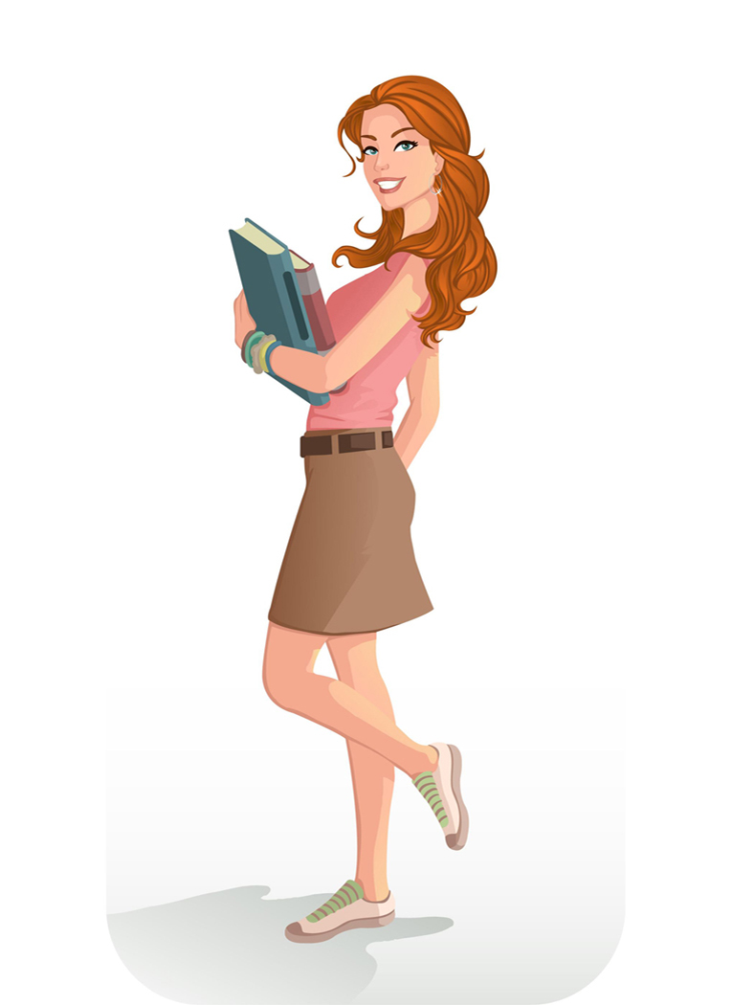
Sometimes, I wish I were a little more talkative. My best friend, who is also quiet, says that some kids think I am a snob because I rarely talk to anyone. Also I know that some teachers think I’m shy or lack confidence because I don’t talk in class. Worse yet, one of my teachers accused me of never preparing for class because I didn’t volunteer to answer his questions. Sometimes, I dream of screaming in the hallways at school, “Listen up! I’m not shy, and I do not lack self-esteem! I’m just QUIET!” But that wouldn’t be quiet, would it?

