Pollution
Pollution is a serious problem on our Earth today. People and companies pollute the water by throwing trash into it. Chemicals that kill plants and fish are also dumped into the water. Air pollution is another type of pollution that we should worry about. Some of the air we breathe is not clean. Factories and power stations pollute the air with smoke and poisonous gases. Cars also make exhaust fumes that pollute the air. When these gases mix with the water in the air, they produce acid rain. This rain is not good for the plants on earth. The more acid there is in the rain, the faster it will kill the plants.

An excerpt from “I Am a Native of North America” by Chief Dan George
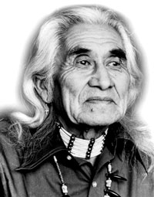
I was born into a culture that lived in communal houses. My grandfather’s house was eighty feet long. It was called a smoke house, and it stood down by the beach along the inlet. All my grandfather’s sons and their families lived in this large dwelling. Their sleeping apartments were separated by blankets made of bull rush reeds, but one open fire in the middle served the cooking needs of all. In houses like these, throughout the tribe, people learned to live with one another.

