Lesson 8
Personal Finance
Student Resources
Resource | Description
Student Resource 8.1 | Worksheet: Creating a Monthly Budget  Make It Local | Modify this section for your community; then remove this callout.
Student Resource 8.2 | Anticipation Guide: Personal Finance Terms
Student Resource 8.3 | Reading: I Need to Stop at the Bank
Student Resource 8.4 | Worksheet: On Banking
Student Resource 8.5 | Reading: On Banking
Student Resource 8.6 | Guided Practice: Managing a Checking Account
Student Resource 8.7 | Reading: Online Banking and Bank Statements

Student Resource 8.1
Worksheet: Creating a Monthly Budget

Make It Local | Modify this document based on your research; costs for specific categories listed below will vary based on your location. See Teacher Resource 8.1 for details. San Francisco pricing is included below as placeholder. Once updated with details from your community, remove this callout and re-save the file before distributing it to students.

Student Name: ___________________________________________________Date: _____________
Directions: Imagine that right now you are 25, single, and living on your own in your same community. Use the following categories and expenses to help you create your monthly expense budget. These are the average monthly costs for one adult living in our community—your own costs may be higher or lower for each category depending on your lifestyle.
HOUSING
- Studio (One Room) Apartment: $1,635
- One-Bedroom Apartment: $2,340
- One Bedroom in Shared Three-Bedroom Apartment w/ Two Roommates: $1,210
TRANSPORTATION
- Car Payment: Used 2009 Toyota Prius: $264
- Public Transportation: Adult Monthly Pass: $74
- Car Insurance for 2009 Prius: $108
- Gasoline: $50–$200 (depending on commute)
PHONE, CABLE, INTERNET, UTILITIES
- Cell Phone Plan: iPhone with Unlimited Voice and Texting: $140
- Cell Phone Plan: Basic with 450 Minutes and No Texting: $50
- Telephone Plan: Home Phone/Landline: $30
- Cable Television: Basic Package: $55
- Internet: High Speed: $35
- Household Utilities: Electric: $58
- Household Utilities: Natural Gas: $55
FOOD
- Groceries: Per Person: $254

EXPENSE CATEGORIES | DESCRIPTION | COST PER MONTH
Housing
Example: Rent | Studio | $1,635.00
Rent
EXPENSE CATEGORIES | DESCRIPTION | COST PER MONTH
Utilities
Electricity
Natural Gas
Telephone (Landline, Cell)
Food
Groceries
Transportation
Public Transportation
Car Payment
Car Insurance
Gasoline
Extra Expenses
 | TOTAL MONTHLY EXPENSES

Student Resource 8.2
Anticipation Guide: Personal Finance Terms
Student Name: Date:
Directions: Read each term listed in the chart below. Under “What I Guessed,” write down your best guess for what that term means. Then, after you read and listen to Student Resource 8.3, you can go back and revise or replace your guess based on what you learned. An example is provided.

Term | What I Guessed | What I Learned
Example: ATM | A machine you can get money out of | Stands for “automated teller machine;” you can take money out of your account and sometimes put money in your account through the ATM, too

Term | What I Guessed | What I Learned
savings account
checking account
deposit
interest
fee

Term | What I Guessed | What I Learned
debit card
credit card
deposit
teller

Student Resource 8.3
Reading: I Need to Stop at the Bank
Characters
- Narrator
- Tre
- Julio
Part One
Narrator: Tre and Julio have been friends since high school. Now Julio works in his aunt’s store part-time and goes to community college, and Tre goes to the nearby state university. They are both still living at home with their parents to save money. One day, Tre stopped by the store to see if Julio wanted to grab a burger and maybe watch the basketball game on TV.
Julio: Sure, but I need to stop at the bank before it closes. Want to come along?
Tre: Sounds good, but why are you going to the bank?
Julio: I got paid today and I want to deposit the check right away.
Tre: You put your check in the bank?
Julio: Yeah. What else am I supposed to do with it?
Tre: My mom and stepdad go to this place down the block. They give you cash for your check right away. You don’t need a bank account.
Julio: Really? My parents keep their money in the bank. As soon as I started working, my mom helped me open my own account.
Tre: I’ve never even been in a bank before. Do they give you your money right away?
Julio: Seriously? Of course they do, it’s your money.
Tre: [Shakes his head.] I don’t know....
Julio: Well, you should think about it. I know you’ve been saying you wanted to save up to buy that old car off your brother. Using the bank might help.
Narrator: So they started to walk down the street toward the bank.
Tre: How would it help me save money?
Julio: Well, there are two kinds of accounts you can open at the bank: a savings account and a checking account. A savings account is designed to help you save money, and a checking account lets you write checks to pay bills and pay for things without having to carry cash with you.
Tre: How does a savings account help you save money?
Julio: When you get paid, you deposit your check in the bank. That means you put the money in the bank, and they put it in your account. It depends on what kind of account you have, but most savings accounts pay you interest.
Tre: Interest?
Julio: Yeah—the bank gives you extra money. It’s like they’re paying you for putting your money in their bank and not someone else’s. So if you put money in a savings account, you will earn interest, which means more money.
Tre: A lot more money?
Julio: It depends on the interest rate that is being offered. The bank gives you a percentage based on how much money you have in your account—like 1% or 2%. It usually isn’t a lot of money, but still—it’s like getting money for free. That’s always good.
Tre: So the bank just gives you money? Why?
Julio: The bank wants you to put your money with them and not somewhere else. They consider it like a rental fee for getting to hold on to your money and use it to give people loans. Besides, the bank makes money off of you, too. They charge you fees.
Tre: Fees?
Julio: Yeah, like if you don’t keep a certain amount of money in your account, they might charge you a fee once a month. Or if you write a check you can’t pay for, they might charge a fee for that.
Tre: So then why do I want to use a bank?
Julio: Tre, you get charged fees at the check cashing place, too—and they’re a lot higher than the fees at my bank!
Stop here. Review your vocabulary terms.
Part Two
Tre: [Looks like he’s thinking about it.] So you got a savings account?
Julio: Actually, I have both—a checking account and a savings account.
Tre: Why does somebody want a checking account?
Julio: A checking account lets you pay people without having to carry cash with you. You can write a check or use a debit card.
Narrator: They turned the corner. The bank was just down the block.
Tre: A debit card? Aren’t those bad?
Julio: No, credit cards are the things that can get you into trouble. When you use a credit card, you’re borrowing money from a bank, and you have to pay it back. A debit card looks a lot like a credit card, but it takes the money out of your bank account. So when you use a debit card, you have to be careful, because if you have no money in your account it won’t work.
Tre: Do you have a debit card?
Julio: [Nods.] I don’t use it too much, except at the ATM.
Tre: What’s an ATM?
Julio: [Points.] See that machine in front of the bank? That’s an ATM machine. That lets you take money out of your account any time. You put your card in and enter a secret code and it lets you get money out of your account. Some banks also let you deposit money through the ATM.
Tre: So are you going to use that today?
Julio: I’d rather deposit my check inside. Besides, one of the tellers is hot.
Tre: What’s a teller?
Julio: The people who work behind the counter at the bank are called bank tellers. They can help you open an account and give you money from your account, just like the ATM. Actually, ATM stands for “Automated Teller Machine.” My dad said in the old days, before we were born, there were no ATMs—you could only deposit or take money out by talking to a real teller!
Narrator: The bank door opened, but Tre hesitated.
Tre: I don’t know, man.
Julio: C’mon. It’s no big deal. I’ll ask them for a brochure on their savings accounts. It might help you finally be able to buy that car.
Tre: All right.
Narrator: And the two of them went inside the bank.
Stop here. Review your vocabulary terms.
Student Resource 8.4
Worksheet: On Banking
Student Name:_______________________________________________________ Date:___________
Directions: Complete this worksheet as you view the presentation. Keep in mind that you will be taking a test on this information and this worksheet will be your study guide, so fill it in carefully!
Question | Your Answer
What does it mean to make a deposit?
What is direct deposit?
What is a credit union?
What does “confidential” mean when we’re talking about banks?
List two reasons why banks are safe places for your money.
What is the FDIC? Why is the FDIC important?
What are payday loan stores and check cashing outlets?
What do you use a checking account for?
What is a check register?
What is a bank statement?
What does it mean to “credit” something to your account? To “debit” an amount to your account?
What does it mean to “balance your checkbook”?
What does it mean to “bounce a check”?
What is overdraft protection? Why should you try not to use your overdraft protection?
What is a debit card? How is it different from a credit card?
What is a savings account?
What is an interest rate?
What is online banking?
Student Resource 8.5
Reading: On Banking
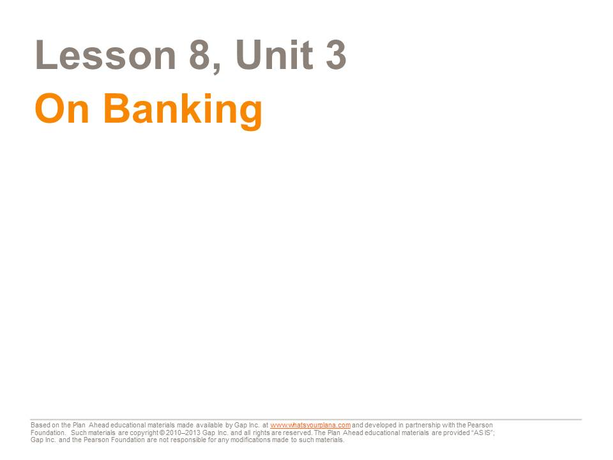

This presentation will teach you about banks and credit unions—how they work and why they are a good place to keep your money.

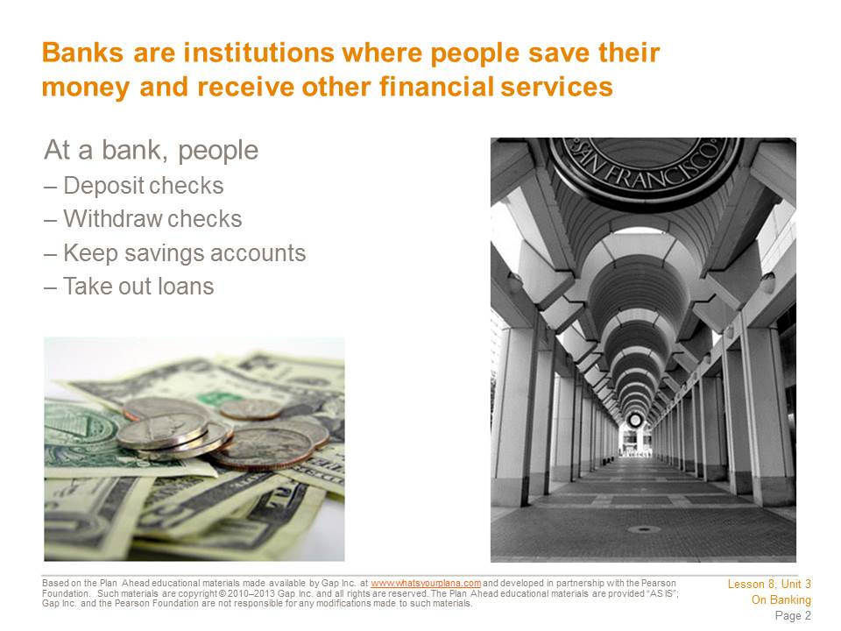

There are two main kinds of bank accounts: savings and checking. You can deposit your paycheck into your checking account, and that money is available to you for paying your bills. You also use this account to withdraw cash.
The money that you don’t want to use for everyday expenses is kept in a savings account. You can take a little bit of your paycheck and put it into your savings account. This money will accumulate and be available for something really important that you want to pay for in the future, like going to college or buying a car.
Putting money into your bank account is called making a deposit. Taking money out of your account is called making a withdrawal. You can make deposits and withdrawals by going to the bank or by using online banking services. Many people have something called direct deposit. Their paychecks go straight into their checking accounts, and they don’t have to go to the bank to deposit them.

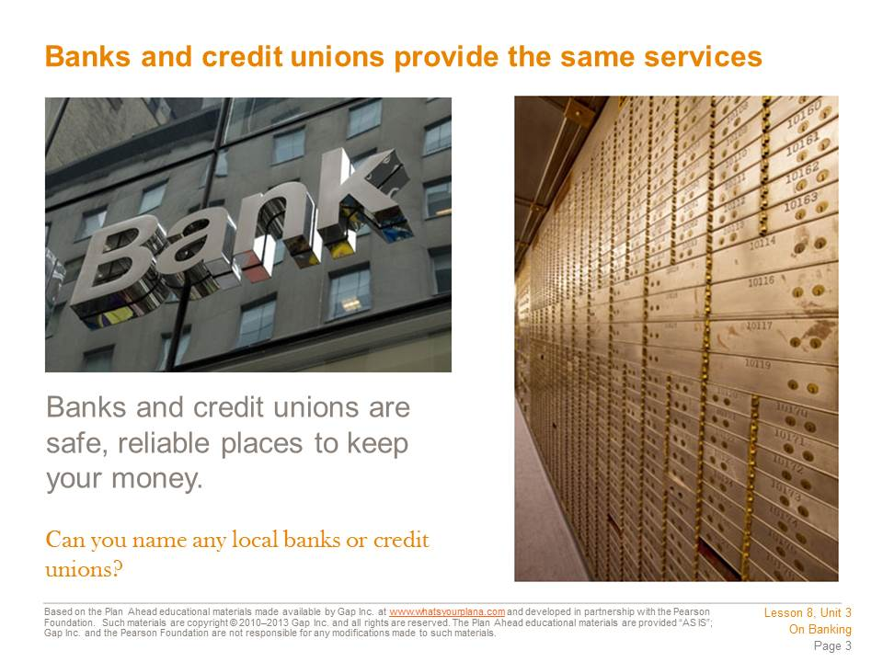

Banks and credit unions offer the same services. But there are a few big differences. Banks are for profit: they are owned by investors who want to make money. Credit unions are not for profit and they are owned by their members. So if you keep your money in a credit union, you are a partial owner! Since a credit union isn’t trying to make a profit for its investors, it can offer lower fees and lower interest rates for people who take out loans.
Then why doesn’t everyone join a credit union? Many credit unions are designed to serve a specific group of people—such as union employees, students, or teachers. Some credit unions serve people who live in a specific neighborhood. So you have to check and see if you qualify for membership in a credit union. Also, they may not be as convenient as banks. Credit unions are usually located in just one building, but banks can have many branches, or local offices, so you can take care of bank business even if you aren’t near one specific branch. Both banks and credit unions offer online banking services so that you can manage your finances no matter where you are.

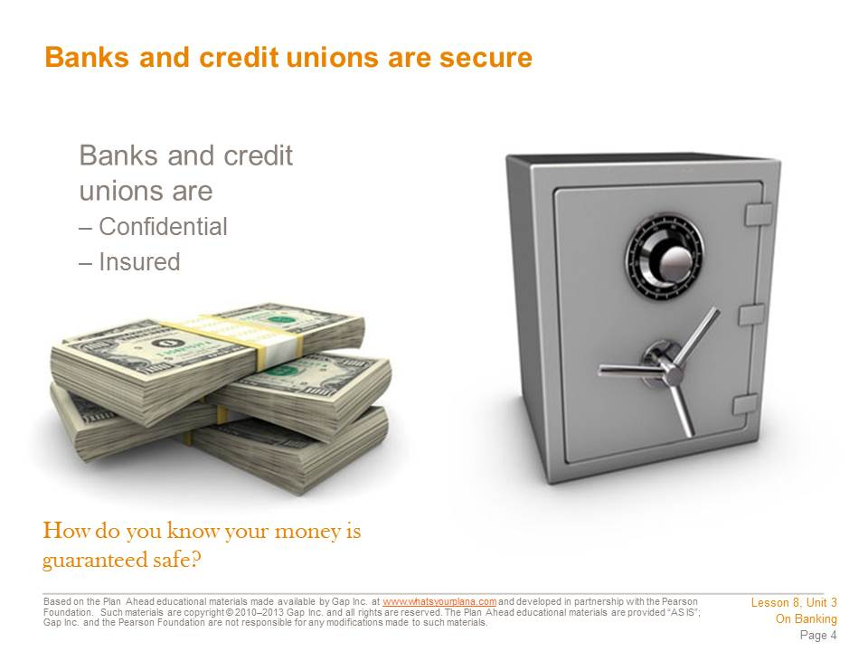

Some people who are not US citizens or who are undocumented are afraid to use banks. Some people don’t want anyone to know how much money they have. But you don’t need to worry about any of that with banks. US banks have confidentiality rules, which means they have to keep your information private. Some banks encourage undocumented workers to open bank accounts.
People who come from countries where it is more common to deal in cash may avoid banks in favor of keeping their money at home. They are not sure if they can trust banks. We’ve been hearing stories about banks “failing,” but this doesn’t mean that people have lost their money.
All US banks and credit unions have insured deposits. In the United States, any money you put in a bank is insured up to $250,000, thanks to the FDIC, or Federal Deposit Insurance Corporation. The FDIC was created by the US government after the Great Depression, when lots of people lost money because banks made bad investment decisions. Today, even if a bank fails, the FDIC will pay you back, so you don’t need to worry about losing your money if you put it in a bank. Credit unions are also insured through the National Credit Union Administration.

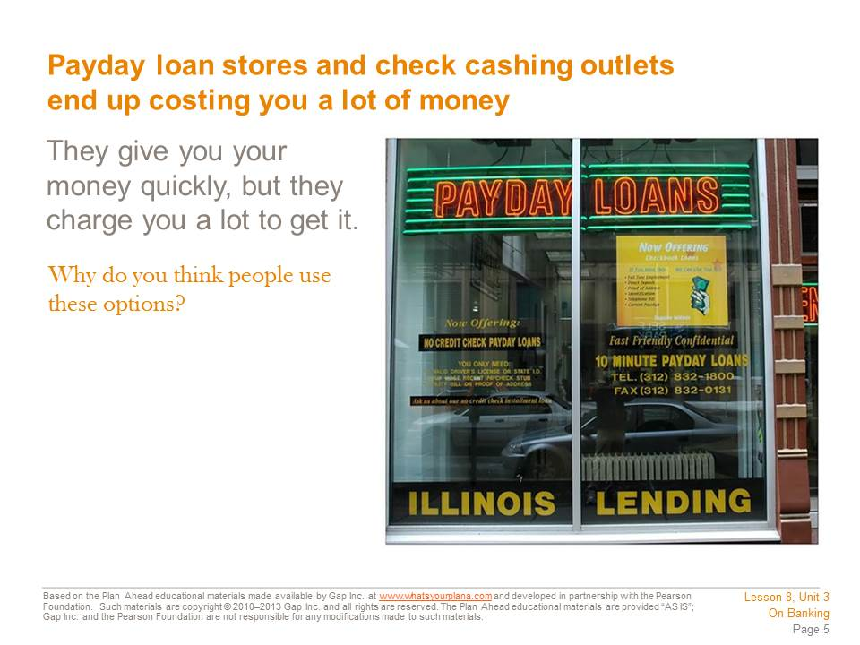

Many people use payday loan stores or check cashing outlets to get access to their money without using a bank. But this is not a good idea.
Payday loan stores will advance you money on your upcoming paycheck. Imagine that you will get paid next week and you know your check will be $200. But you need that money this week to pay your bills. A payday loan store will give you the money this week, but they will charge you for the money they are lending you. So you might have to pay $30 to get that $200 early. If you kept your money in a bank, you wouldn’t pay anything to get access to your money. It’s true that banks can’t give you your paycheck money early, but they can help you with good budgeting and money management. Some institutions offer ways to help people stop using payday loans (as well as build their credit ratings, which you will learn about later).
Check cashing outlets are another way people avoid using a bank. You can take your paycheck to one of these places and they will give you the amount of the check in cash. So what’s the problem? They may charge you 2–3% of the amount just for having the check cashed. Again, you are paying someone to get access to your own money. And unlike a bank or a credit union, you won’t earn interest.
Still, a lot of people use these options instead of banks and credit unions. They are called unbanked or underbanked.

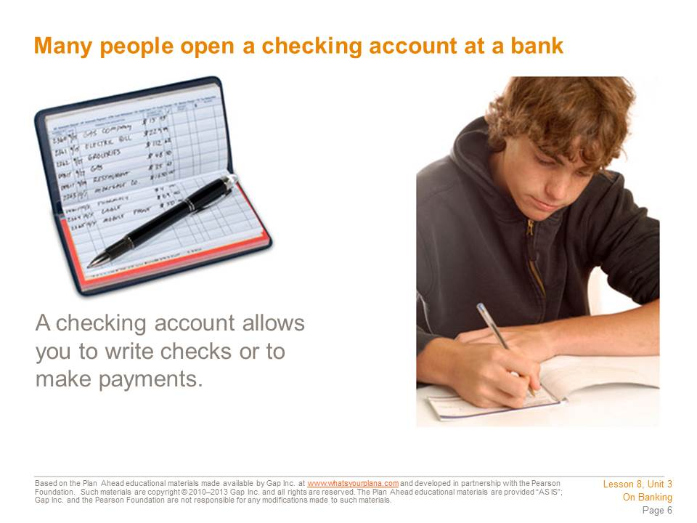

Most people use their checking account as a way to pay their expenses.
Let’s say you have graduated from college. You’re working full-time and sharing an apartment with some friends. You will have certain expenses to pay for: your rent, your utilities, your food, maybe a cell phone bill, and maybe a payment on a student loan. You need a way to pay these expenses, so you open a checking account and keep your money in it. Now you can write a check to your landlord for the rent, write a check to pay your student loan bill, and so on. When the landlord receives your rent check, he deposits it into his bank account, and your bank transfers that amount out of your account and into his account. When people say the check “cleared,” they mean this process occurred successfully. So long as you have money in your account to cover the amount of your check, the check will clear.

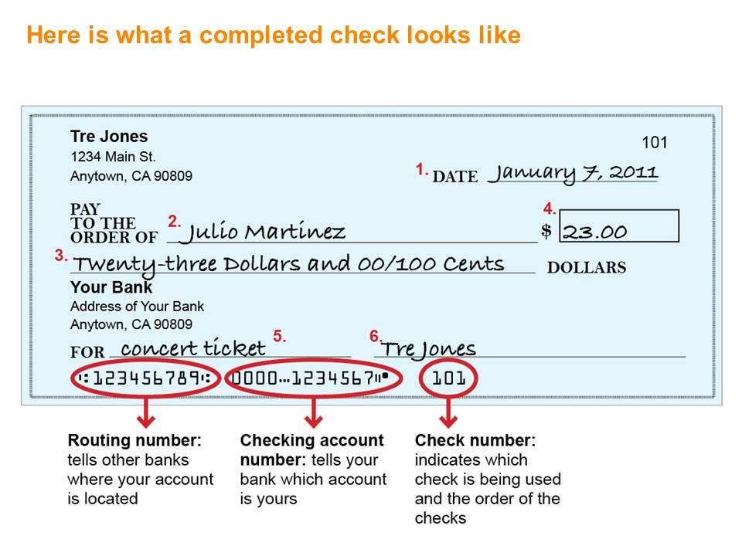

After talking with Julio, Tre decided to open a checking account. Once he received his first checks, he decided to write one for $23 to Julio to pay him back for a concert ticket. These are the steps he followed to write his first check:
1. Enter the date in the upper right-hand corner. Include the month, day, and year.
2. Write the name of the person or business that you are making the check to on the Pay to the Order of line. If it’s to a person, write the first and last name.
3. Write the amount of the check in word form.
4. Write the amount in number form next to the dollar sign, including dollars and cents.
5. Include any information you’d like on the memo line, such as what you’re paying for.
6. Sign your check; it can’t be cashed or deposited into an account without your signature. Keep in mind that it needs to be your complete signature. Your bank will have a copy of your signature on file, so don’t sign with a nickname or with just your first name. You need to sign every check with your full name; some people even use a middle name or middle initial on their checks.

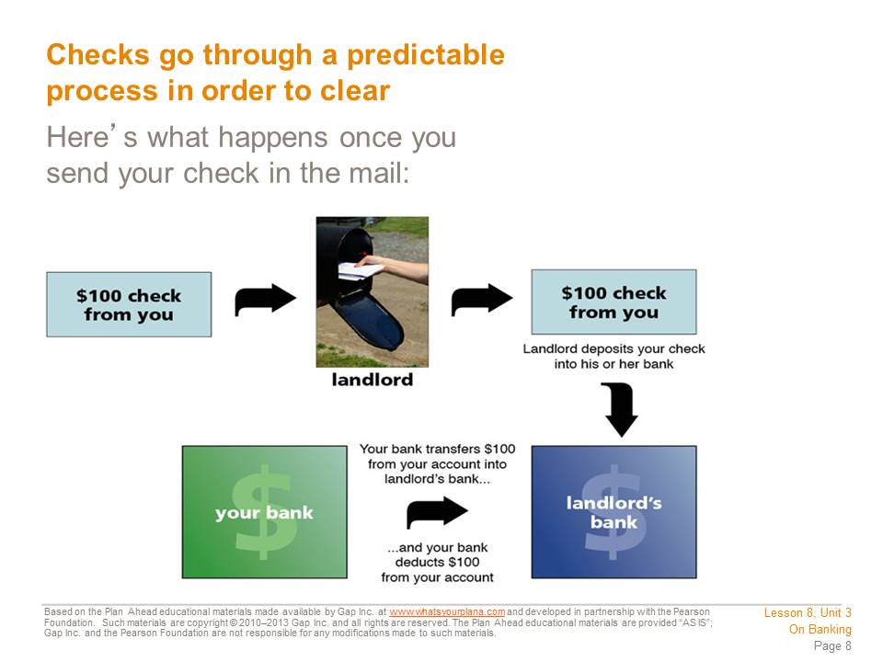
It can be hard to imagine how money comes and goes from your account when you write a check, but it’s pretty straightforward. In this example, the check is to the landlord. Once the landlord deposits your check into her account, her bank immediately contacts your bank with the amount to be transferred. Both of your banks keep accurate records of the whole transaction: the number of the check and the amount it was for, exactly what day the money was transferred out of your account and into the landlord’s, and what each of your account balances are now. The information about your account will appear on your monthly statement.
This check clearing process may soon be a thing of the past. These days checks are becoming less common as more and more people are using online banking services to pay their bills. We’ll talk more about online banking later.

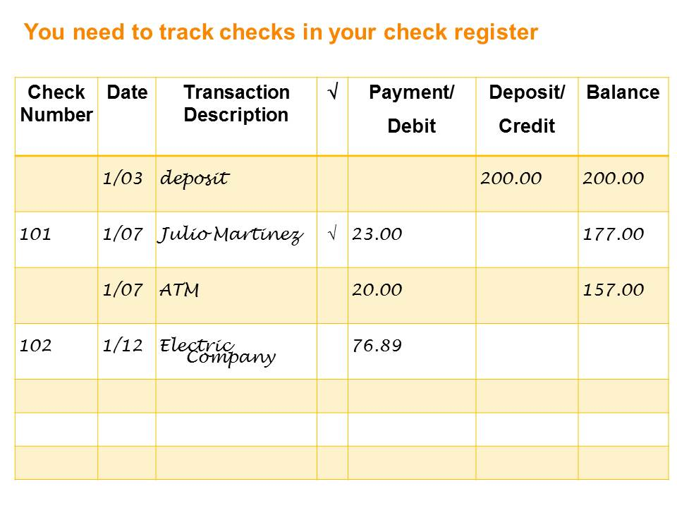
Each box of checks comes with a register, a booklet you use to keep track of payments, purchases, and deposits. Each time Tre uses money from his account—whether by check, debit card, or ATM withdrawal—or makes deposits, he updates the register like this:
1. Writes the check number from the upper right-hand corner of his check.
2. Writes the date he wrote the check.
3. Writes who he wrote the check to in the Transaction Description column.
4. Writes the amount of the check in the Payment/Debit column.
5. Uses the Deposit/Credit column when he puts money into the account.
6. Writes the new total in the Balance column each time he debits or credits his account.
7. Every time a check clears, he puts a check mark next to it in his register.

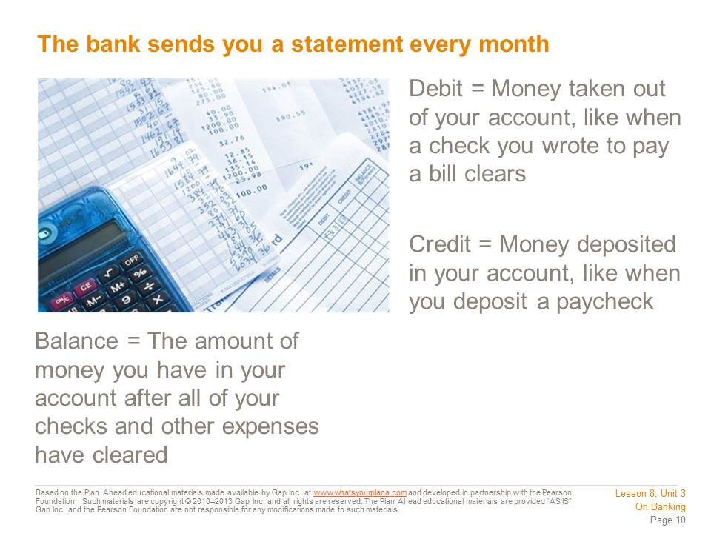
Every month your bank sends you something called a statement. It lists all of the banking activity that occurred in the previous month, including which checks cleared. You should compare your check register to your monthly statement. That way you know which checks have cleared and which ones are still outstanding—meaning that they haven’t been withdrawn from your account yet. Comparing your own records with the bank statement is called balancing your checkbook, and it will help you keep track of your money.

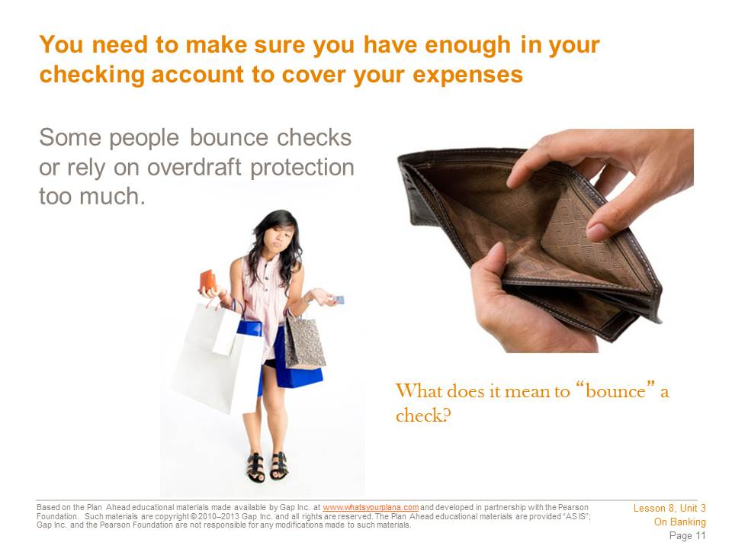
If you write checks that you can’t pay, the checks will “bounce,” or be rejected by the bank. Imagine you have spent all the money in your account, but you see something that you really want to buy. You can write a check, but when it goes to the bank, you won’t have the money to pay for it. So your check will be rejected—it will bounce. Banks will charge you a fee if you bounce checks, and if you bounce a lot of checks, you can get in trouble with the law. Some stores don’t take checks because too many customers’ checks have bounced.
Some banks offer overdraft protection, which helps to ensure that you will never bounce a check. If you have overdraft protection on your account and you write a check you can’t pay for, the bank will loan you enough money to cover the check. But once you have money in your account again, the bank will take its money back and charge you a fee. The bank can also transfer money out of your savings account into your checking account to cover the amount, if you have that money available in a savings account. But you still have to pay a fee.

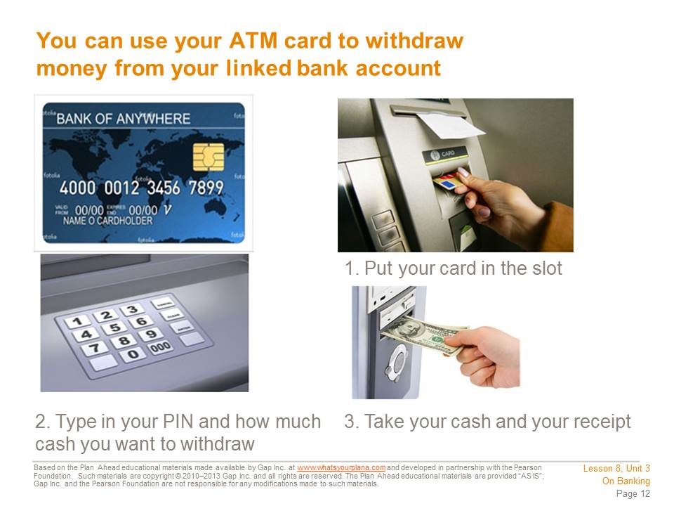

An ATM (Automated Teller Machine) is a machine that gives you access to your money even if the bank is closed. ATMs are often outside of bank branches, but they can be many other places as well. ATMs are part of a network, sort of like a computer network, so even if you keep your money in Bank of America, you can use an ATM at a Wells Fargo Bank and still get your money. However, if you use an ATM that isn’t part of your bank network, you may be charged a fee.
To access money at an ATM, you need an ATM or a debit card. You insert the card into the machine and then enter a PIN, or personal identification number. Your PIN is a way of proving to the machine that you really are the person who is supposed to have access to this account. You punch in the amount you want to withdraw, and that amount comes out of the money slot.

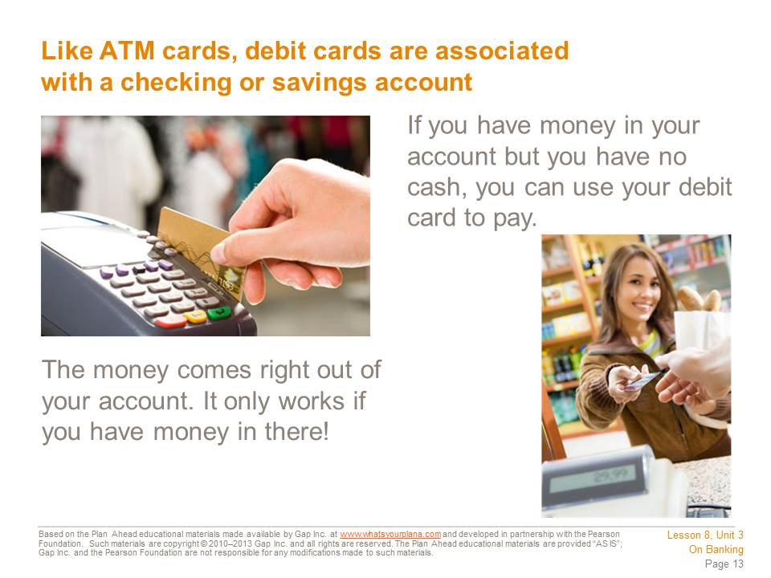

Debit cards are also very popular nowadays. A debit card is an ATM card that can be used to make purchases. If you want to get gas for your car or buy groceries, you can “swipe” your debit card rather than write a check or pay cash. However, when you use your debit card, it takes money right out of your checking account, just like writing a check. You need to track your debit card purchases just like tracking your checks, so you always know how much money you have left in your account.
Debit cards look like credit cards. But a credit card doesn’t take money out of your account. Instead, using a credit card is like borrowing money from a bank, which means you will have to pay it back. If you hear a cashier asking a customer “debit or credit?” it means they need to know whether the purchase will be coming from a person’s bank account or charged to her credit card.

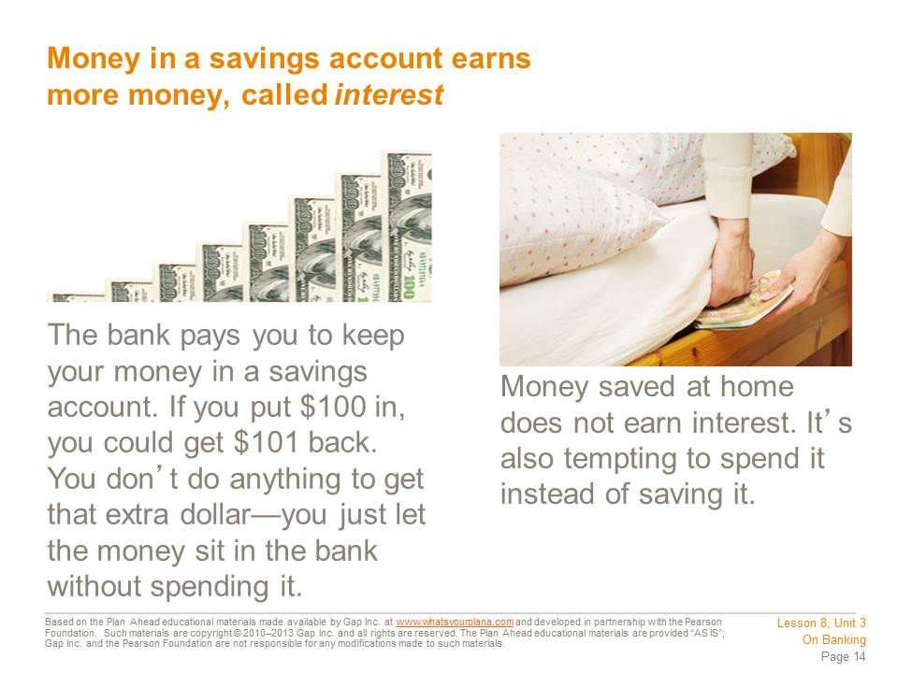

Banks pay interest because they get to use your money. If you put in $100, the bank takes that money and uses it.
How do banks use your money? They lend it to other people. The bank takes your $100 and the money that other people have put in the bank. It lends this money to other people so they can buy a car or a house or open a business. The bank makes money on that loan, so it gives a little bit of what it earns back to you. The interest the bank pays you is an incentive for you to invest your money at its institution.

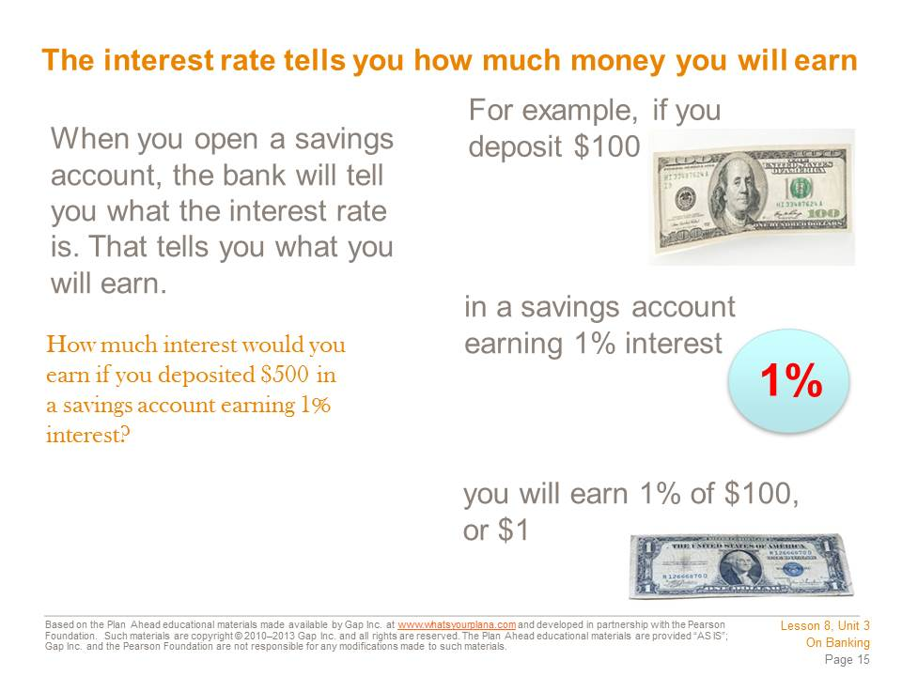
There are many different types of savings accounts and each type offers a different annual, or yearly, interest rate. If you had $500 and you deposited it in a savings account earning 1% interest annually, you would earn an additional $5 in one year. That means you would end up with $505.
The more money you put in a savings account, the more interest you will earn.

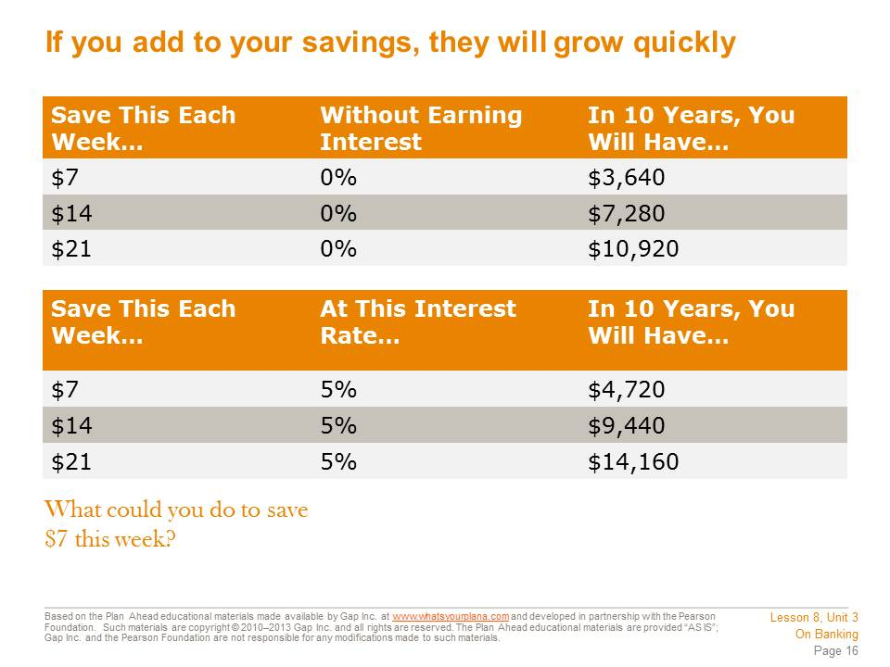

Interest helps your savings add up. Imagine, if you tried to save $7 each week and put it in an account that earned 5% interest, you would end up with $4,720 in 10 years. That’s almost $5,000 you would have, just from that little bit of savings. If you skipped grabbing a latte one morning or ate one meal at home instead of getting fast food, that’s your $7 in savings, right there.

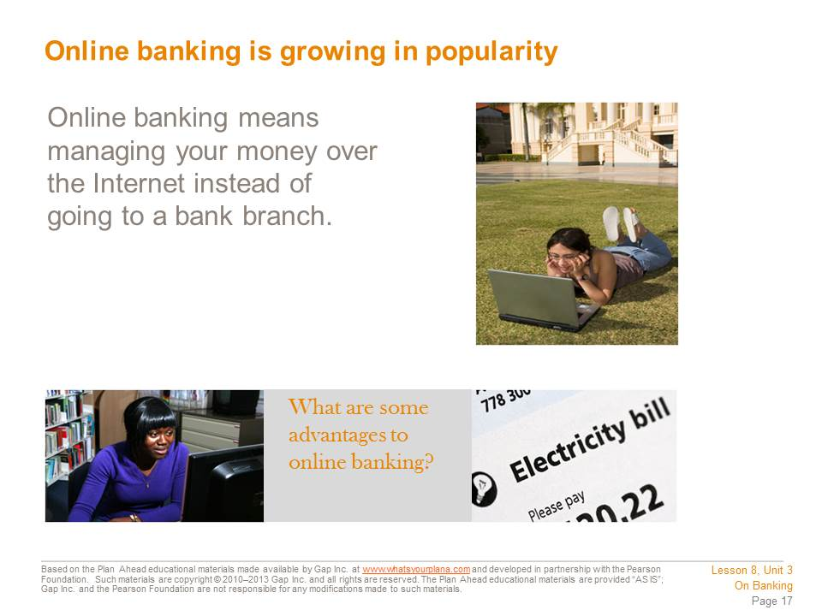

Most major banks now offer online access, which means you can check your account balance, move money between your accounts, or even make payments through the bank’s website.
If you are comfortable using the computer, online banking can be very convenient. You don’t need to write checks that you need to send in the mail, and you can check your balance while sitting comfortably at home, listening to your favorite music. Banks are very careful with their online access so your account stays safe and protected. Today there are even “virtual banks” that don’t have any branches at all—you do all of your banking through the Internet, the phone, and ATM machines.

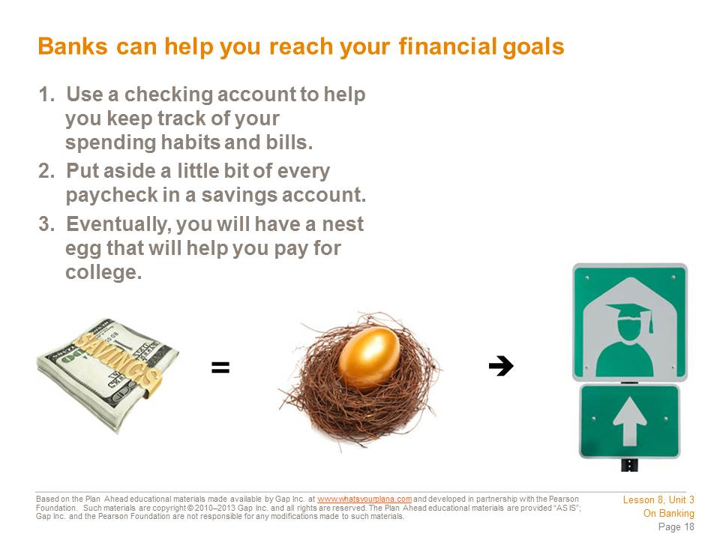

Once you get a job—and this could be part-time, such as babysitting or bagging groceries—opening a savings and checking account is really smart. It’s hard to stay on a budget. If you cash your whole paycheck, you will spend it before you know it and you won’t be sure where the money went. If you deposit your paycheck into your checking account and just let yourself have a little spending money, you will take control of your spending habits. You can start saving up for the future too. A “nest egg” is the money you’ve been saving up for something important.
We always think that people are rich because they make a lot of money. But more often, people who are financially successful are good at saving and spending what they have wisely.

Student Resource 8.6
Guided Practice: Managing a Checking Account
Student Name: Date:
Directions: Use this worksheet to help you practice writing a check and updating a check register.

A Check for the Utilities
Right after he opened his checking account, Tre’s mother tells him she’s short on cash and says if he can write a check for this month’s bill for their gas and electricity, she’ll pay him back soon. He said yes, and she told him the amount of the bill.
Now, write the check for Tre, using the following information:
- The date is January 12, 2012 (or the current year).
- The check is to City Gas and Electric
- The amount is $76.89.
- Remember to sign with Tre’s full name.

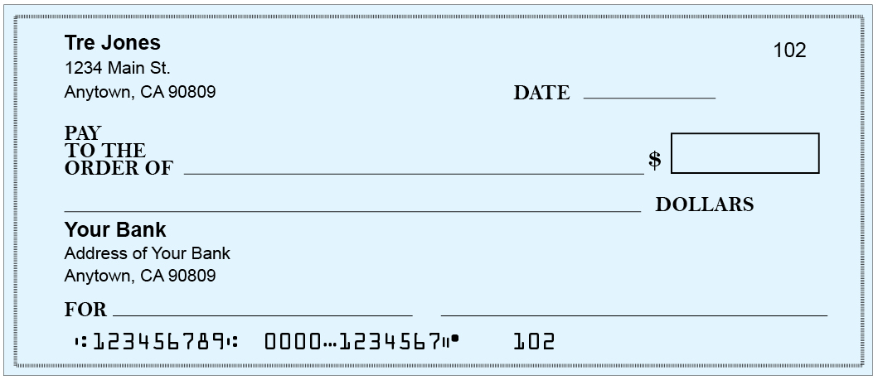

Tre Manages His Check Register
Tre remembered to enter the electric bill in his register, but forgot to update the balance. He has a few more transactions to complete this week as well.
Enter the following transactions into Tre’s register.
- Update the balance after the City Gas and Electric bill on 1/12.
- Deposit a $100.00 check for doing odd jobs for his neighbor on 1/13.
- Pay for dinner ($13.65) at Tommy’s Restaurant with debit card on 1/14.
- Pay for Sprint cell phone bill ($45.23) with check number 103 on 1/15.

Check Number | Date | Transaction Description | √ | Payment/Debit | Deposit/Credit | Balance
 | 1/03 | deposit |  |  | 200.00 | 200.00
101 | 1/07 | Julio Martinez | √ | 23.00 |  | 177.00
 | 1/07 | ATM |  | 20.00 |  | 157.00
102 | 1/12 | City Gas & Electric |  | 76.89

What is Tre’s checking account balance after all of these transactions?

Student Resource 8.7
Reading: Online Banking and Bank Statements
Student Name: Date:
Tre Learns about Online Banking
The next time Tre goes to the bank to deposit a check the teller asks him if he’d like to register for online banking.
“What’s online banking?” he asks.
“It’s great,” she explains. “You can track all of your credits and debits instantly and see what your most up-to-date balance is.”
“Oh, so I don’t have to bother writing down my transactions in the register?” Tre asks.
“Actually, you should still do that—you should keep your own record, and then compare it to your bank statement because banks can make mistakes every now and then. But the great thing about online banking is that you can compare your register to the bank’s record as you go. Some of our customers also choose to receive their monthly statements online in order to save paper.”
“Wow. That sounds great. How do I get started?” Tre asks.
A bank employee helps him set up his account on a computer. Tre looks at the information on the screen and compares it to his check register. “I’m so glad you’re showing me this,” he says. “I think I forgot to write something down in my register!”

Account Activity
Checking Account #1234567
Current Balance
Date | Check # | Transaction Description | Payment/Debit | Deposit/Credit | Balance
1/03 |  | DEPOSIT |  | 200.00 | 200.00
1/07 | 101 | CHECK: JULIO MARTINEZ | 23.00 |  | 177.00
1/07 |  | ATM | 20.00 |  | 157.00
1/07 |  | SERVICE FEE: OTHER BANK’S ATM | 3.00 |  | 154.00
1/12 | 102 | CITY GAS & ELECTRIC | 76.89 |  | 177.11
1/13 |  | PAYMENT ODD JOBS |  | 100.00 | 277.11
1/14 |  | DINNER, TOMMY’S RESTAURANT | 13.65 |  | 263.35
1/15 | 103 | SPRINT CELL PHONE BILL | 45.23 |  | 218.12

Now take a look at Tre’s check register, which you updated during the last class period (Student Resource 8.6). What did he not include on his register?

Tre Receives His Bank Statement
The day after Tre learned about online banking, he runs into Julio.
“Hey man! I’m so glad you talked me into opening a bank account. I feel like I’m really taking charge of my finances—I even learned how to do online banking so I can check my account any time I want.”
Julio smiles, “That’s great. You sound like a pro already. Online banking is cool, but don’t forget to write down your transactions in your register too—my bank made a mistake once.”
“I know, I know! The teller told me that banks can make mistakes. I was going to go ‘paperless’ and get my monthly statements online too, but I’m afraid I might forget to look at them—I’d rather get them in the mail for the first few months until I get the hang of balancing my checkbook. I’m also going to try to put some money away each week to save for that car.”
A few days later, Tre receives his first bank statement in the mail. As he expects, it includes a summary of every transaction that has taken place in his checking account over the past month. He notices it includes the following information:
- Transaction dates
- Name, address, and account number
- An account summary, which gives a quick snapshot of the beginning balance, the total deposits and withdrawals, the total service charges and/or fees, and the ending balance for the specific statement record dates
- All deposits, including direct deposits, credits, ATM deposits, and deposits made in the branch
- Withdrawal list, including ATM withdrawals, detailed check list, debit card transactions

