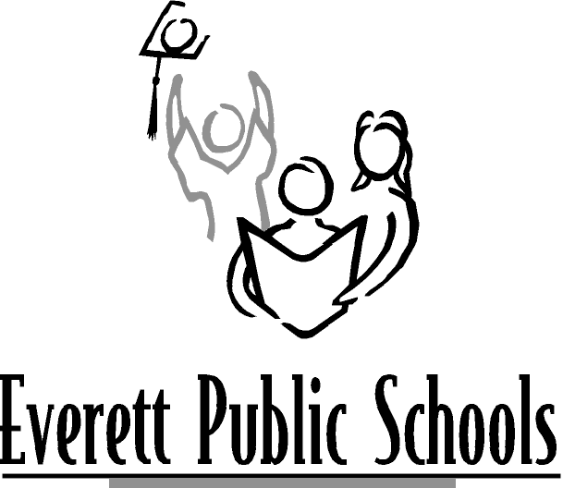 | Career and Technical Education  Automotive  Committee Member Job Description

Summary:

The Automotive Committee assists teachers in making curriculum and equipment recommendations to the General Advisory Council. These recommendations improve the quality and impact of instruction in programs that prepare students for specific occupations. This committee is made up of members of the community that represent employees and management who share expert working knowledge of the competencies required in the automotive field.

Responsibilities:

- Attend all Automotive Committee quarterly meetings.
- Support industry, state and district standards.
- Assist in developing and implementing a two-year automotive plan.
- Serve as a community link between your represented profession and Everett Public Schools.
- Advise Everett Public Schools on the current industry standards to ensure that curriculum taught in today’s schools will prepare students for what to expect when they enter the work force.
- Participate in the review, planning and evaluation for the automotive curriculum.
- Assist in recruiting Automotive Committee members.
- Serve as a resource to Everett Public Schools by providing or finding work-based learning experiences, classroom guest speakers, job shadow and internship opportunities for students.

Time Commitment:

- Attend Automotive Committee meetings quarterly for two hours.
- Occasional work outside of meetings.

Career and Technical Education Staff Representatives
Larry Galli, Instructional Support/Student Services Director (425) 339-4264
Rose Smith, Career and Technical Education Curriculum Specialist (425) 339-4284
Lauren Hadley, Communications/Partnership Coordinator (425) 339-4267

