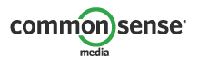

**Copyrights & Wrongs**

Name:

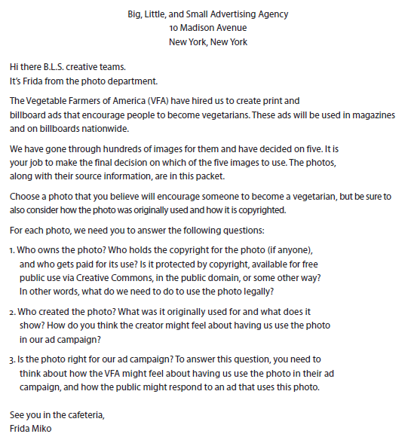***Read the instructions below and be prepared to share your findings with the class.***

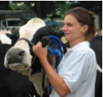

**PHOTO BOOK-** For Creative Team’s Eyes Only

**Photo 1: Cattle Show, Flickr**

**Owner and copyright status: ______________________________**

**Creator and original context: ______________________________**

**Right for the ad campaign? Why or why not? ________________**

**_______________________________________________________**

Okay, Frida. Photo 1 comes to us from Flickr, the photo-sharing site on the web. This photo is in a public album, created by a member of the Future Farmers of America, and is copyrighted through Creative Commons, a license that allows free use of materials by others. Some are allowed to be used for commercial purposes and some aren’t. But don’t worry, this one is okay to use for commercial purposes. However, we don’t really know if this young farmer is aware that her photo from the local cattle show is available for commercial use.

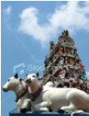

**Photo 2: Hindu Temple, Stock**

**Owner and copyright status: ______________________________**

**Creator and original context: ______________________________**

**Right for the ad campaign? Why or why not? ________________**

**_______________________________________________________**

We can buy some images called stock photos. Well, technically, we buy permission to use it for a fee.

But we can’t forget to credit them! That’s part of the deal. This photo comes from Pronto Pictures. It would cost $1,500 to use in our advertising campaign. The image shows a Sri Mariamman Hindu Temple in Singapore. The cows are statues. Keep in mind that for Hindus, cows hold special significance as religious icons.

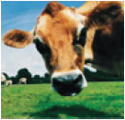

**Photo 3: Dairy Cow, Owned by B.L.S.**

**Owner and copyright status: ______________________________**

**Creator and original context: ______________________________**

**Right for the ad campaign? Why or why not? ________________**

**_______________________________________________________**

This photo takes me back to my days on the dairy farm. It’s by one of our in-house photographers, Duncan. This means that we own the copyright. If someone else wanted to use this photo of Bessie, we would license the photo to them for a fee, depending on the use. But we can use it for free. Look at those big cow eyes.

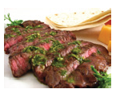

**Photo 4: Flank Steak, Flickr**

**Owner and copyright status: ______________________________**

**Creator and original context: ______________________________**

**Right for the ad campaign? Why or why not? ________________**

**_______________________________________________________**

Photo 4 looks yummy! It’s also from a public album on Flickr, one on how to prepare flank steak. The photo was taken and posted by a local chef, and it is listed for commercial use under Creative Commons. One thing this particular Creative Commons license allows us to do is alter or change the image.

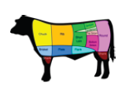

**Photo 5: Cuts of Beef, Public Domain**

**Owner and copyright status: ______________________________**

**Creator and original context: ______________________________**

**Right for the ad campaign? Why or why not? ________________**

**_______________________________________________________**

So, do you know your cuts of beef? This photo is in the public domain, meaning that it’s available for public use or alteration for any purpose. There’s no author we need to get permission from to use it, and no one will come knocking to claim their “cut.”