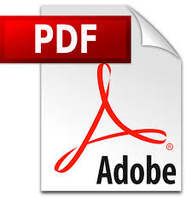

**Creating an Electronic Resume:**

**How to save as a .PDF to send via email**

1. Open your resume in Microsoft Word.

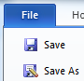

1. Go to the **File** tab, **Save As…**
2. In the pop-up window you will see the **File Name** & below it will be **Save as type**



1. Click the drop-down box next to **Save as type:** and scroll down to select **PDF.**

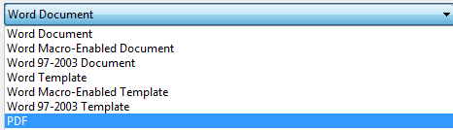

1. Click **SAVE!**
2. When you attach it to an email you will look for the Adobe PDF icon next to the document. 