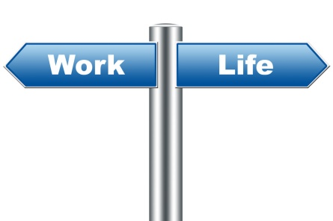

**NCRC**

**Learning Outcomes:** **Students will** **successfully complete a portable credential that demonstrate workplace employability.**

|  |  |  |  |
| --- | --- | --- | --- |
| **Alignment with Standards:** | **American School Counselor Association National Standards:** This lesson is aligned with ASCA Standard A: Students will acquire the skills to investigate the world of work in relation to knowledge of self and to make informed career decisions. C:A1 Develop Career Awareness, C:A1.3. Develop an awareness of personal abilities, skills, interests and motivations.  **21st Century Skills:**   * **Digital Communication:** Electronic environments * **Problem Solving:** Solving the problem | | |
| **Materials:** | * **Teacher Lesson** | * **Copies of hand outs:**   *CE NCRC Test Guide*  *How to Obtain NCRC Scores*  *Student_NCRCreflectionandscores* | * **Computer/Internet Access** * **Projector** |
| **Implementation:** | **Teacher Prep:**  **Introduce** the NCRC- **ACT National Career Readiness Certificate (NCRC)**  ACT's National Career Readiness Certificate (NCRC) is a portable credential that demonstrates achievement and a certain level of workplace employability skills in Applied Mathematics, and Locating Information, and Reading for Information. In the future, ACT Career Credentials powered by ACT WorkKeys is an expanding program that will offer certifications in other areas.  Individuals can earn the NCRC by taking three [WorkKeys](http://www.act.org/products/workforce-act-workkeys/)® assessments:   * Applied Mathematics * Locating Information * Reading for Information   WorkKeys assessments measure "real world" skills that employers believe are critical to job success. Test questions are based on situations in the everyday work world.   * **Show** the short video <http://www.youtube.com/watch?v=DoznUUQM78g> * **Confirm**  that you were sent a list of students in the system to take the NCRC test * You will need to **register** your students for the tests prior to them logging on. **NCRC Test Portal – Teacher** [**https://vtc.act.org/1036553068**](https://vtc.act.org/1036553068) * Using the **NCRC Test Guide** document *(CE NCRC Test Guide)* go to **page 2**, ***Registering Students for a Test.*** * Next, **no more than 30 minutes prior to the test,** you will need to go in & **authorize** your students for a test(s). * Using the **NCRC Test Guide** document *(CE NCRC Test Guide)* go to **page 4, *Authorizing Students for a Test.*** * Once you have ***authorized*** them, you can now have the students log in and take the test. * Teacher will select the order and there will be 3 days in a row * When you are ready to test, students will need to each have their own computer. * After all three tests have been taken, students will follow instructions to collect their NCRC scores (***How to Obtain NCRC Scores***) and **download/save** and **complete** the document titled ***Student_NCRCreflectionandscores.*** * When students have completed their **Student_NCRC reflectionandscores,** they will need to **UPLOAD** it with their name to the class Moodle site. | | |
| **Additional Resources:** | * NCRC Test Portal – Student <https://rsp.act.org/1036553068> * NCRC Test Portal – Teacher <https://vtc.act.org/1036553068> | | |