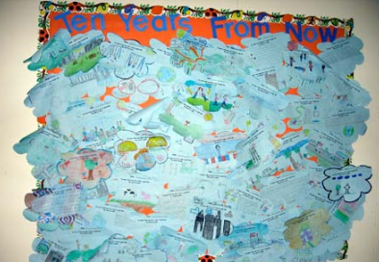

“BLUE SKY” ACTIVITY

This activity focuses students on identifying and responding to community needs.

Blue Sky is a visioning exercise that guides students in imagining a better world. Students are asked to take a look at their class, school neighborhood, community, state, nation, and/or the world.

They reflect on the way it is and then imagine the way they would like it to be. Service leaders are encouraged to use this strategy at the beginning of the service experience and to revisit it before planning each service project with the students.

Blue Sky serves as a launch pad for the school year of service. The service leader may refer to the students’ Blue

Sky thoughts throughout the year as a form of evaluation (How are we doing on the issues we identified?) and review (What issues are still important to us that need to be addressed?).

This activity encourages empathy, compassion, and self-expression. It also helps students learn to react to a negative situation with a positive action.

The activity can be on a small or large scale. On a smaller scale, Blue Sky serves as a classroom activity. A service coach may lead a personalized visioning activity with one class or group, facilitating brainstorming of real issues that students have passion for, and then guiding the students to use those results as a focus for their future service projects.

On a large scale, the activity may be conducted as a Community Blue Sky Event with the whole school and include family and community members. Hold a breakfast or town hall meeting. Organize the group into smaller groups for brainstorming, and have each small group share their main ideas for improving the community.

Encourage students to organize much of the Community Blue Sky Event because they will be setting the tone for the years’ service goals. They may create the invitation list, organize the breakfast and activity, and select topics for discussion.