EVERETT PUBLIC SCHOOLS
HUMAN RESOURCES DEPARTMENT

PERSONNEL SELECTION RECOMMENDATION FORM

Building: _ _____ Position: _ __ FTE: 1.0 Posting #: _______

Interview Team Members:

For Human Resources Use Only
Fingerprints:  Need per SPI ____________ (Date)
 OK per SPI _______________(Date)
____________WSP _____________FBI
 OK Current Employee/Substitute
Certification Expiration Date: _____________
 Received
 OSPI Verification (Attached)
 Pending
ParaEd (NCLB) Requirements:
 2yrs of study (72qtr/48semester credits)
 Associates Degree or higher
 Passed Assessment on ____________
w/Score: _______________________

1. __ ________________________
2. __ __________________________
3. ________________________________________
4. ________________________________________
5. ________________________________________
6. ________________________________________
Candidates Interviewed:
1. __ _________________________
2. __ _________________________
3. ________________________________________
4. ________________________________________
5. ________________________________________
6. ________________________________________
☒ Candidate Recommending: ____ ___________________________________
- Recommended Start Date: ____ ______________________________________

Reasons for Recommendation:
(Documented from personnel folder, application, references, education, training, experience, rating from formal interview, etc.)

1. __ _______________________________
2. __ ____________ _____________________
3. _____________________________________________ _______
4. ______________________________________________________________________________________

__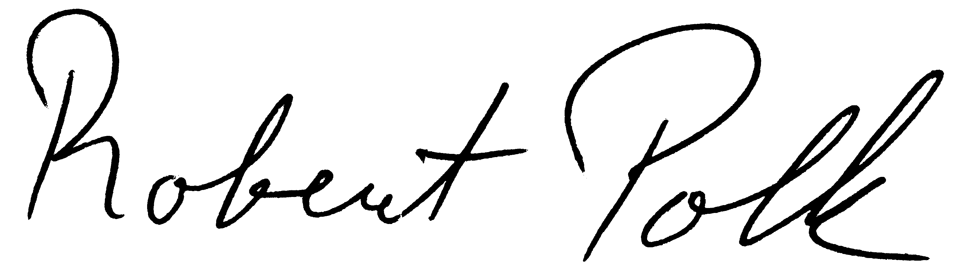_______________________ ___ ________________
Principal’s / Supervisor’s Signature Date

_______________________________________________ ___________________________________
Human Resources Administrator’s Signature Date

Prospective Candidates for Future Positions:
_______________________________________________ ____________________________________________

Revised 9/15/04

