Beginning  Hook the reader  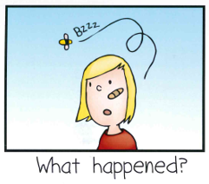  Characters – Who was there?  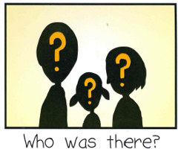  Setting – Where and when did it  happen?  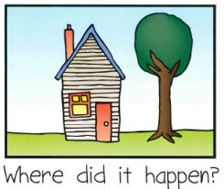  Event – What happened? | Middle  Problem - What happened?  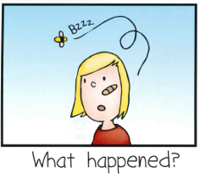  Emotion - Feeling in the middle?  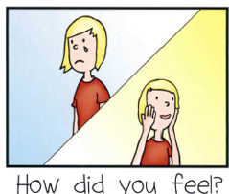 | End  Solution – How was the problem solved at the end?  Feeling at the end? –  What did you say?  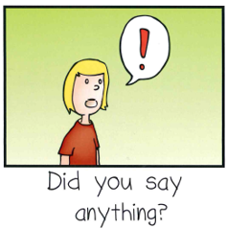
Middle
What did you say?

Add details
