*School Menu Website & Available Apps*

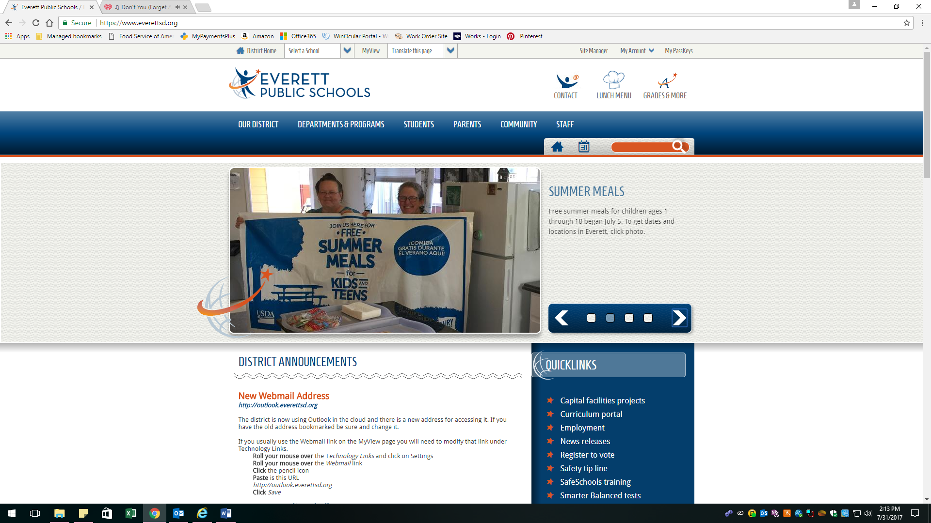

Click on the Chef Hat on District Website

Type in School Name

Select Menu: Breakfast or Lunch

Link to current Wellness Policy

Link to Free & Reduced Application

Link to other Language Application

Link to MyPaymentsPlus to see account balances, purchases and to make payments

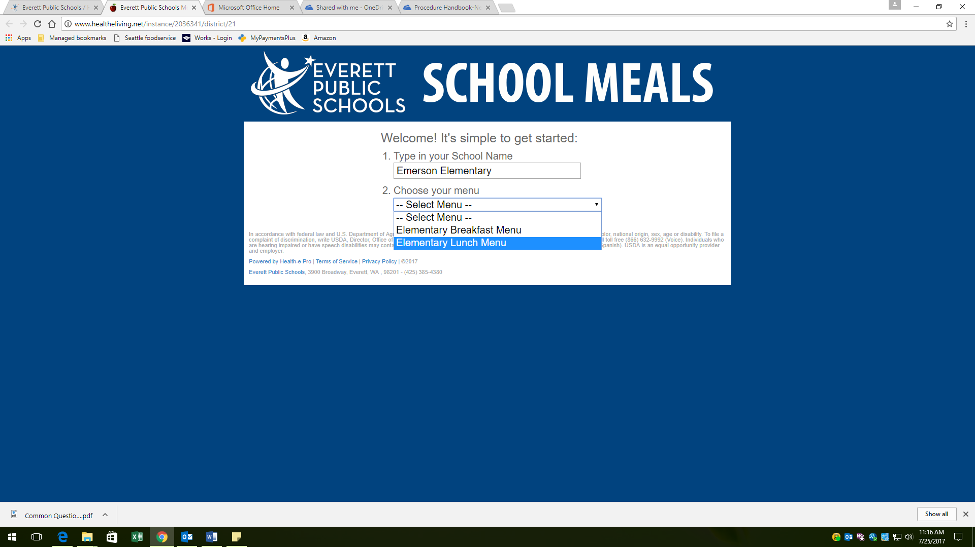

**Links to Apps are available on the School Meal Website:**

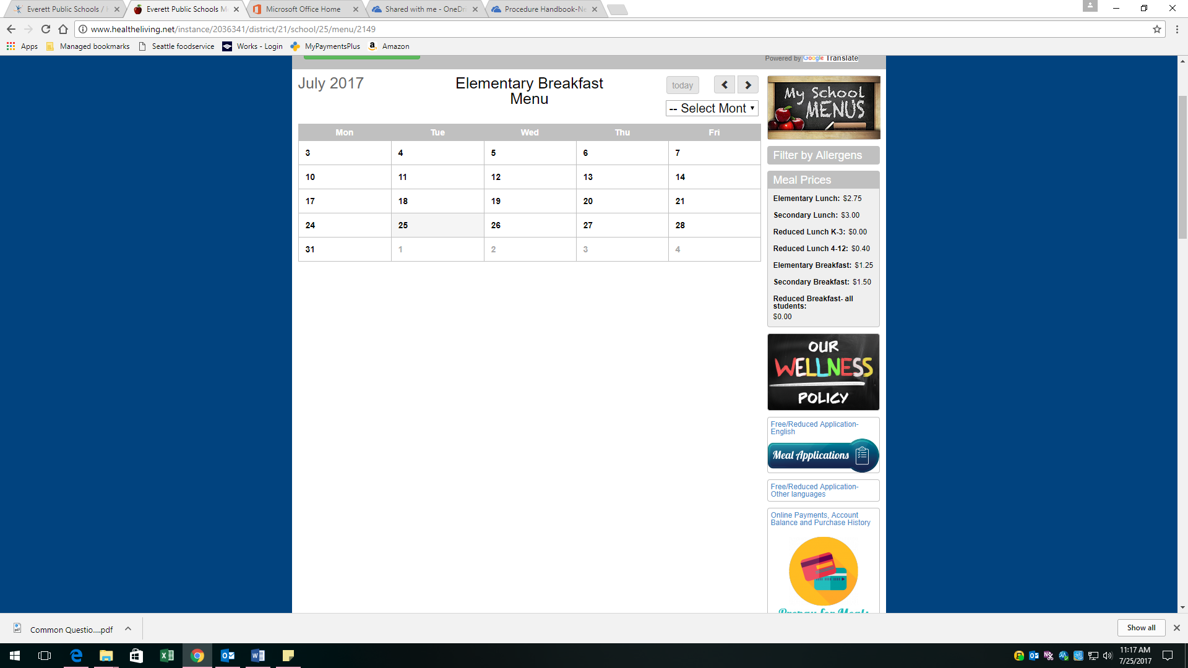

The School Meal website is easy to get to and has many links available for fast access. Please direct parents to this valuable tool to answer their questions.

