**Website Analytics May 2018**

Website analytics provides insight into who is visiting the website with details of traffic patterns, demographics and technology used. This tool provides the information to create and maintain an effective website.

Analytics are provided on a monthly basis.

**Overview**

339,926 **53,362**individuals visited the site

739,795 visits were made by the individuals above

1,721,461 pages were viewed during those visits

73% of the visitors were new to the site.

The average number of pages visited on each visit was 2.33**5.66 5.66**.

The average time spent on each page was 02:23.

Most visits came from the following countries:

1. United States
2. Canada
3. India
4. Philippines
5. United Kingdom
6. France
7. Mexico
8. Germany
9. South Korea
10. Ukraine

People who prefer to view the web with a different language have a setting on their computers that the analytic tool can read. The top five languages preferences that were not a variant of English (US, AU, UK) were:

1. Korean
2. Spanish
3. Chinese
4. Russian
5. French

**Browsers**

This data shows that Chrome is the most popular browser.

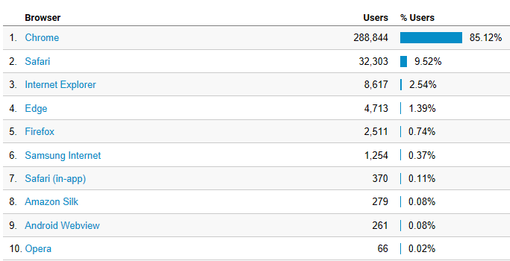

**Operating System**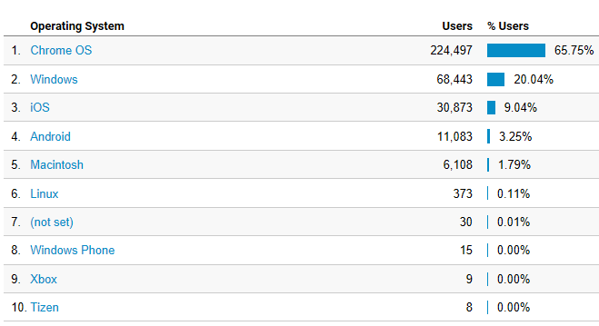

**Service Providers**

This tells us what provider the visitor is using.

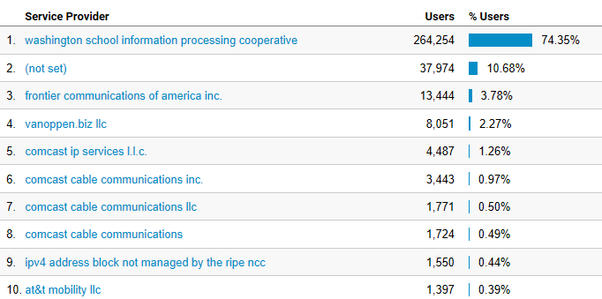

**Mobile Operating Systems**

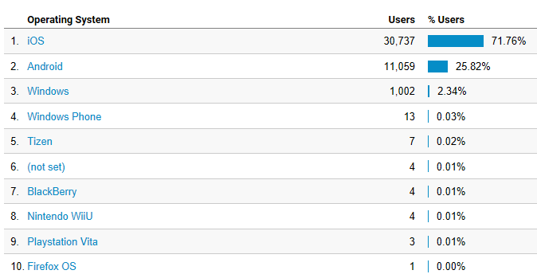

**Overall Screen Resolution**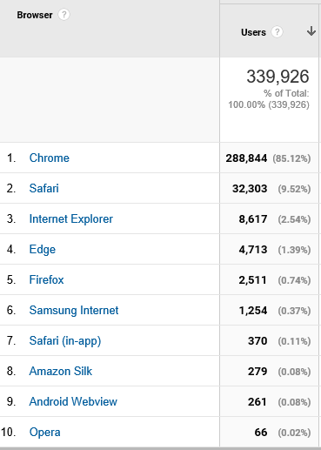

**Mobile Screen Resolution** 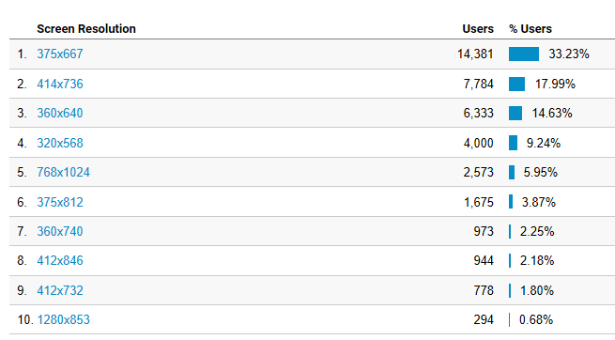

**Mobile Devices**

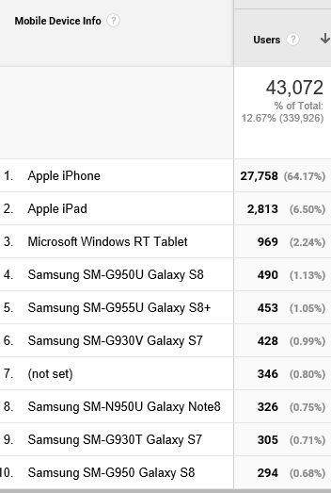

**Device Category**

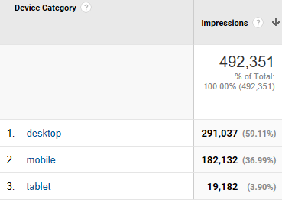

**Most visited pages**

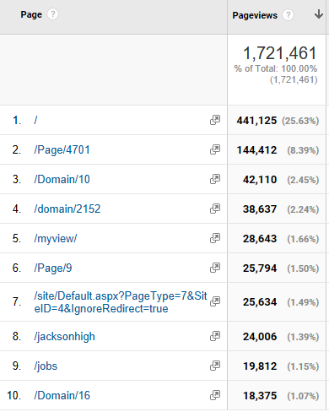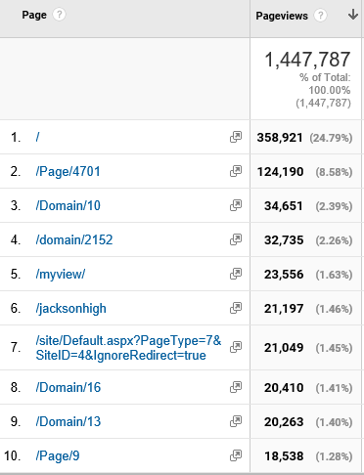

Jackson High

North Middle

Cascade High

Login page

Employment

Jackson High

Student Tools

MyView (must login to see)

LMS welcome page

District home page