Name Date

1. The total weight in grams of a can of tomatoes and a jar of baby food is shown to the right.

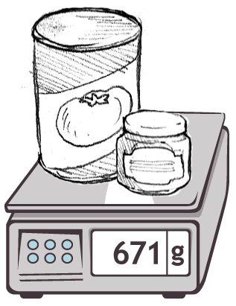

**671**

1. The jar of baby food weighs 113 grams. How much does the can of tomatoes weigh?
2. How much more does the can of tomatoes weigh than the jar of baby food?
3. The weight of a pen in grams is shown to the right.

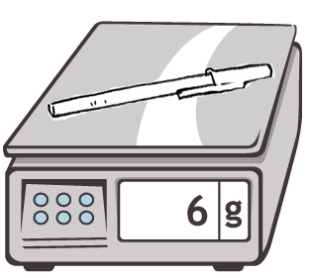

**6**

1. What is the total weight of 10 pens?
2. An empty box weighs 82 grams. What is the total weight of a box of   
   10 pens?

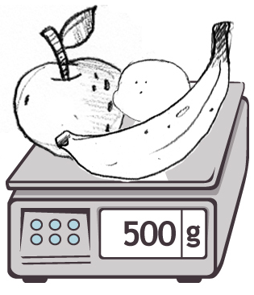

**508**

1. The total weight of an apple, lemon, and banana in grams is shown to the right.
2. If the apple and lemon together weigh 317 grams, what is the weight of the banana?
3. If we know the lemon weighs 68 grams less than the banana, how much does the lemon weigh?
4. What is the weight of the apple?

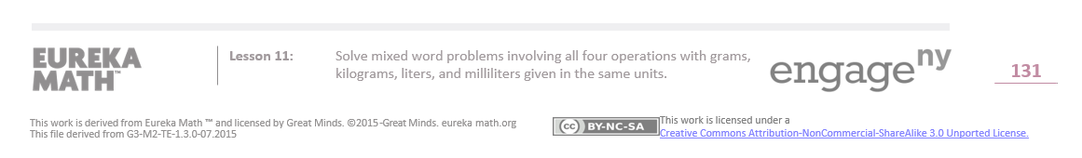

1. A frozen turkey weighs about 5 kilograms. The chef orders 45 kilograms of turkey. Use a tape diagram to find about how many frozen turkeys he orders.
2. A recipe requires 300 milliliters of milk. Sara decides to triple the recipe for dinner. How many milliliters of milk does she need to cook dinner?
3. Marian pours a full container of water equally into buckets. Each bucket has a capacity of 4 liters. After filling 3 buckets, she still has 2 liters left in her container. What is the capacity of her container?

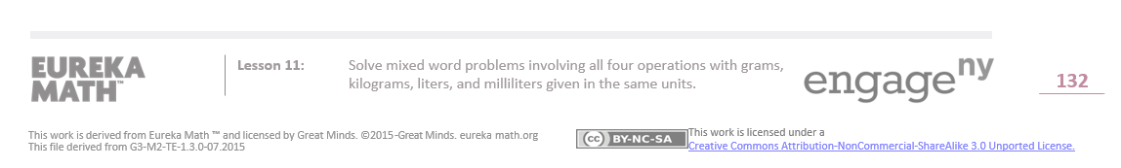Name Date

The capacities of three cups are shown below.



*Cup A*

160 mL

*Cup B*

280 mL

*Cup C*

237 mL

1. Find the total capacity of the three cups.
2. Bill drinks exactly half of Cup B. How many milliliters are left in Cup B?
3. Anna drinks 3 cups of tea from Cup A. How much tea does she drink in total?

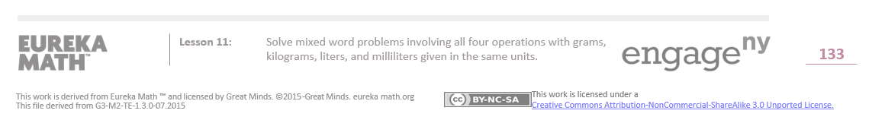



Name Date

1. Karina goes on a hike. She brings a notebook, a pencil, and a camera. The weight of each item is shown in the chart. What is the total weight of all three items?

**Item**

**Weight**

Notebook

312 g

Pencil

10 g

Camera

365 g

The total weight is __________ grams.

1. Together a horse and its rider weigh 729 kilograms. The horse weighs 625 kilograms. How much does the rider weigh?

The rider weighs __________ kilograms.

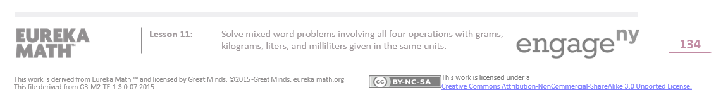



1. Theresa’s soccer team fills up 6 water coolers before the game. Each water cooler holds 9 liters of water. How many liters of water do they fill?
2. Dwight purchased 48 kilograms of fertilizer for his vegetable garden. He needs 6 kilograms of fertilizer for each bed of vegetables. How many beds of vegetables can he fertilize?
3. Nancy bakes 7 cakes for the school bake sale. Each cake requires 5 milliliters of oil. How many milliliters of oil does she use?

